(An Autonomous Institute, affiliated to VTU, Belagavi, Accredited by NAAC with ‘A’ Grade)



**Near** **Jnana** **Bharathi** **Campus,** **Bengaluru** **-** **560056**

#### DEPARTMENT OF COMPUTER SCIENCE AND ENGINEERING

**Cloud** **Computing** **Laboratory** **Report**

Submitted in partial fulfilment of the requirement for the award of the Degree of

***Submitted*** ***By***

#### ESHAN KESARWANI 1DA22CS048

***Submitted*** ***to,***

**Dr.** **Praveena** **M** **V** **Assistant** **Professor,** **Dept.** **Of** **CSE,**

**Dr.** **AIT,** **Bengaluru-56**

###### DEPARTMENT OF COMPUTER SCIENCE AND ENGINEERING 2024-2025

(An Autonomous Institute, affiliated to VTU, Belagavi, Accredited by NAAC with ‘A’ Grade)



Near Jnana Bharathi Campus, Bengaluru – 560056

**CERTIFICATE**

### “Cloud Computing Laboratory”

This is to certify that the submitted document in the partial fulfillment of the requirement of the 6th semester Cloud Computing laboratory curriculum during the year 2024-25 is a result of Bonafede work carried out by-

#### ESHAN KESARWANI 1DA22CS048

##### Signature of the Incharge,

**Dr.** **Praveena** **M** **V** **Associate** **Professor** **Dr.** **AIT** **CSE**

1. Internal Examiner
2. External Examiner

Dr. Nandini Head of Department

CSE Dr. AIT

## TABLE OF CONTENTS

**Chapter** **No.** **Title**

###### PART A

**Page** **No.**

Chapter 1 Salesforce 1



Chapter 2 Cloud Analyst 63

Chapter 3 Google App Engine 107

Chapter 4 Amazon Web Services – RDS 115

Chapter 5 VMware Workstation 129

File Transfer in Virtual Machines 149

PART B

Chapter 6 Mini Project 167

Chapter 7 Industry Certification - Salesforce

## SALESFORCE

Salesforce is an American cloud-based software company headquartered in San Francisco, California. It provides customer relationship management (CRM) service and also provides enterprise applications focused on customer service, marketing automation, analytics, and application development.

**History:**

The company was founded on February 3, 1999 by former Oracle executive Marc Benioff, together with Parker Harris, Dave Hoelterhoff, and Frank Dominguez as a software as a service (SaaS) company, and was launched publicly between September and November 1999.

In June 2004, the company had its initial public offering on the New York Stock Exchange under the stock symbol CRM and raised US$110 million. Early investors include Larry Ellison, Magdalena Yesil, Halsey Minor, Stewart Henderson, Mark Iscaro, and Igor Sill, a founding member of Geneva Venture Partners.

In October 2014, Salesforce announced the development of its Customer Success Platform to tie together Salesforce's services, including sales, service, marketing, analytics, community, and mobile apps. In October 2017, Salesforce launched a Facebook Analytics tool for business- to-business marketers. In September 2018, Salesforce partnered with Apple intended on improving apps for businesses.

In February 2020, co-chief executive officer Keith Block stepped down from his position in the company. Marc Benioff remained as chairman and chief executive officer.

On December 1, 2020, it was announced that Salesforce would acquire Slack for

$27.7 billion. The acquisition closed on July 21.

In February 2021, Salesforce announced that CFO Mark Hawkins would be retiring from his position after six years of working for the company; however, retaining a position as CFO emeritus until October. Amy Weaver was selected as his replacement.

Salesforce.com's customer relationship management (CRM) service comprises several broad categories: Commerce Cloud, Sales Cloud, Service Cloud, Data Cloud (including Jigsaw), Marketing Cloud, Community Cloud (including Chatter), Manufacturing Cloud, Analytics Cloud, App Cloud, Vaccine Cloud,IoT and Work.com with over 100,000 customers.

Main services

Salesforce's main services are tools for case, task and issue management. It also gives customers tracking abilities for their raised cases and conversation features for social networking Web sites, provides analytical tools and other services including email alert, Google search, and access to customers' entitlement and contracts. They also partner with companies like IBM, Accenture, and Saggezza to help integrate Salesforce's cloud-based services into their businesses.

**Lightning** **Platform**

Lightning Platform (also known as Force.com) is a platform as a service (PaaS) that allows developers to create add-on applications that integrate into the main Salesforce.com application. [failed verification] These third-party applications are hosted on Salesforce.com's infrastructure.

Force.com applications are built using declarative tools, backed by Lightning [further explanation needed] and Apex, a proprietary Java-like programming language for Force.com, as well as Visualforce, a framework including an XMLsyntax typically used to generate HTML. The Force.com platform typically receives three complete releases a year. As the platform is provided as a service to its developers, every single development instance also receives all these updates.

In 2015, a new framework for building user interfaces – Lightning Components – was introduced in beta. Lightning components are built using the open-source Aura Framework but with support for Apex as the server-side language instead of Aura's JavaScript dependency. This has been described as an alternative to, not necessarily a replacement for, Visualforce pages.

As of 2013, the Force.com platform has 1.4 million registered developers. Lightning Base Components is the component library built on top of Lightning Web Components.

Experience Cloud

Experience Cloud (formerly Community Cloud) provides Salesforce customers the ability to create online web properties for external collaboration, customer service, channel sales, and other custom portals in their instance of Salesforce. Tightly integrated to Sales Cloud, Service Cloud, and App Cloud, Experience Cloud can be quickly customized to provide a wide variety of web properties. Experience Cloud combines the functionality of the former Salesforce Customer and Partner Portals with some additional features.

**Work.com**

Work.com, previously Rypple, is a social performance management platform for managers and employees. It allows continuous coaching, real-time feedback, and recognition. It is aimed at sales management, customer service, marketing, and can be utilized by human resource departments.

Work.com, then known as "Rypple", was founded by Daniel Debow and David Stein, to create a simple way of asking for feedback anonymously at work. The company was formed in May 2008 and their client list included Mozilla, Facebook, LinkedIn and the Gilt Groupe. Rypple aims to get employees to build and manage their own coaching networks.

In September 2011, Rypple announced that they had hired Bohdan Zabawskyj as its Chief Technology Officer. In 2011, Rypple developed a more formalized management methodology called OKR ("Objectives and Key Results") for Spotify. Rypple also partnered with Facebook to create "Loops", short for "feedback loops", which gathers feedback from co-workers, including praise, progress against goals, and coaching from supervisors into one channel.

In December 2011, Salesforce.com announced that they would acquire Rypple. The transaction was completed in 2012 and Rypple was rebranded as Work.com in September 2012.

AppExchange

Launched in 2005, the Salesforce AppExchange is an online application marketplace for third- party applications that run on the Force.com platform. Applications are available for free, as well as via yearly or monthly subscription models. Applications available range from integrations with SharePoint to mobile approval management. As of June 2016, it features 2,948 applications which have driven 3+ million installs. The "AppExchange" is also a place customers can search for cloud consulting partners to help them implement the technology in their own organization. Cloud consulting partners for Salesforce include large companies like IBM's "Bluewolf" and Accenture as well as smaller ones like Cloudreach.

myTrailhead

Launched in 2019, Salesforce's myTrailhead is an online training platform that can be customized for the specific needs of its customers. The platform extends functionality to provide users with training content specific to their usage of Salesforce and enables them to create and publish their own training content and programs.

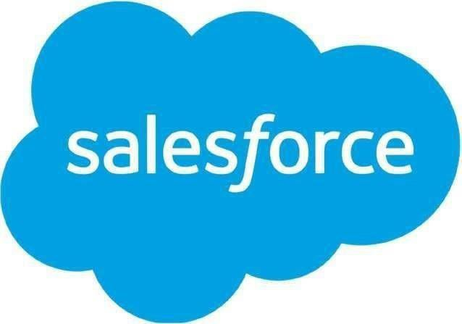

**Technologies:**

Salesforce is powered by the Model–view–controller architecture.

**Apex**

Apex is a proprietary programming language provided by the Force.com platform to developers similar to Java and C#. It is a strongly typed, object-oriented, case- insensitive programming language, following a dot-notation and curly-brackets syntax. Apex can be used to execute programmed functions during most processes on the Force.com platform including custom buttons and links, event handlers on record insertion, update, or deletion, via scheduling, or via the custom controllers of Visualforce or Lightning Experience pages.

Due to the multitenant nature of the platform, the language has strictly imposed governor limitations to guard against any code monopolizing shared resources. Salesforce provides a series of asynchronous processing methods for Apex to allow developers to produce longer- running and more complex Apex code.

Lightning

In 2014, Salesforce made public the front end of its platform, called Lightning. This component-based framework is what the Salesforce mobile app is built on. Salesforce built on this framework in 2015 by releasing the Lightning Design System, an HTML style framework with default CSS styling built in. This framework allows customers to build their own components to either use in their internal instances or sell on the AppExchange.

The Salesforce Lightning App Builder is a tool for rapid application development of responsive web interfaces. This interface allows for different screens to be put together based on Lightning components. This can be used as layouts for records or specific applications.

Lightning Experience, released in 2016, is the new redesigned interface in Salesforce for processes enhancement. Since then all the apps available on AppExchange need to be Lightning and those built on Classic have to migrate to Lightning as Classic is not to be updated any more by Salesforce. The platform offers an option for developers to employ migration techniques to enable the new user-friendly interface and switch to Lightning.

What is Salesforce used for?

* Engage customers with relevant, empathetic digital marketing from anywhere.
* Sell smarter and grow your business faster from anywhere.
* Quickly launch and scale ecommerce built around your customer — from anywhere.
* Provide great customer service from anywhere.
* Go digital fast and empower your teams to work from anywhere.



(Followed By 10 Playgrounds)

1. Create a web application to enter student details like Name, USN, Semester, Section and CGPA to a database on Salesforce Cloud Platform.

Steps:

* 1. 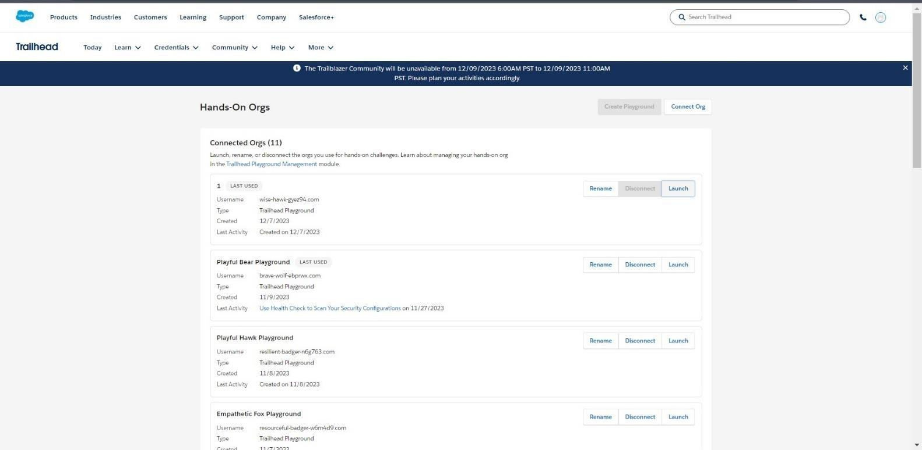Launch Salesforce Trailhead Playground by going to https://trailhead.salesforce.com. Now switch to Hands on orgs by clicking your picture in the top right corner and then click on “Hands on orgs”.
  2. Click on create playground to create a new one. And follow the instructions.
  3. After creating the playground click on Launch.
  4. Click on the gear icon on top right menu and click “setup.”
  5. Now is the time to create our objects, hence we navigate to “Object Manager” hover on “Create” and click on “Custom Object” under it.

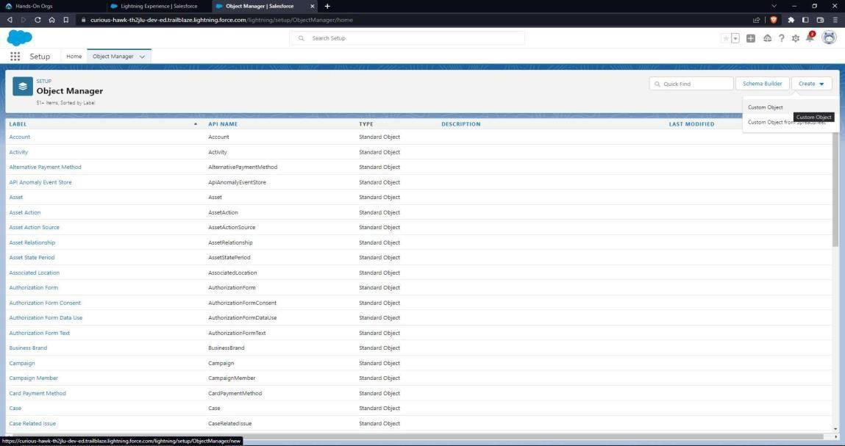

* 1. Name the object as “Student”. Allow reports and search
  2. Go back to home, search for Tab, navigate to custom object tab and click on new. Create a tab for “student” object.
  3. Now let’s add fields to the object: Go to “Fields & Relationships” option of student object and click “New”.
  4. Add the following fields one by one:

➔ Field Label: **USN**, Length: **10**, Data Type: **Text**, provide an example as Help Text, make it as required field and don’t allow duplicate values and make it as case insensitive.

➔ Field Label: **Section**, Data Type: **Picklist,** provide the sections you could think of, make it as required.

➔ Field Label: **Semester**, Data Type: **Picklist**, provide 1-8 numbers, make it as required.

➔ Field Label: **CGPA**, Length: **2**, Decimal Place: **2**, Data Type: **Number**, make it as required field.

➔ Optionally we can also add phone number and email ID.

* 1. 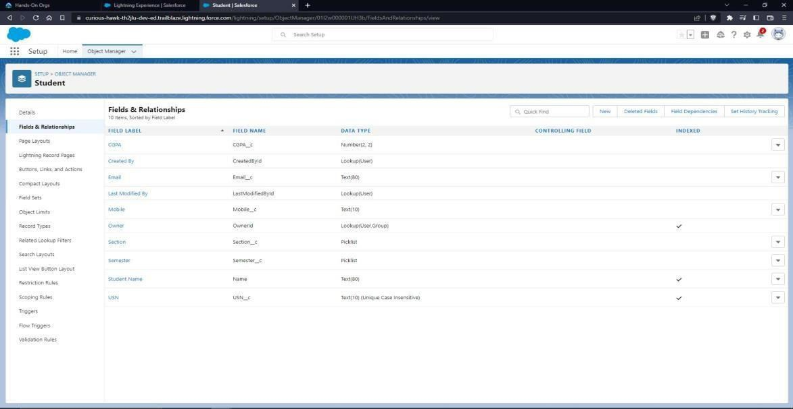Let’s start validating each data
     1. Name validation
        + Go to validation rule and click “New”
        + Name it as “Student name validation”
        + Error condition Formula: “NOT(REGEX(Name, “[a-zA-Z]+[a-zA-Z]+”))”
        + Error Message: “Please Enter a valid name”.
        + Error Location: Field – Student name
        + Click Save

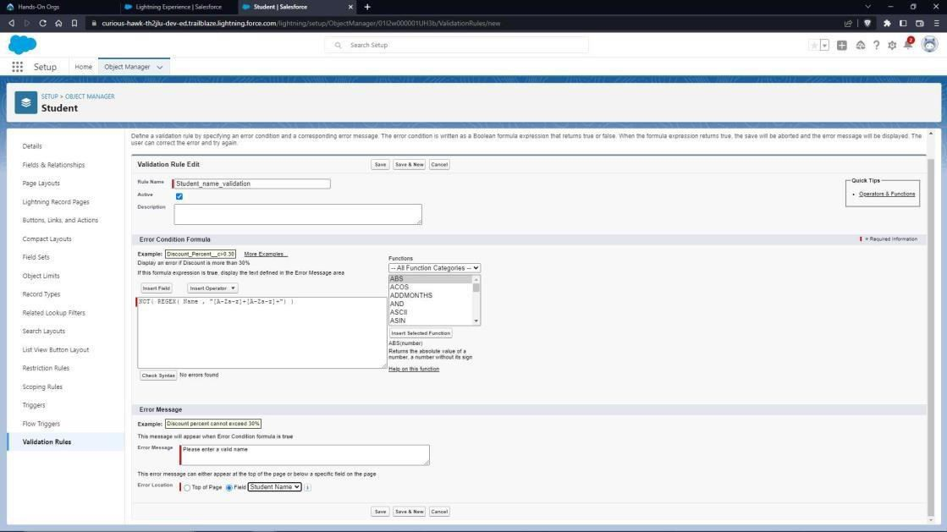

* + 1. USN validation
       - Go to validation rule and click “New”
       - Name it as “USN validation”
       - Error condition Formula: “NOT(REGEX( USNc , "[1-4]{1}[A-Z]{2}[0-9]{2}[A-Z]{2}[0- 9]{3}"))”
       - Error Message: “Please Enter a valid USN”.
       - Error Location: Field – USN
       - Click Save

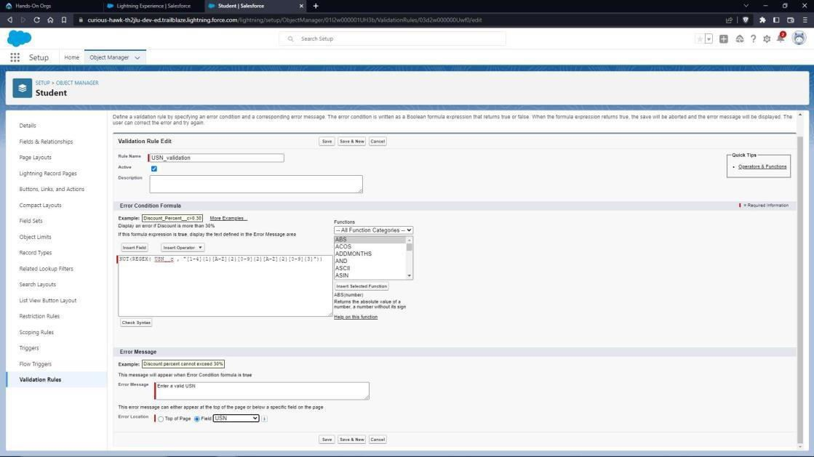

* + 1. CGPA validation
       - Go to validation rule and click “New”
       - Name it as “CGPA validation”
       - Error condition Formula: “AND(CGPA c<=10.00, CGPA c>0.00)”
       - Error Message: “Please Enter a valid CGPA”.
       - Error Location: Field – CGPA
       - Click Save

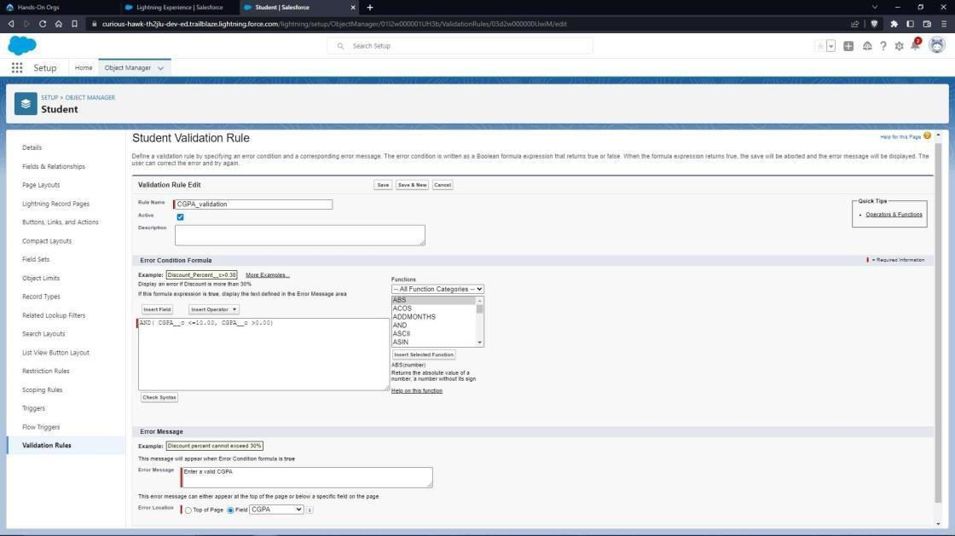

* + 1. Similarly give validation rules for email and phone number if you have added.
  1. Now create an application: navigate to home and search for “App Manager”. Click on it
  2. Click on “New Lightning App” to create a Lightning Application.
  3. Name it as “Student Details”, give your description, upload an image and change colors as you wish, click on “Next”.

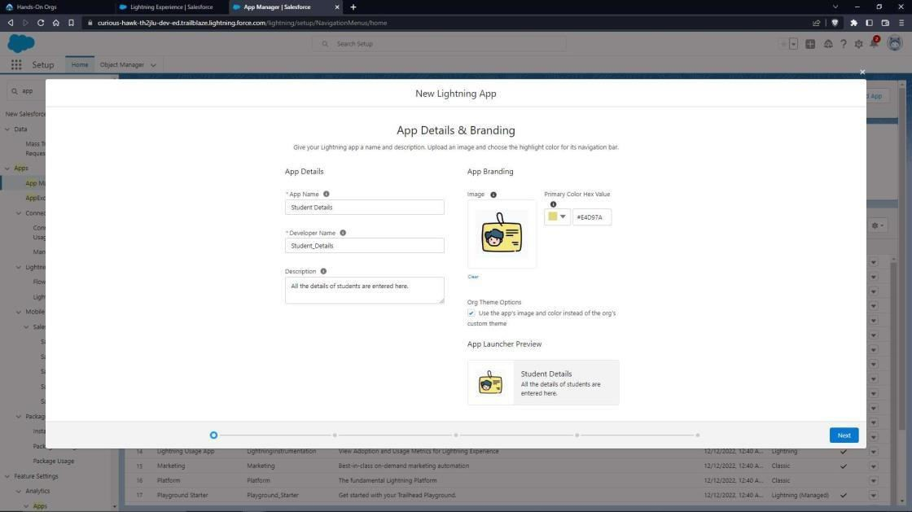

* 1. Set navigation style to standard navigation click next, let the utility bar have defaults so click next.
  2. In navigation items add Dashboard, Reports and Student click next.
  3. Assign it to System Administrator profile then click save and finish.
  4. Click on app launcher (3x3 dots on top left corner) then click on view all, you’ll see your application. Click on it.
  5. 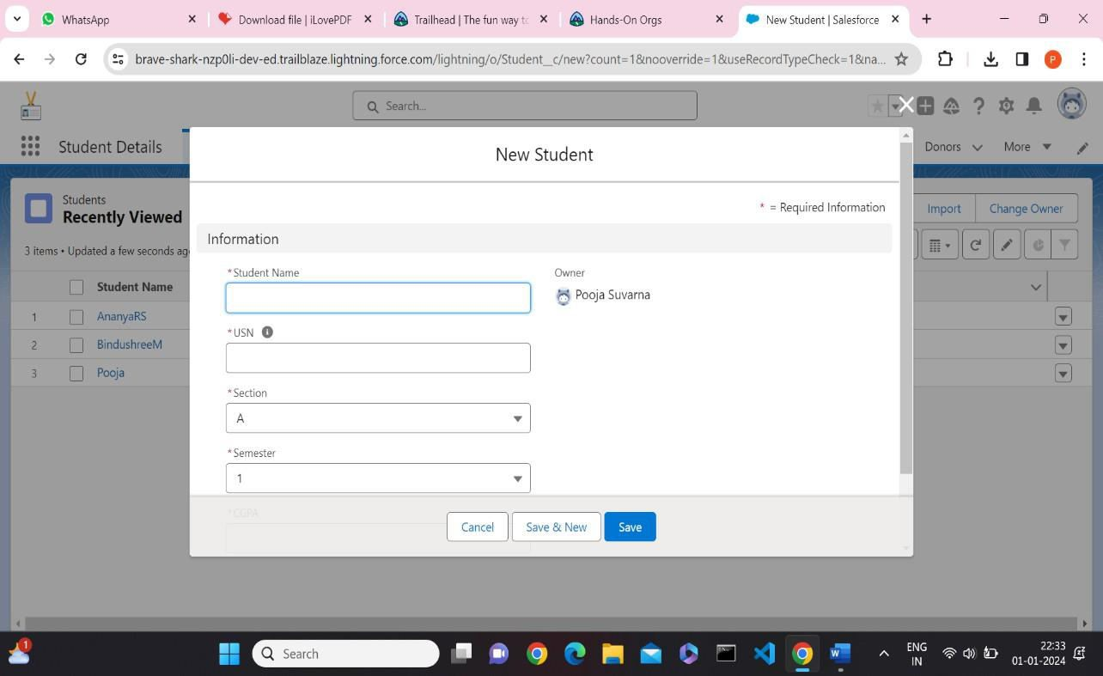Enter the details.
  6. Now let’s check what happens if we give invalid details.
  7. Enter few more details. Now we can use the reports and dashboard
  8. First let us create a student report
     1. Navigate to “Reports” tab and click on “New folder”, give any name and click save.
     2. Click on “New Report” and search for “Students”, select it and click on “Start Report”
     3. On left you see Add column option. From there add all the columns you require.
     4. Also add a group if you wish to.
     5. Click on save and name the report as “Student Report” and save it in folder you had created.
     6. Click on Save and then Run.

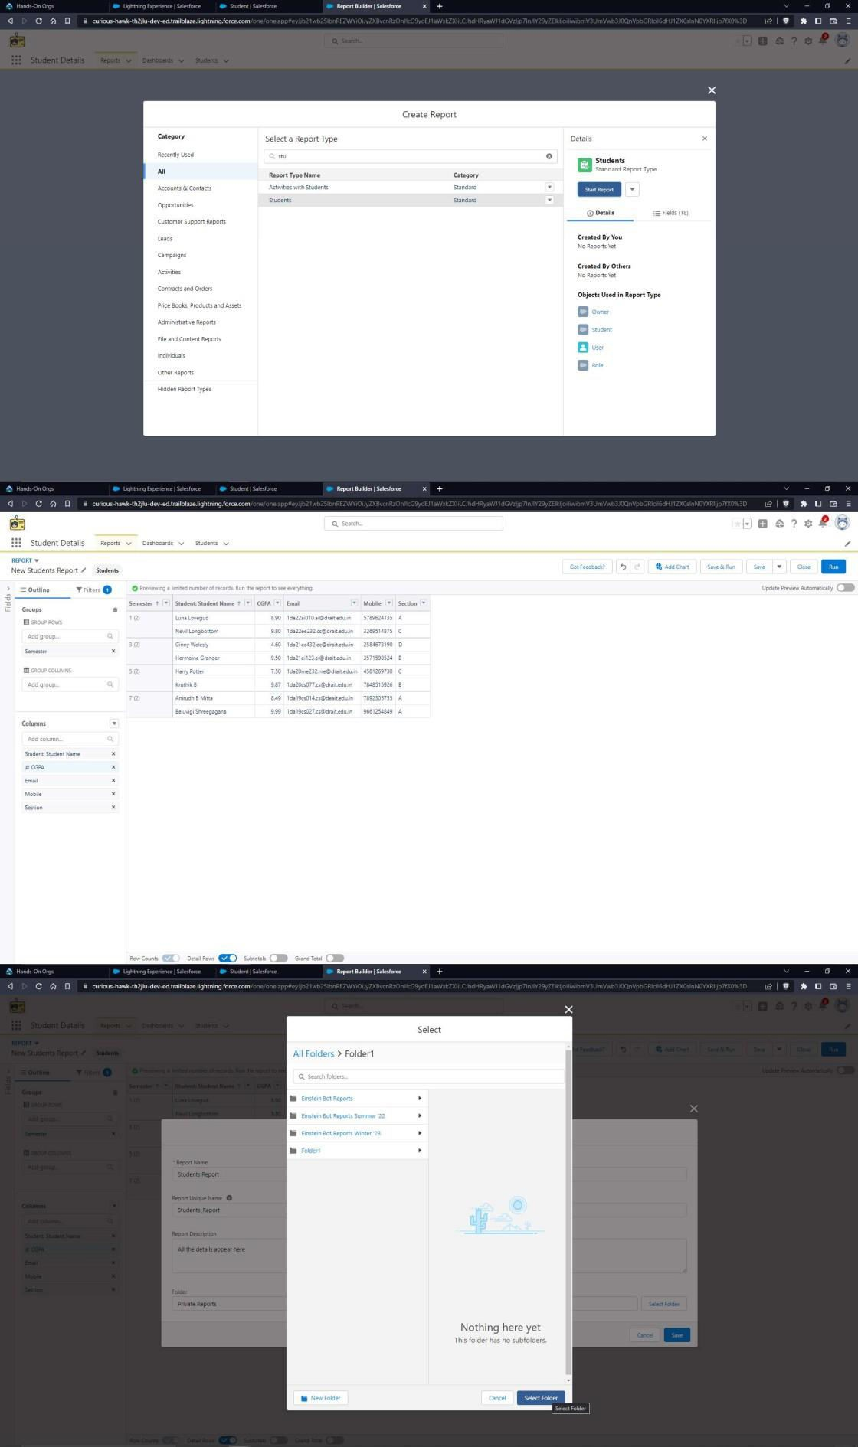

* 1. Now let’s create a dashboard
     1. Go to “Dashboard” tab and then click on “New folder” and give it any name.
     2. Click on “New Dashboard” and then name it as “Students Dashboard” and select folder that you have created Click on Create.
     3. Click on the report that you have created and click on that and click select.
     4. Select any style to represent the data in dashboard.
     5. Add any filter(s), otherwise it is optional.
     6. Click on Save and Click Run.

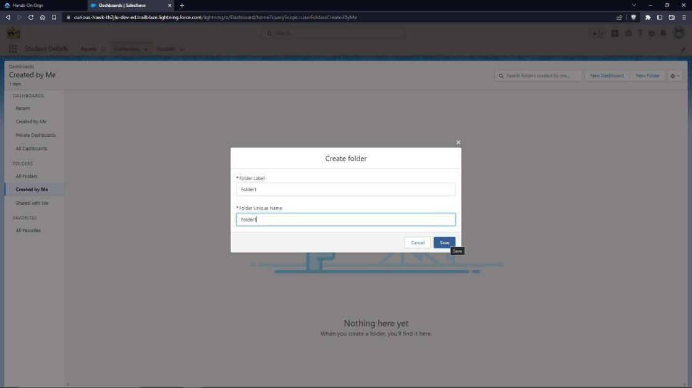

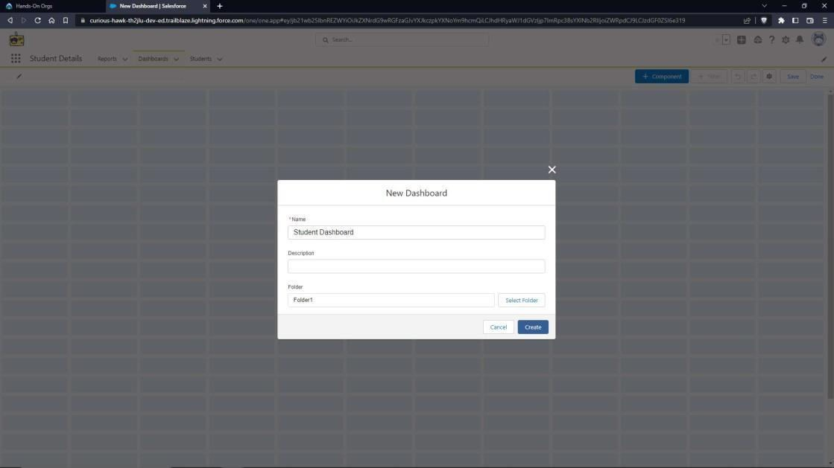

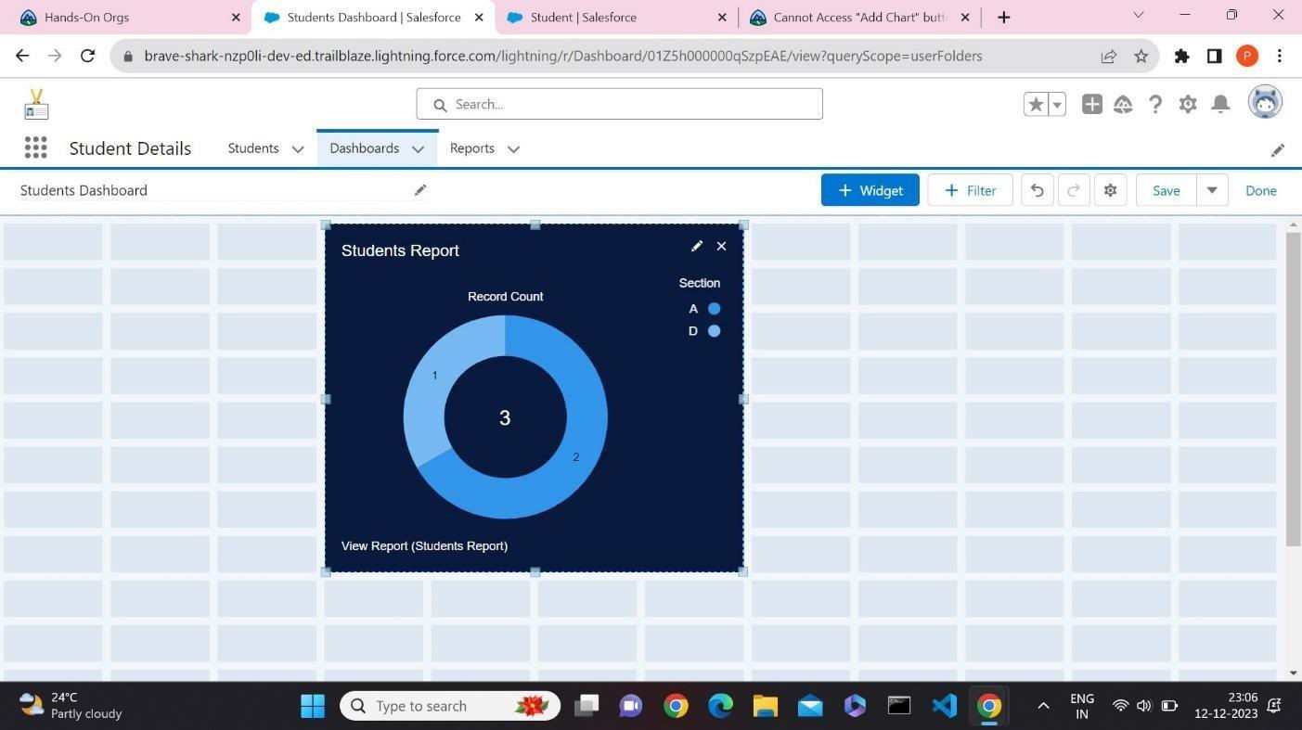

1. Create a web application to implement an online cart for adding items to a shopping cart and deleting it.

**Steps:**

* 1. Launch your Salesforce Trailhead Playground by opening any module and Switch to Lightning Experience if you are currently in Salesforce Classic by clicking your picture in the right top corner and then click on “Switch to Lightning Experience”.
  2. Then go to Setup gear icon and click “Setup”.
  3. Click on “Object Manager” and click “Create> Custom Object” to create new Custom Object.
  4. Name the object “Cart”.
  5. Allow Reports and Allow Search.
  6. Check the box in front of “Launch New Custom Tab Wizard after saving this custom object”

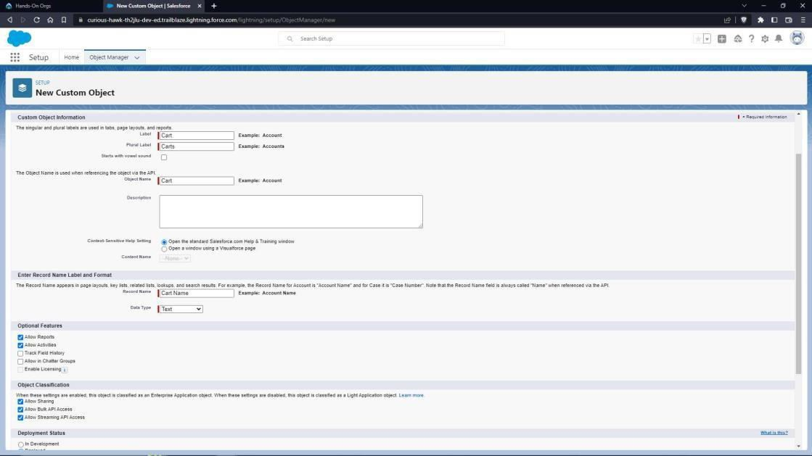

* 1. To create a Tab for the Object: Select any Tab Style for the object “Cart”. Click Next, Next, leave the defaults and save.
  2. To add fields to the Object: Go to “Fields & Relationships” option of Student object and Click “New”.
  3. Add the following fields one after the other:
* Field Label: Item Name, Data Type: Text Area, make it as Required Field.
* Field Label: Category, Data Type: Picklist, click radio button in front of Enter values, with each value separated by a new line Values are Books, Electronics & Accessories, Furniture & Home Appliances, Fashion – Men, Fashion – Women, Fashion – Kids, Footwear and Others.
* Make it as Required Field and Restrict the values to the values in the picklist.
* Field Label: Quantity, Data Type: Number, make it as Required Field.
* Field Label: Price, Data Type: Currency (Length 16, Decimal Places 2), Make it as Required Field.

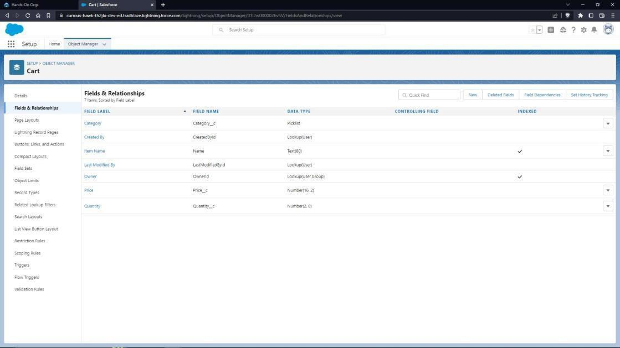

To create an application:

* 1. Go to “Setup” and type “App Manager” in Quick Find Box.
  2. Click on “New Lightning App” to create a Lightning Application.
  3. Name it as “Online Shopping Cart”, give the description for your application.
  4. Uploading Image and changing colours are optional, then click Next.
  5. Navigation Style: Standard Navigation, click Next.
  6. No need to add any Utility Bar, click Next.
  7. Add the following Items: Carts, Reports and Dashboards, click Next.
  8. Assign it to System Administrator Profile by selecting System Administrator and pressing right arrow and then click Save & Finish.
  9. Go to App Manager, select your application and select Carts and click “New” to add some details to your application.

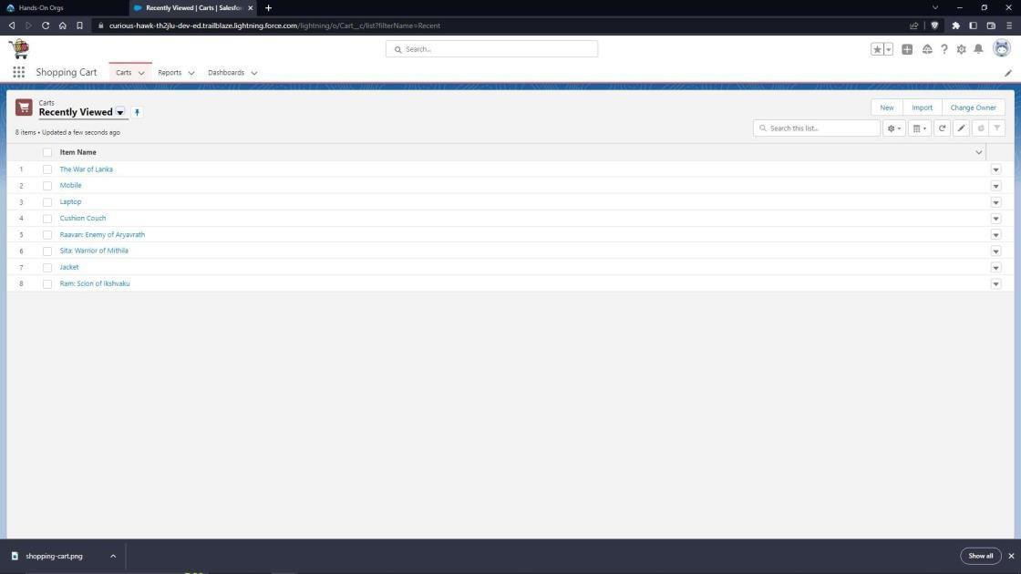

* 1. Create Report
* Go to “Reports tab” Click on “New Folder” And give it any name and then click Save.
* Click on “New Report” and from search bar Search for “Carts” and then select it and click Continue.
* If you Want the report to be grouped by any specific fields, then Search for the field in “Add groups” otherwise it is optional.
* Click on save and name the report as “New Carts Report” and then select the folder which you have created.
* Click Save and then Click Run.

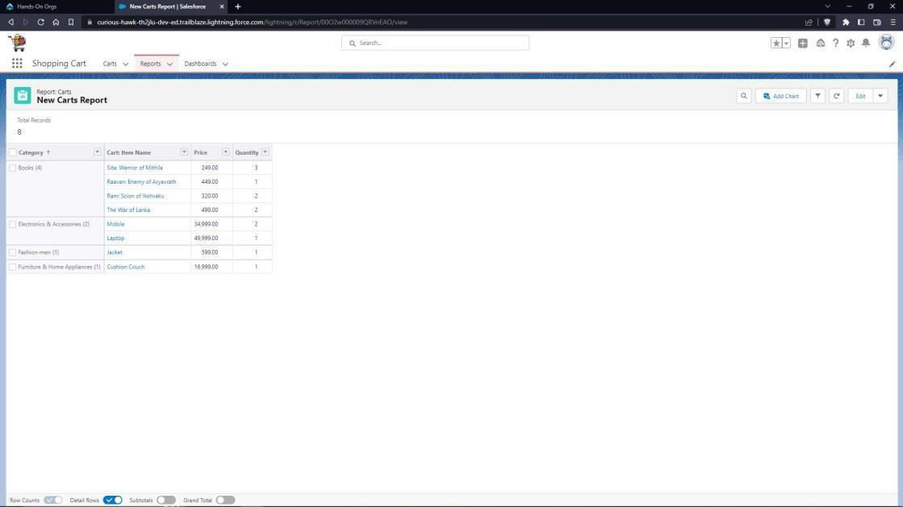

* 1. Create Dashboard
* Go to “Dashboard tab” and then click on “New Folder” and give it any Name.
* Click on “New Dashboard” and then name it as “Shopping cart” and select folder that you have created Click on Create.
* Click on the report that you have created and click on that and click select.
* Select any style to represent the data in dashboard.
* Add any filter(s), otherwise it is optional.
* Click on Save and Click Run.

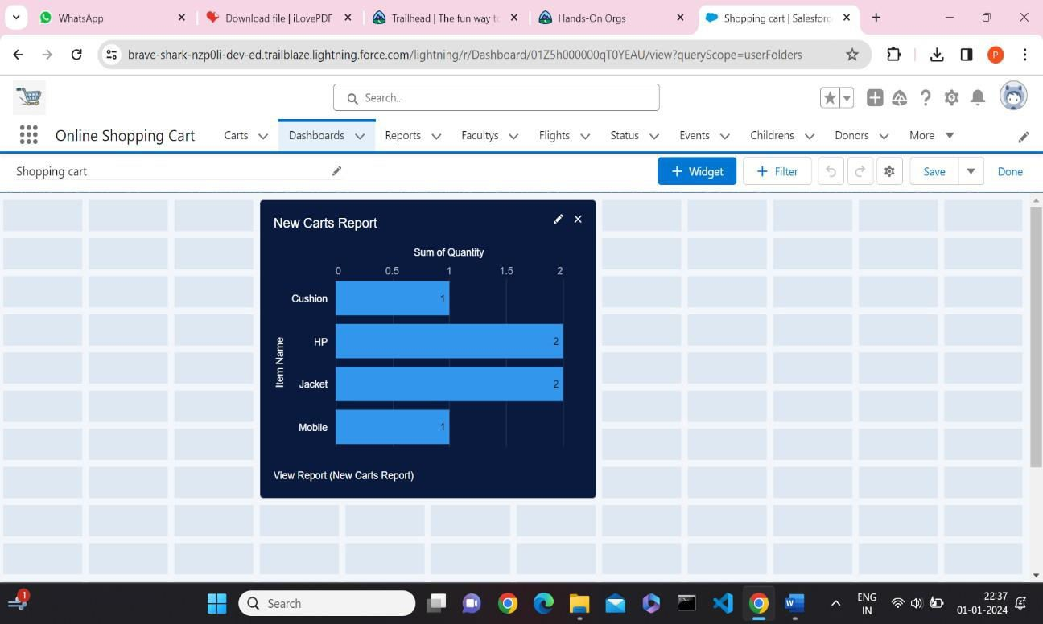

1. Create a web application to enter the faculty details like faculty ID, faculty name, and salary to a database and calculate the income tax to be paid by the faculty at the end of financial year.

**Steps:**

* 1. Launch your Salesforce Trailhead Playground by opening any module and Switch to Lightning Experience if you are currently in Salesforce Classic by clicking your picture in the right top corner and then click on “Switch to Lightning Experience”.
  2. Then go to Setup gear icon and click “Setup”.
  3. Click on “Object Manager” and click “Create> Custom Object” to create new Custom Object
  4. Name the object “Faculty” 2. Allow Reports and Allow Search.
  5. Check the box in front of “Launch New Custom Tab Wizard after saving this custom object”
  6. To create a Tab for the Object: Select any Tab Style for the object “Faculty”. Click Next, Next, leave the defaults and save.

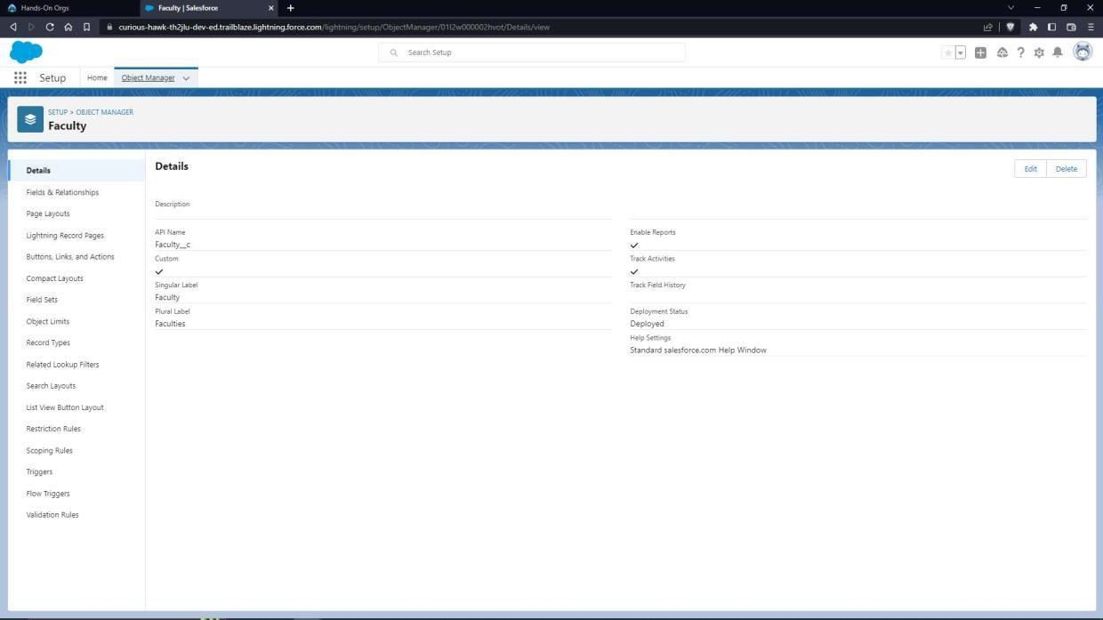

* 1. To add fields to the Object: Go to “Fields & Relationships” option of Student object and Click “New”. Add the following fields one after the other:
* Field Label: ID (Length 10), Data Type: Text, provide an example ID as Help Text, make it as Required Field, don’t allow Duplicate Values, make it as Case Insensitive and Set this field as the unique record identifier from an external system
* Field Label: Salary, Data Type: Currency (Length 16, Decimal Places 2), Make it as Required Field.

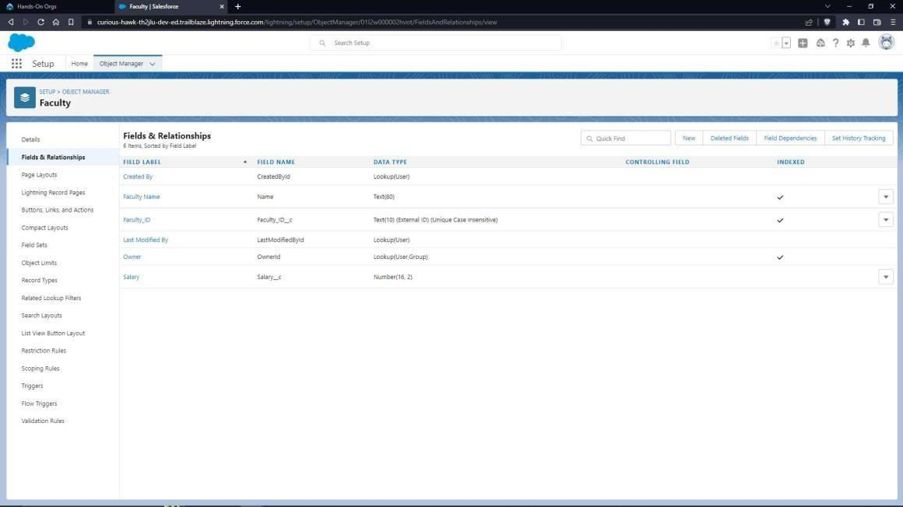

To calculate Income Tax to be paid:

* 1. Go to “Buttons, Links and Actions” of Faculty Object and click “New Button or Link”
  2. Name it as “Tax Calculation”. Select the radio button “Detail Page Link” as it is a website link.
  3. Behaviour: Display in new window.
  4. Content Source: URL.
  5. Field Type: Faculty
  6. In the empty space provided, type https://[www.incometaxindia.gov.in/Pages/tools/income-tax-calculator-234ABC.aspx](http://www.incometaxindia.gov.in/Pages/tools/income-tax-calculator-234ABC.aspx) It is a link which redirects to the income tax calculation website.
  7. Link Encoding: Unicode (UTF-8).
  8. Click Save.

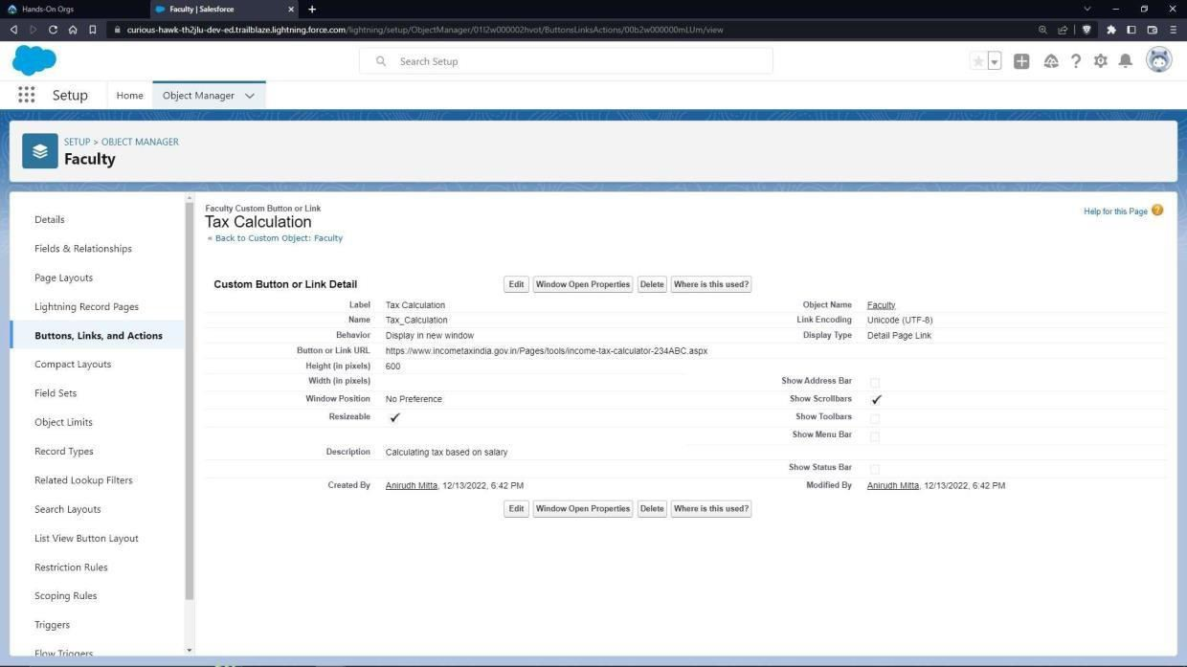

* 1. Go to Page Layout, Click Faculty Layout.
  2. Click Custom Links, Drag and drop the “Tax Calculation” link in the Custom Link area.
  3. Click Save.

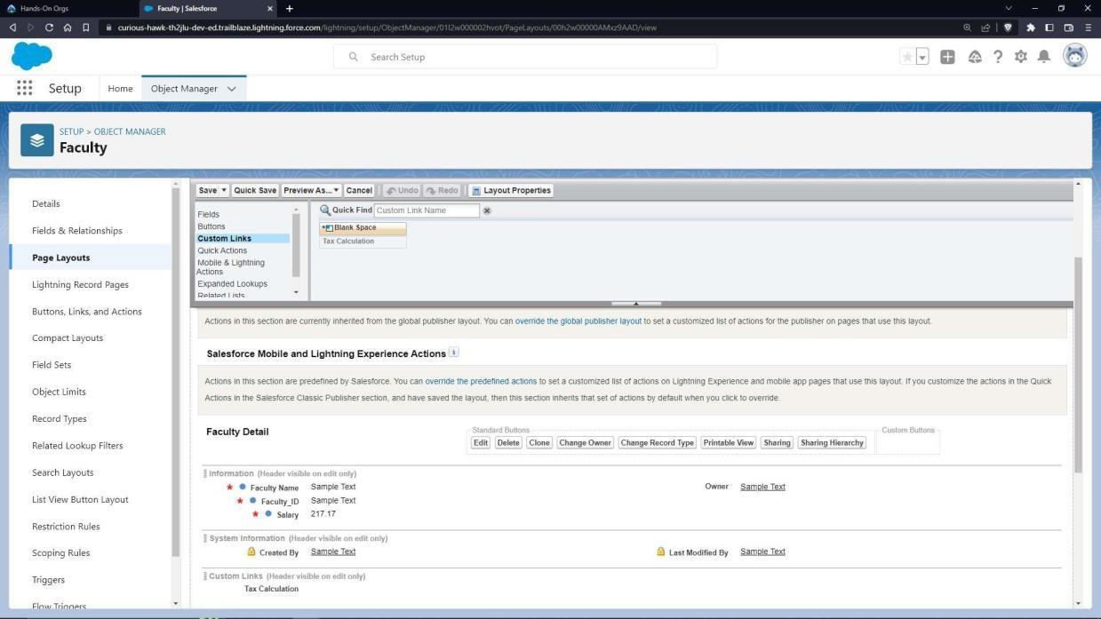

* 1. To add a rule to the faculty name so that it should take only valid names:
* Go to Validation Rule of Flight Object and click “New”
* Name it as “Name Validation”.
* Error Condition Formula: NOT(REGEX(Name,”*a-zA-Z ]+[ a-zA-Z++”)).
* Error Message: Please Enter a valid name.
* Error Location: Field – Faculty name.
* Click Save.

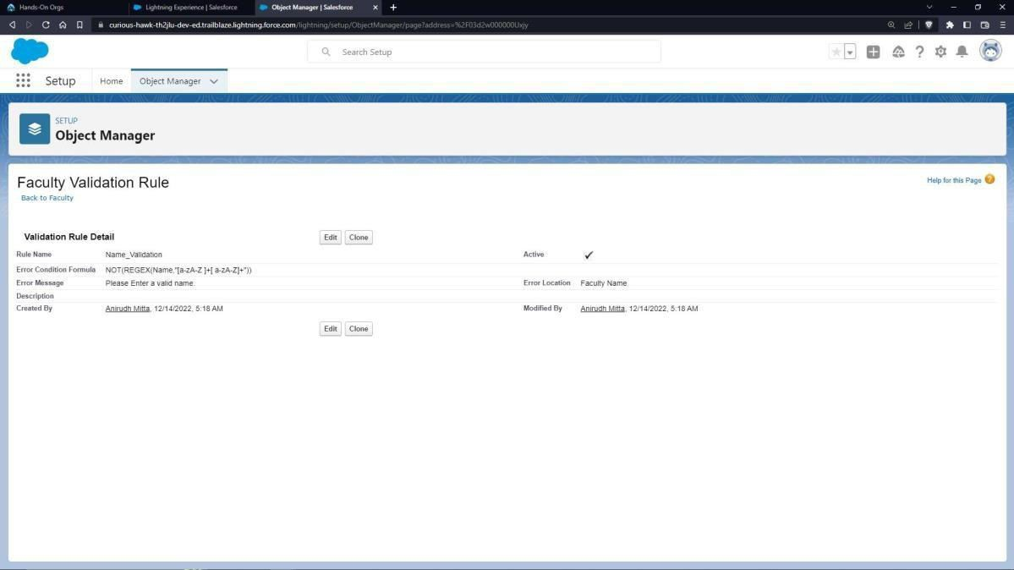

Create an application:

* 1. Go to “Setup” and type “App Manager” in Quick Find Box.
  2. Click on “New Lightning App” to create a Lightning Application.
  3. Name it as “Faculty Database”, give the description for your application.
  4. Uploading Image and changing colours are optional, then click Next.
  5. Navigation Style: Standard Navigation, click Next.
  6. No need to add any Utility Bar, click Next.
  7. Add the following Items: Faculties, Reports and Dashboards, click Next.
  8. Assign it to System Administrator Profile by selecting System Administrator and pressing right arrow and then click Save & Finish.
  9. Go to App Manager, select your application and select Faculties and click “New” to add some details to your application.
  10. Click the entry you added, go to details. Make sure you will get an error message when you enter an invalid name and invalid id.
  11. Press the “Tax Calculation” link to calculate income tax. Click OK so that it will

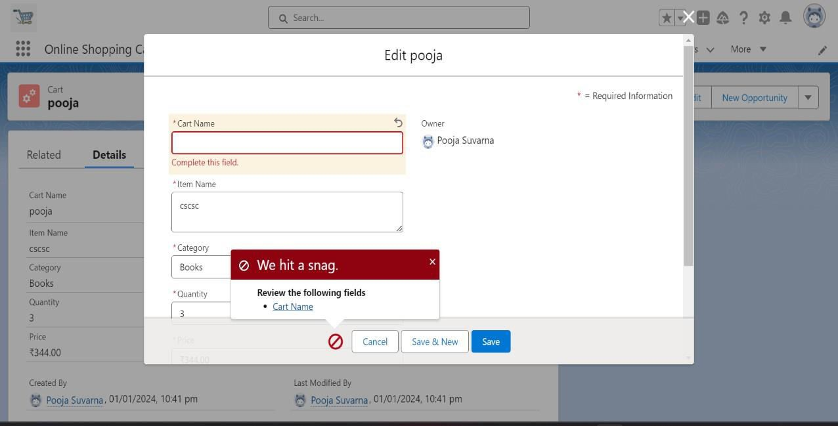

redirect you to the income tax calculator website.

* 1. Enter the required Details and press “Calculate”.

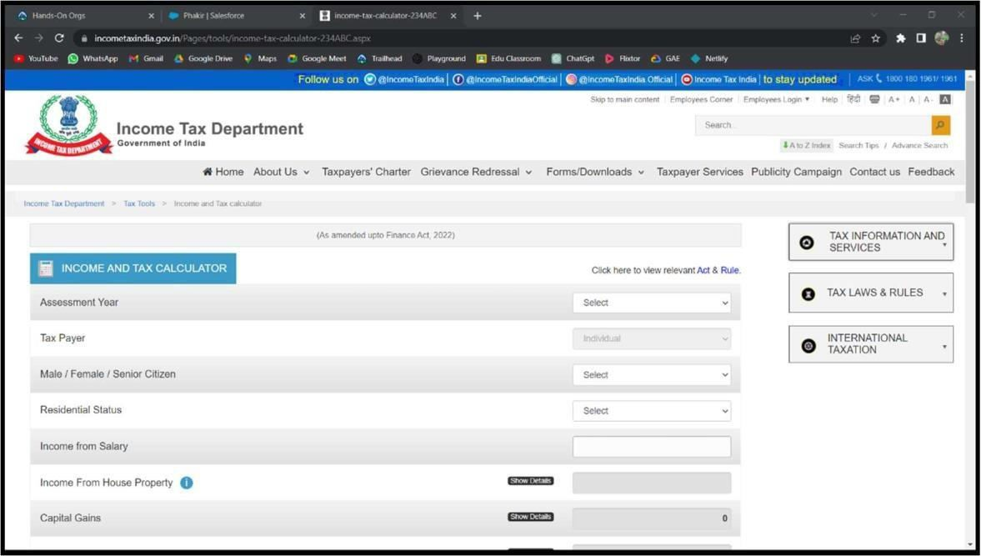

* 1. To Create a Faculty Report:
* Go to “Reports tab” Click on “New Folder” And give it any name and click on Save.
* Click on “New Report” and from search bar Search for “Faculty” and then select it then Click Continue.
* Add the required Columns to get the Complete Entered data.
* If you want the report to be grouped by any specific Fields, then Search for the field in “Add groups” otherwise it is optional.
* Click on save and name the report as “New Faculties Report” and then select the folder which you have created.
* Click Save and then Click Run.

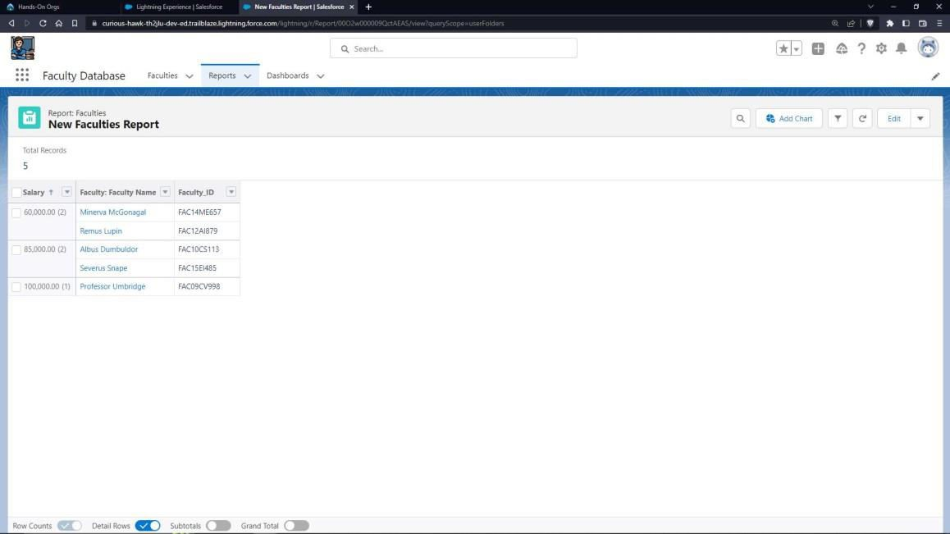

* 1. To Create a Faculty Dashboard:
* Go to “Dashboard tab” and then click on “New Folder” and give it any Name.
* Click on “New Dashboard” and then name it as “Income Tax Dashboard” and select folder that you have created Click on Create.
* Click on the report that you have created and click on that and click select.
* Select any style to represent the data in dashboard.
* Add any filter(s), otherwise it is optional.
* Click on Save and Click Run.

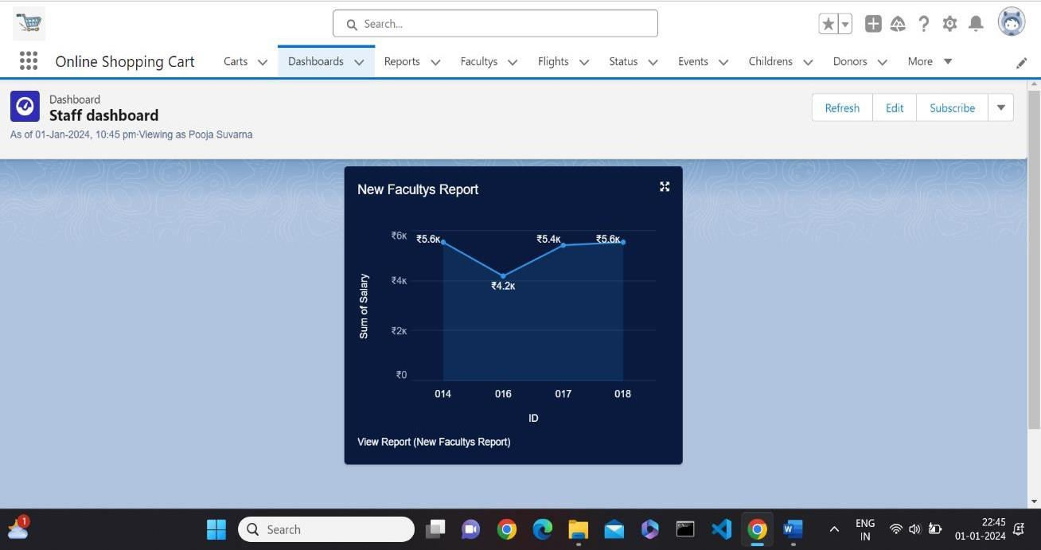

1. Create a web application to book a flight from a source to destination and store the status of flight, and departure timings on database.

**Steps:**

* 1. Launch your Salesforce Trailhead Playground by opening any module and Switch to Lightning Experience if you are currently in Salesforce Classic by clicking your picture in the right top corner and then click on “Switch to Lightning Experience”
  2. Then go to Setup gear icon and click “Setup”.
  3. Click on “Object Manager” and click “Create > Custom Object” to create new Custom Object.
  4. Name the object “Flight”.
  5. Allow Reports and Allow Search.
  6. Check the box in front of “Launch New Custom Tab Wizard after saving this custom object”.
  7. To create a Tab for the Object: Select any Tab Style for the object “Flight”. Click Next, Next, leave the defaults and save.

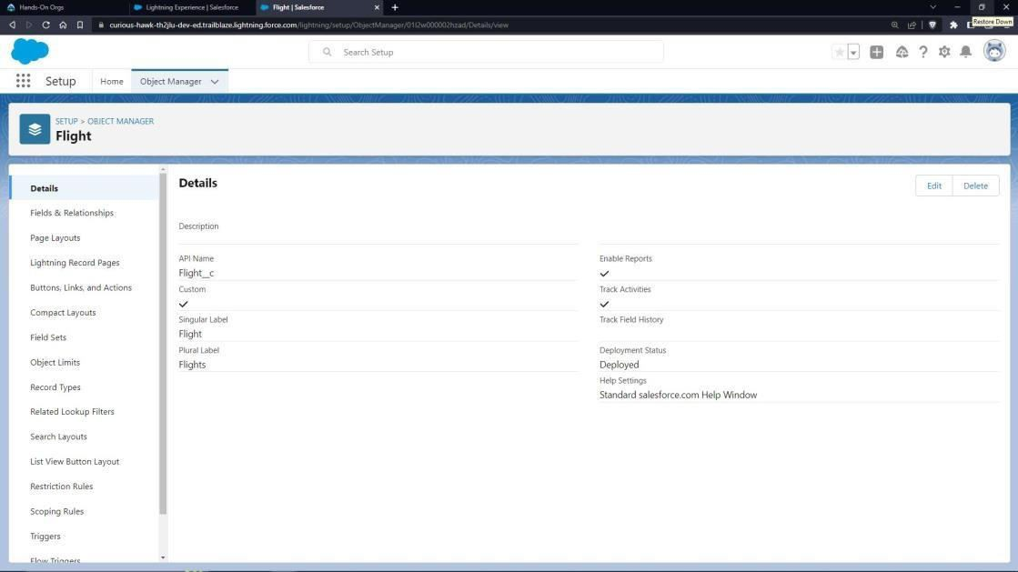

* 1. To add fields to the Object: Go to “Fields & Relationships” option of Student object and Click “New”.
  2. Add the following fields one after the other:
* Field Label: Source, Data Type: Text Area, make it as Required Field.
* Field Label: Destination, Data Type: Text Area, make it as Required Field.
* Field Label: Departure Timing, Data Type: Date/Time, make it as Required Field.

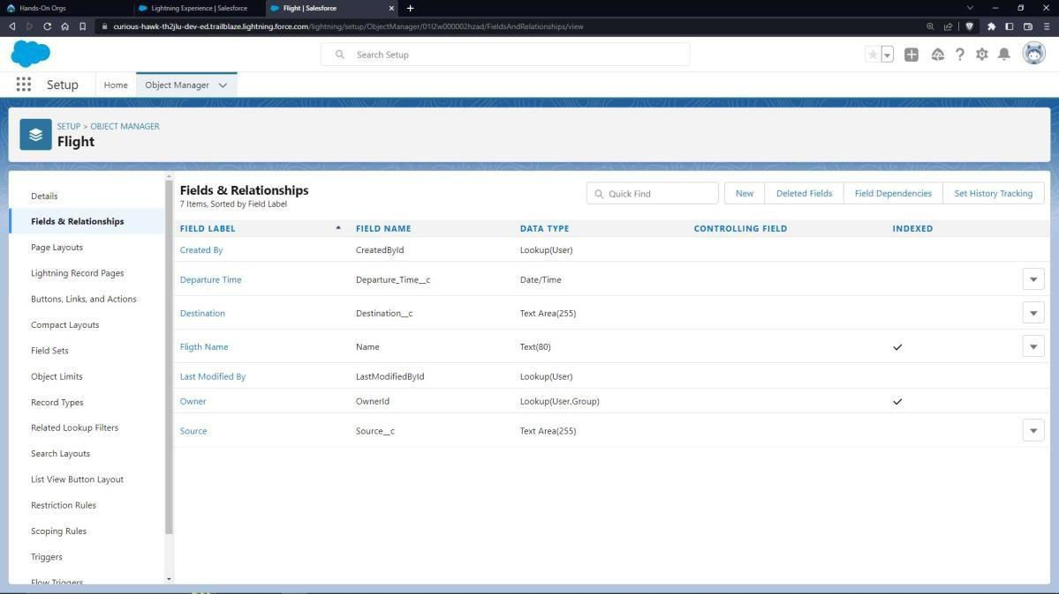

* 1. Validation rules:
     1. Date and time validation
* To add a rule to the departure timing so that it is greater than today’s date and the present time:
* Go to Validation Rule of Flight Object and click “New”
* Name it as “Date Time should be in Range”
* Error Condition Formula: Departure_Time c<NOW()
* Error Message: Departure Date/Time cannot be in past or present.
* Error Location: Field – Departure Timings.
* Click Save.

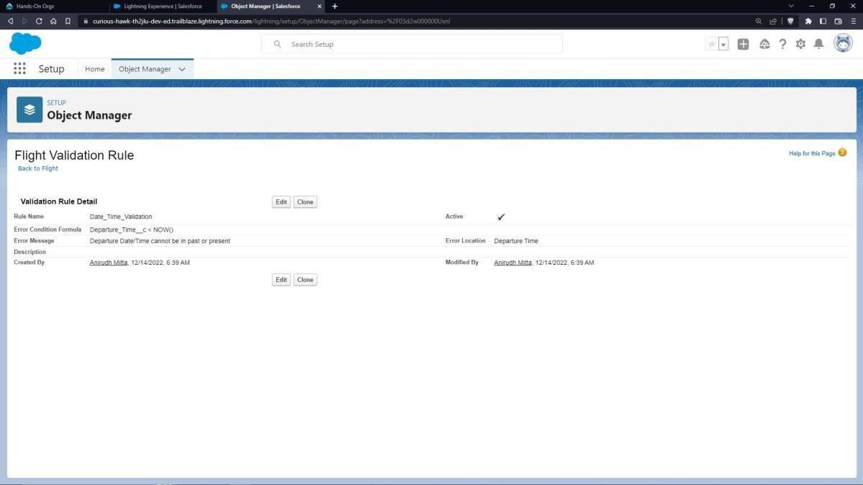

* + 1. Source and destination validation:
* To add a rule to the Source and destination so that Source and destination should not be equal:
* Go to Validation Rule of Flight Object and click “New”
* Name it as “Source and destination Checking”
* Error Condition Formula: Source c = Destination c
* Error Message: Source and destination can never be equal.
* Error Location: Top of the Page.
* Click Save

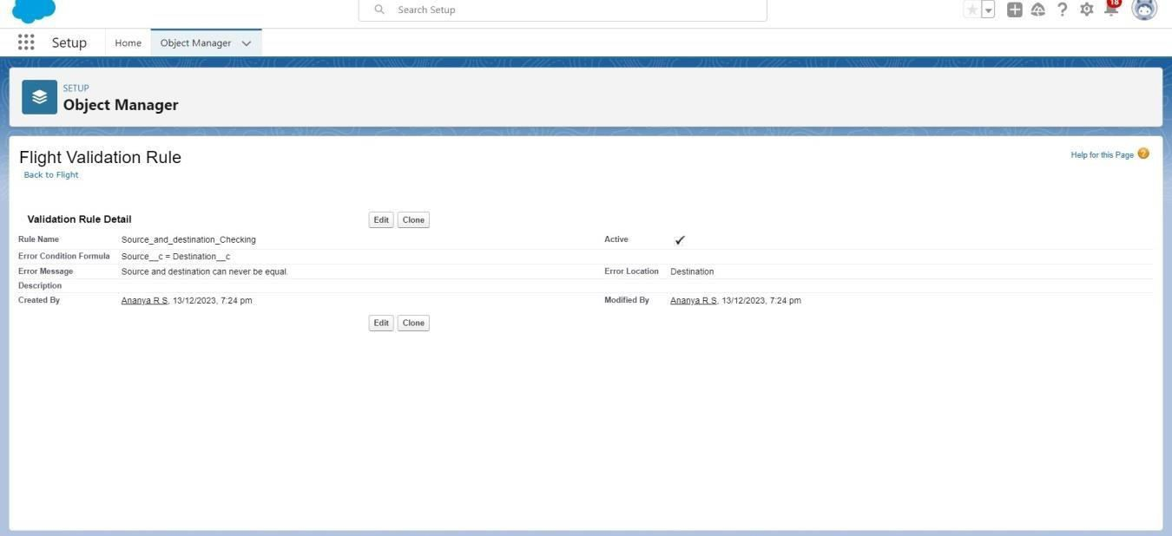

* + 1. Create one more object to provide status of the flight:
  1. Name the Object “Status”
  2. Allow Reports and Allow Search.
  3. Check the box in front of “Launch New Custom Tab Wizard after saving this custom object”
  4. Create a Tab for the Object.
  5. To add fields to the Object: Go to “Fields & Relationships” option of Student object and Click “New”.
  6. Add the following fields one after the other:
* Field Label: Flight Name, Data Type: Master-Detail Relationship, Related to: Flight.
* Sharing Setting: Read-Only. Leave the defaults and save.
* Master – Detail relationship is provided to enter status only to the existing flights.
* Field Label: Flight Status, Data Type: Picklist, click radio button in front of Enter values, with each value separated by a new line.
* Values are: Arrived, Cancelled, Delayed and Departed.
* Make it as Required Field and Restrict the values to the values in the picklist.

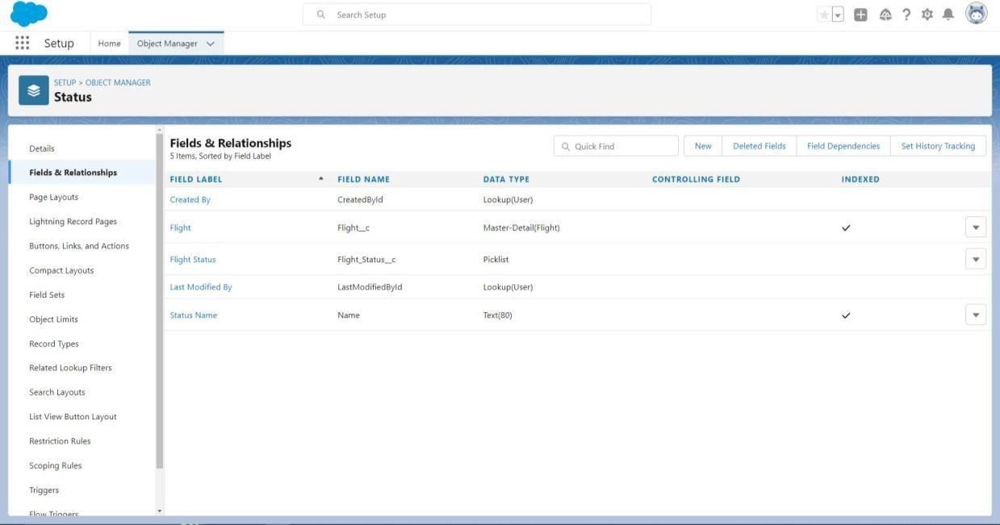

To create an application:

* 1. Go to “Setup” and type “App Manager” in Quick Find Box.
  2. Click on “New Lightning App” to create a Lightning Application.
  3. Name it as “Flight Details”, give the description for your application.
  4. Uploading Image and changing colours are optional, then click Next.
  5. Navigation Style: Standard Navigation, click Next.
  6. No need to add any Utility Bar, click Next.
  7. Add the following Items: Flights, Statuses, Reports and Dashboards, click Next.
  8. Assign it to System Administrator Profile by selecting System Administrator and pressing right arrow and then click Save & Finish.
  9. Go to App Manager, select your application and select Flights and click “New” to add some details to your application.

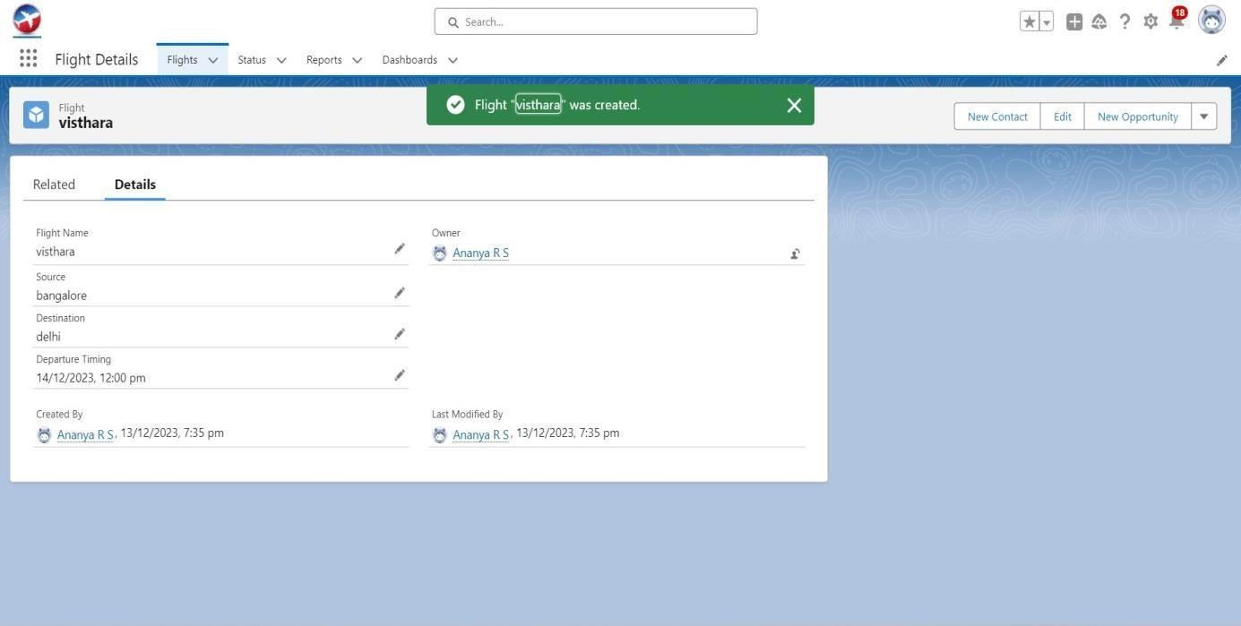

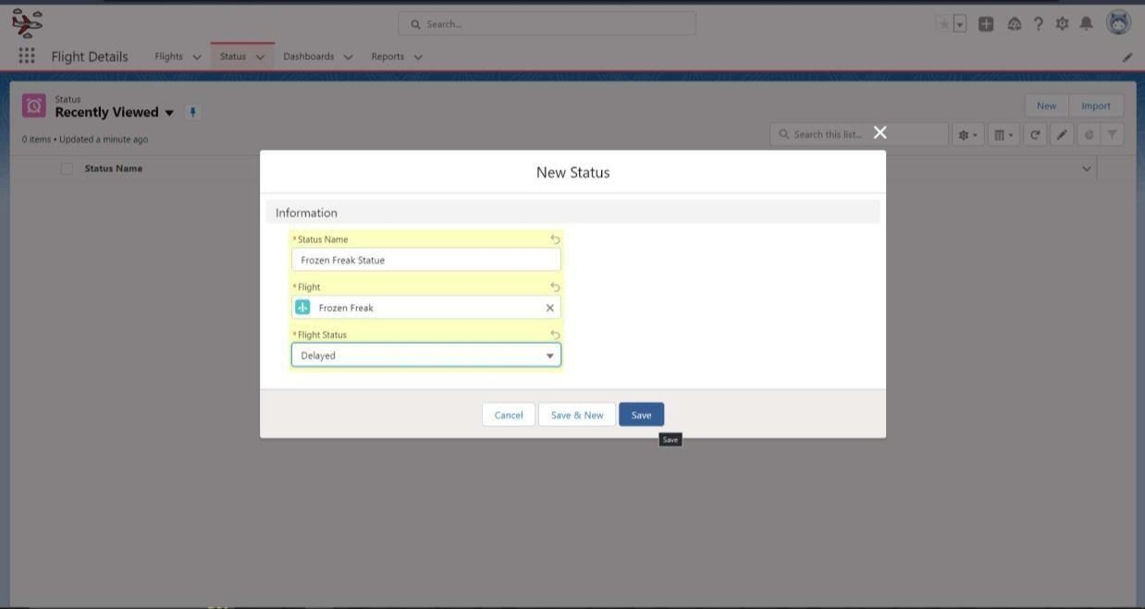

1. Make sure you will get an error message when you try to give the Departure Timing less than the current time and today’s date.
2. Create a flight report
   * Go to “Reports tab” Click on “New Folder” And give it any name and then click Save.
   * Click on “New Report” and from search bar Search for “Flights” and then select it and Click Continue.
   * Add the required Columns to get the Complete Entered data.
   * If you want the report to be grouped by any specific Fields, then Search for the field in “Add groups” otherwise it is optional.
   * Click on save and name the report as “New Flights Report” and then select the folder which you have created.
   * Click Save and then Click Run

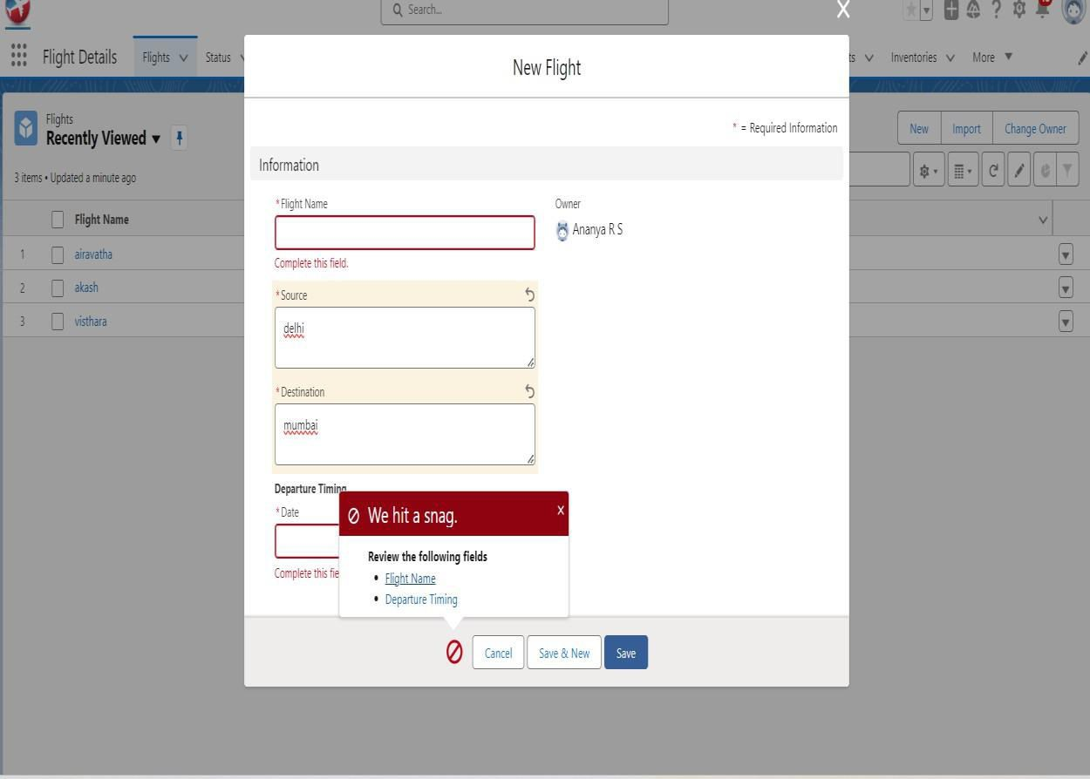

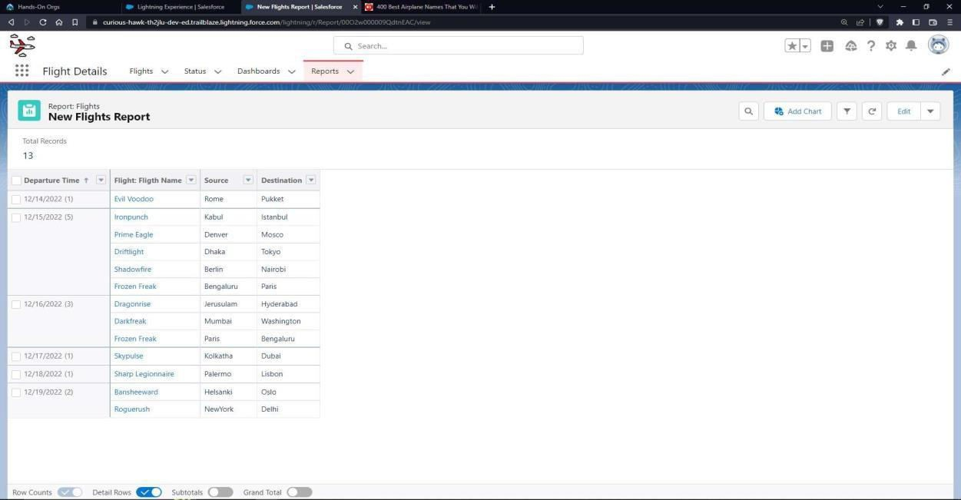

1. Create a status report
   * Go to “Reports tab” Click on “New Folder” And give it any name and then click Save.
   * Click on “New Report” and from search bar Search for “Flights with Status” and then select it and then click Continue.
   * Add the required Columns to get the Complete Entered data.
   * If you want the report to be grouped by any specific Fields, then Search for the field in “Add groups” otherwise it is optional.
   * Click on save and name the report as “New Flights with status Report” and then select the folder which you have created.
   * Click Save and then Click Run.

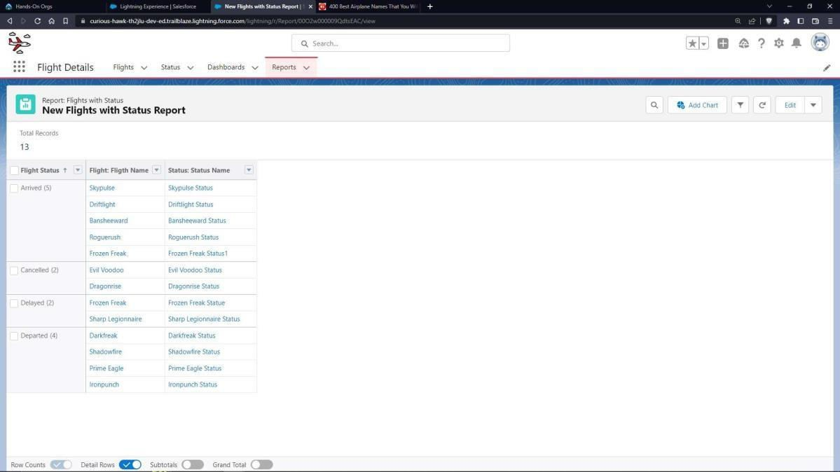

1. Create a Dashboard with both reports
   * Go to “Dashboard tab” and then click on “New Folder” and give it any Name.
   * Click on “New Dashboard” and then name it as “Flights and Status” and select folder that you have created Click on Create.
   * Click on the report that you have created and click on that and click select.
   * Select any style to represent the data in dashboard.
   * Add any filter(s), otherwise it is optional.
   * Click on Save and Click Run.

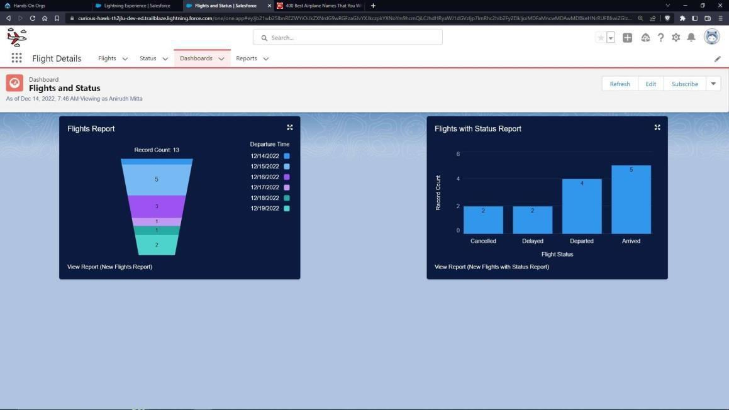

1. Create a Collaborative learning environment for a particular learning topic using Google Apps. Google Drive, Google Docs and Google Slides must be used for hosting e- books, important articles and presentations respectively.

**Steps:**

* 1. Open <http://drive.google.com/> and Sign In with your google account.
  2. Create a new folder named “My Learning Environment” by clicking “New” button on the top left corner.

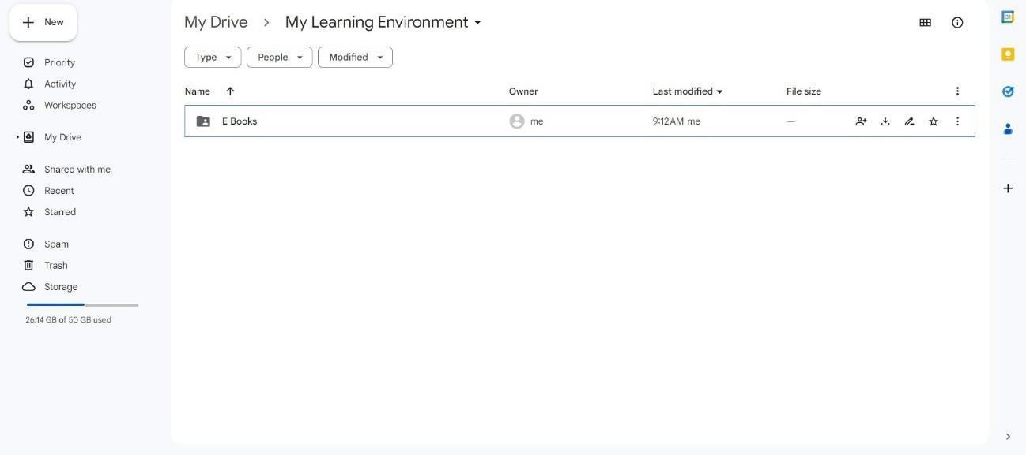

* 1. Right click on the folder created and tap “Share” then click on “Advanced”.
  2. Under the “Who has Access” section click on “Change” of the first option.
  3. 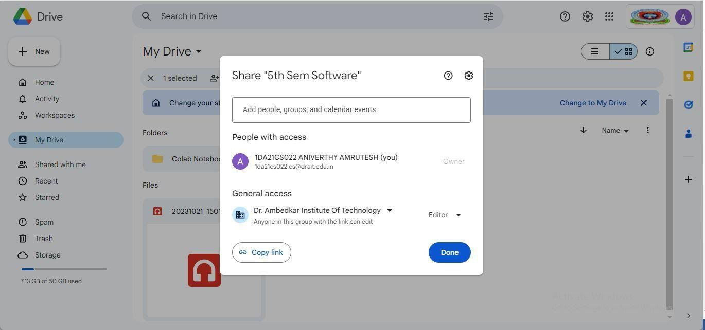Now check on the “On- Public on the web” option & set the Access to “Can View Only” and Click Save. This will make your folder to be accessible by anyone on the internet to view its contents and download them.
  4. Double click on the folder you just created and click “New” button again.
  5. Add these items:
     1. Folder: Named “E-Books” where you will open the folder and click “New”

and “Upload a file” like a Book from your hard drive.

* + 1. Google Docs: Named “Important Quotes” where you will add some important links to the doc file. The file will keep saving hence you need to press save. click “Share” if you wish to share it.

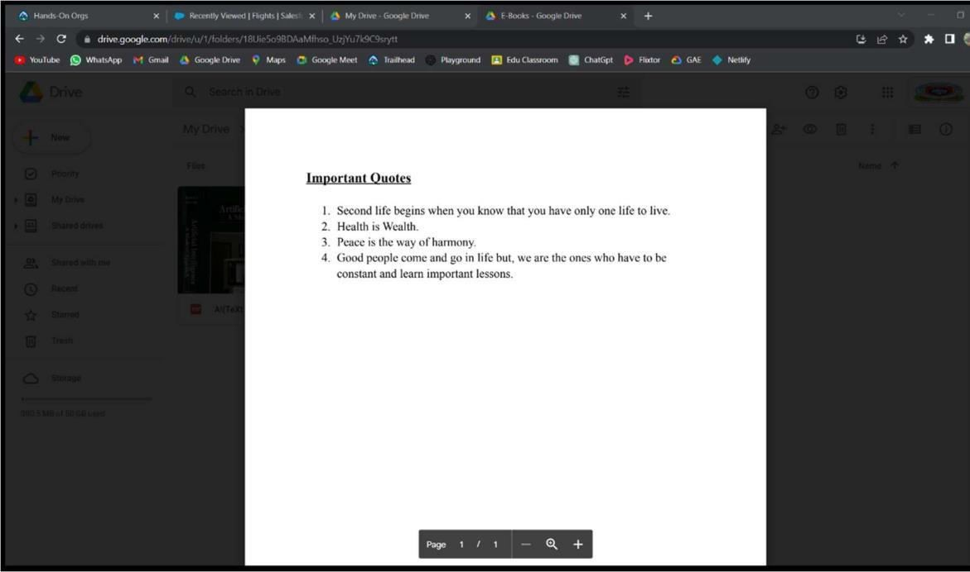

* + 1. Google Slide: Named “Welcome Folks” make a few changes and add your content and choose your theme.

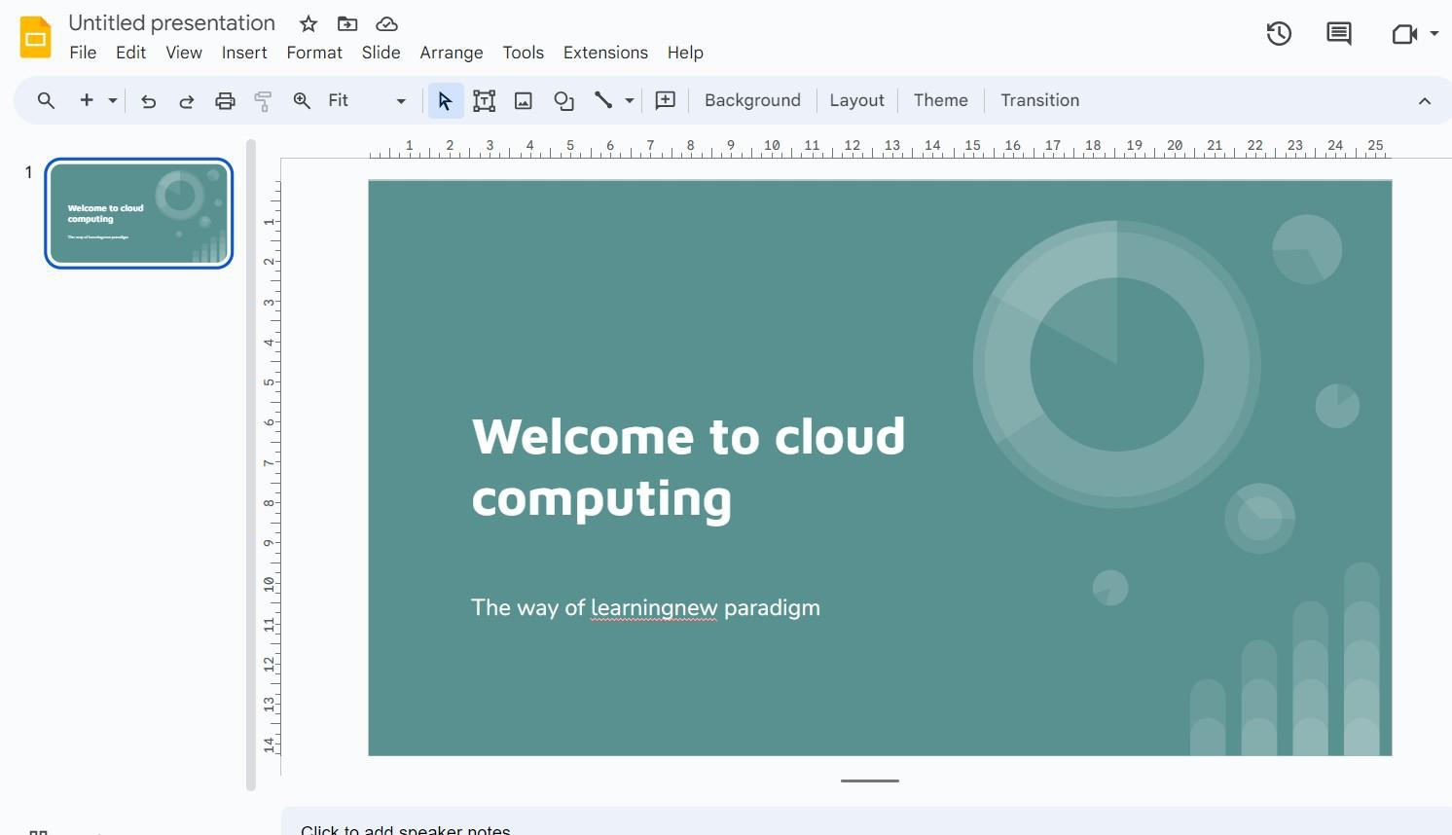

* + 1. You may also add many other items as necessary.
       - At any point in future if you wish to share this environment right click on the folder and click share. Copy the link and share.

<https://drive.google.com/drive/folders/1Fw3m9PKVk82BtbglowQLRvITYLCJ7S6U?usp=sharing>

1. Develop Department events' registration app with an object containing event name, date/time, venue as parent relationship, another object containing student name, branch, event name , date/time , venue as child relationship.

**Steps:**

* 1. Launch your Salesforce Trailhead Playground by opening any module and Switch to Lightning Experience if you are currently in Salesforce Classic by clicking your picture in the right top corner and then click on “Switch to Lightning Experience”.
  2. Then go to Setup gear icon and click “Setup”.
  3. Click on “Object Manager” and click “Create > Custom Object” to create new Custom Object.
  4. Name the object “Event”.
  5. Allow Reports and Allow Search.
  6. Check the box in front of “Launch New Custom Tab Wizard after saving this custom object”.
  7. To create a Tab for the Object: Select any Tab Style for the object “Event”. Click Next, Next, leave the defaults and save.
  8. To add fields to the Object:

- Go to “Fields & Relationships” option of Student object and Click “New”.

* 1. Add the following fields one after the other:
* Field Label: Event Time, Data Type: Date/Time, make it as Required Field.
* Field Label: Event Venue, Data Type: Text Area, make it as Required Field.

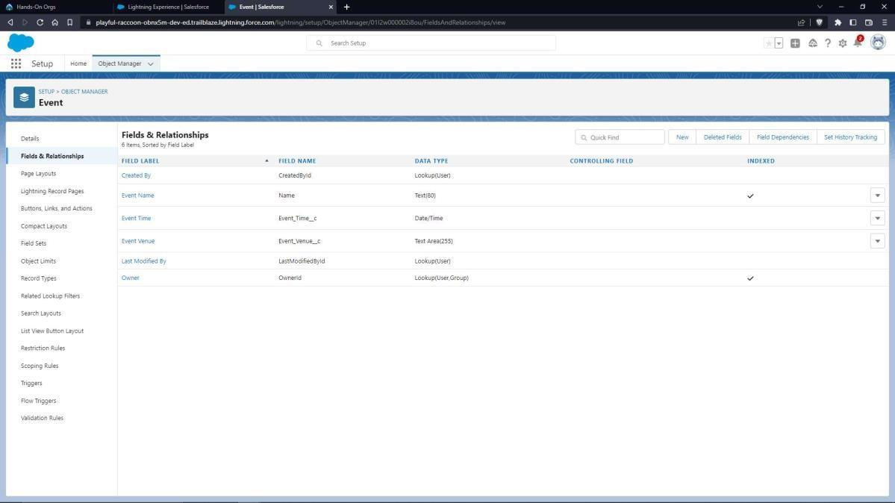

* 1. To add a rule to the Event Date/Time so that it is greater than today’s date and the present time:
* Go to Validation Rule of Event Object and click “New”.
* Name it as “Date and Time in Range”.
* Error Condition Formula: Event_Time c<NOW ()
* Error Message: Date or time less than the current one.
* Error Location: Field – Event Time.
* Click Save.

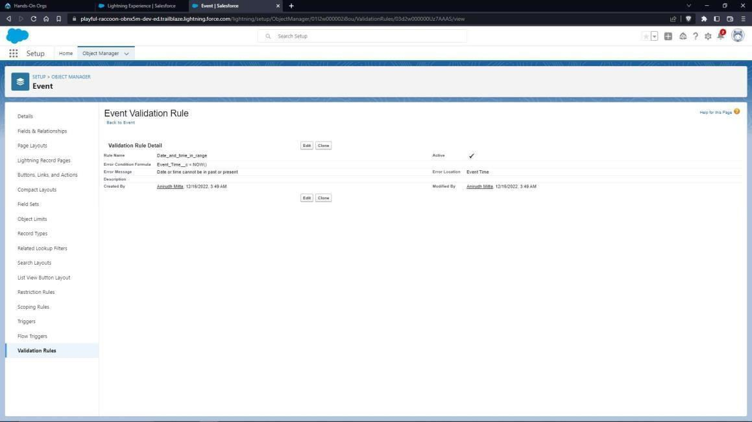

Create one more object to store student details:

* 1. Name the Object “Student”.
  2. Allow Reports and Allow Search.
  3. Check the box in front of “Launch New Custom Tab Wizard after saving this custom object”.
  4. Create a Tab for the Object.
  5. To add fields to the Object:

- Go to “Fields & Relationships” option of Student object and Click “New”.

* 1. Add the following fields one after the other:
* Field Label: Event Name, Data Type: Text.
* Field Label: Event Time, Data Type: Master-Detail Relationship, Related to: Event. Sharing Setting: Read-Only. Leave the defaults and save.
* Field Label: Event Venue, Data Type: Look up Relationship, Related to: Event.
* Field Label: Branch, Data Type: Text, Make it as a Required Field.

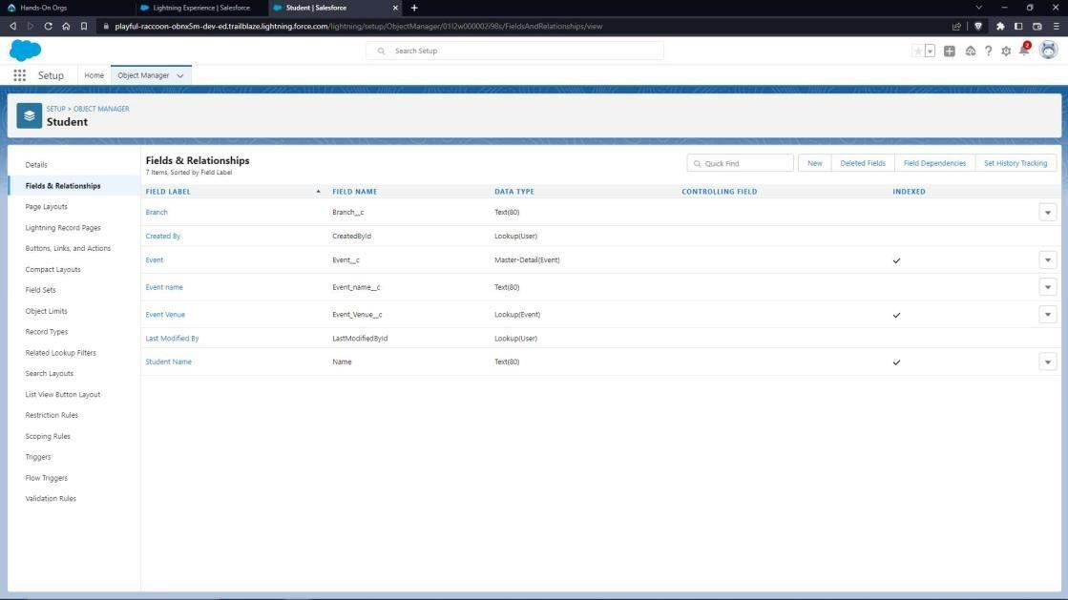

* 1. To create an application:
  2. Go to “Setup” and type “App Manager” in Quick Find Box.
  3. Click on “New Lightning App” to create a Lightning Application.
  4. Name it as “Events’ Registrations”, give the description for your application.
  5. Uploading Image and changing colours are optional, then click Next.
  6. Navigation Style: Standard Navigation, click Next.
  7. No need to add any Utility Bar, click Next.
  8. Add the following Items: Events, Students, Reports and Dashboards, click Next.
  9. 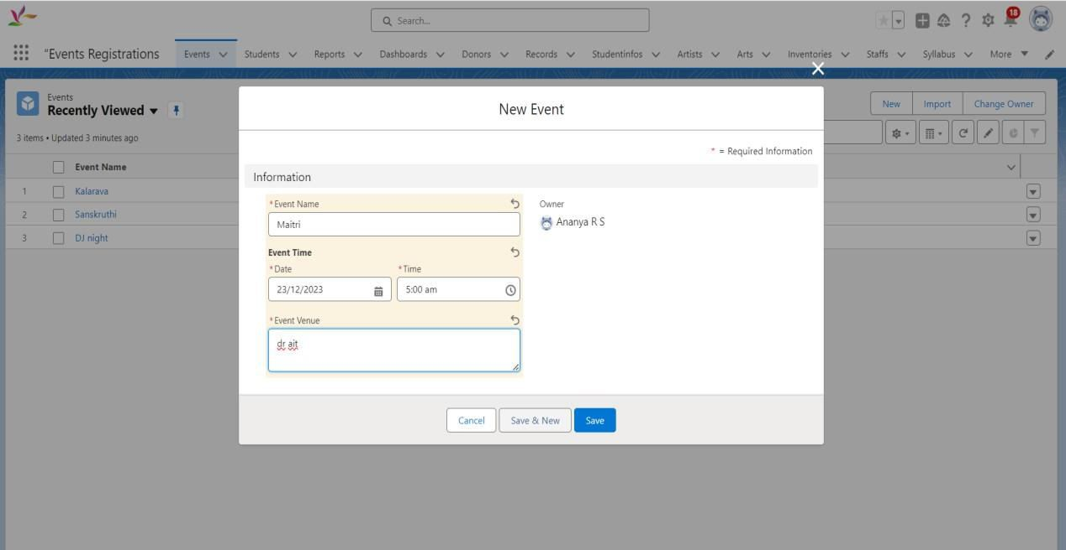Assign it to System Administrator Profile by selecting System Administrator and pressing right arrow and then click Save & Finish.
  10. Go to App Manager, select your application and select Events and click “New” to add some details to your application.
  11. Make sure you will get an error message when you try to give the Event Time less than the current time and today’s date and also you can’t select events which are not there in the list.

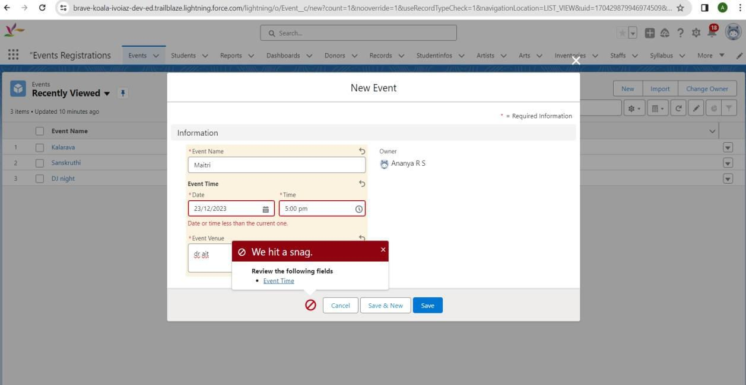

* 1. To Create an Event Report:
* Go to “Reports tab” Click on “New Folder” And give it any name and Click Save.
* Click on “New Report” and from search bar Search for “Events” and then select it then Click Continue.
* Add the required Columns to get the Complete Entered data.
* If you want the report to be grouped by any specific Fields, then Search for the field in “Add groups” otherwise it is optional.
* Click on save and name the report as “New Events Report” and then select the folder which you have created.
* Click Save and then Click Run.

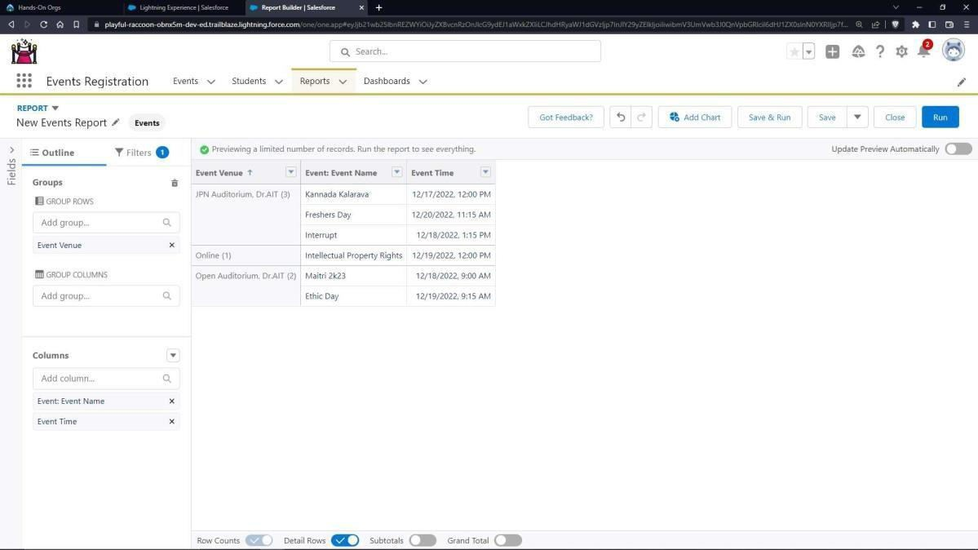

* 1. To Create a Students Report:
* Go to “Reports tab” Click on “New Folder” And give it any name and Click Save.
* Click on “New Report” and from search bar Search for “Students with Events” and then select it then Click Continue.
* Add the required Columns to get the Complete Entered data.
* If you want the report to be grouped by any specific Fields, then Search for the field in “Add groups” otherwise it is optional.
* Click on save and name the report as “New Events with Students Report” and then select the folder which you have created.

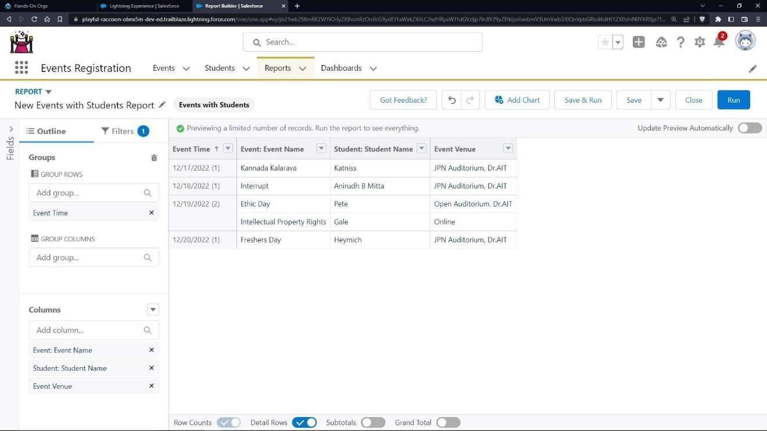

* 1. To Create a Dashboard:
* Go to “Dashboard tab” and then click on “New Folder” and give it any Name.
* Click on “New Dashboard” and then name it as “Event Dashboard” and select folder that you have created, Click on Create.
* Click on the report that you have created and click on that and click select.
* Select any style to represent the data in dashboard.
* Add any filter(s), otherwise it is optional.
* Click on components
* Click another report you created and select a style to represent.
* Click on Save and Click Run.

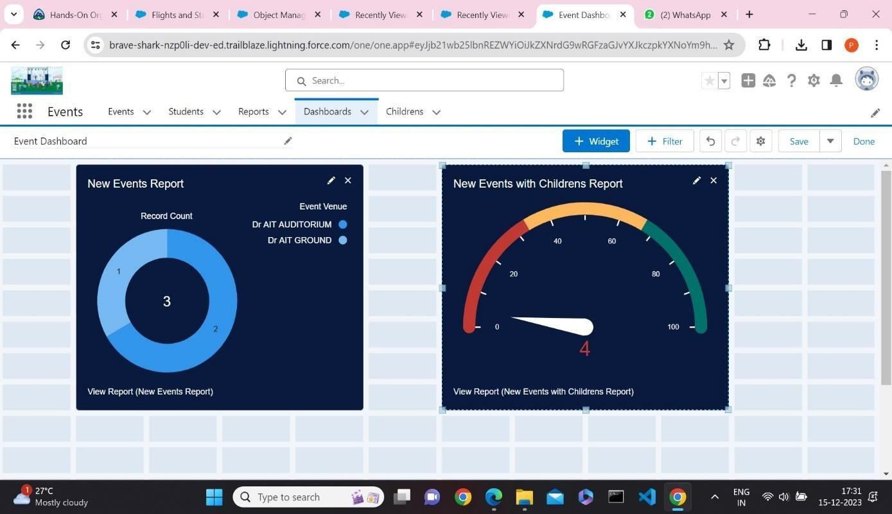

1. Develop Blood donation registration app with an object which records donors' name, age and blood group as parent relationship and another object containing haemoglobin level, donated or not details (if age>18) child relationship.

**Steps:**

* 1. Launch your Salesforce Trailhead Playground by opening any module and Switch to Lightning Experience if you are currently in Salesforce Classic by clicking your picture in the right top corner and then click on “Switch to Lightning Experience”
  2. Then go to Setup gear icon and click “Setup”.
  3. Click on “Object Manager” and click “Create > Custom Object” to create new Custom Object.
  4. Name the object “Donor”
  5. Allow Reports and Allow Search.
  6. Check the box in front of “Launch New Custom Tab Wizard after saving this custom object”.
  7. To create a Tab for the Object: Select any Tab Style for the object “Donor”. Click Next, Next, leave the defaults and save.
  8. To add fields to the Object: Go to “Fields & Relationships” option of Student object and Click “New”.
  9. Add the following fields one after the other:
* Field Label: Age, Data Type: Number (3,0).
* Field Label: Blood Group, Data Type: Picklist, click radio button in front of Enter values, with each value separated by a new line.
* Values are A+ve, B+ve, A-ve, B-ve, O+ve, O-ve, AB+ve, AB-ve.
* Make it as Required Field and Restrict the values to the values in the Picklist.
* Field Label: Gender, Data Type: Picklist, click radio button in front of Enter values, with each value separated by a new line.
* Values are Male, Female, Others.
* Field Label: Weight, Data Type: Number (3,2).

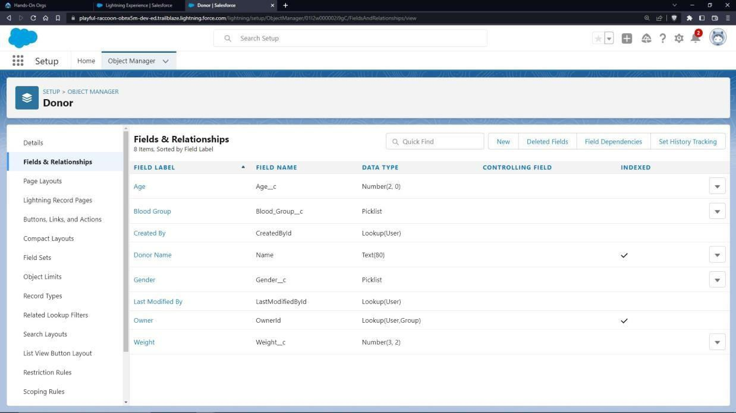

Create one more object to store Collection details:

* 1. Name the Object “Record”.
  2. Allow Reports and Allow Search.
  3. Check the box in front of “Launch New Custom Tab Wizard after saving this custom object”
  4. Create a Tab for the Object.
  5. To add fields to the Object:

- Go to “Fields & Relationships” option of Student object and Click “New”.

* 1. Add the following fields one after the other:
* Field Label: Haemoglobin level, Data Type: Number (2,2).
* Field Label: Donor Name, Data Type: Look up Relationship, Related to: Donor.
* Field Label: Blood Group, Data Type: Look up Relationship, Related to: Donor.
* Field Label: Age, Data Type: Master-Detail Relationship, Related to: Donor. Sharing Setting: Read-Only. Leave the defaults and save.
* Field Label: Status, Data Type: Picklist, Values: Donated, Not Donated, Make it as a Required Field.

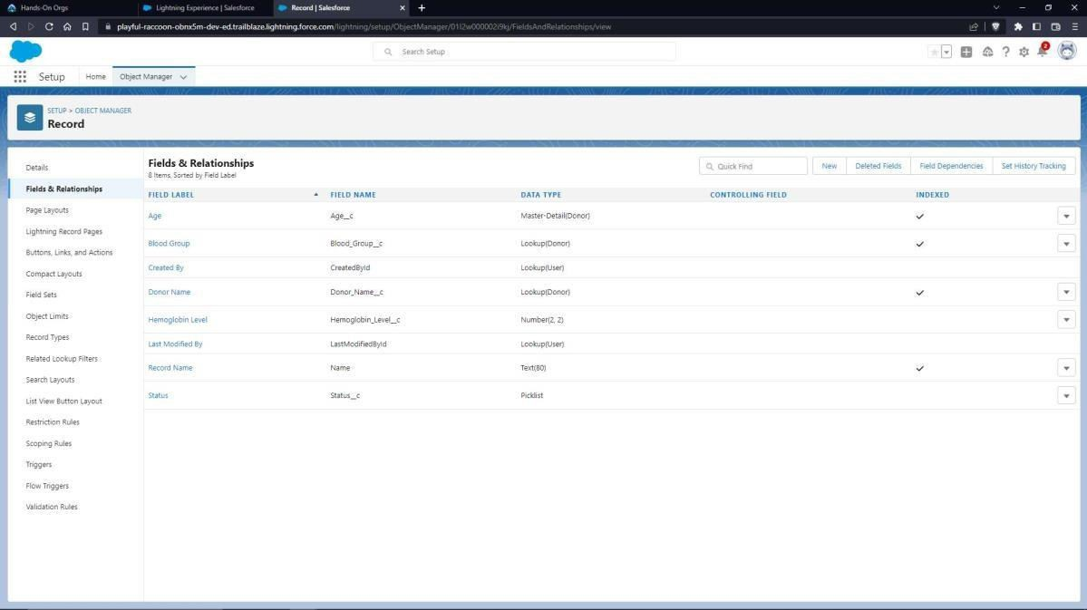

* 1. Validation rules
     1. Age Validation:
        + To add a rule to the Donor age so that it is greater than 18 years:
        + Go to Validation Rule of Donor Object and click “New”
        + Name it as “Age Validation”.
        + Error Condition Formula: AND (Age c < 18,Age c>75).
        + Error Message: Age must be greater than 18.
        + Error Location: Field – Age.
        + Click Save.

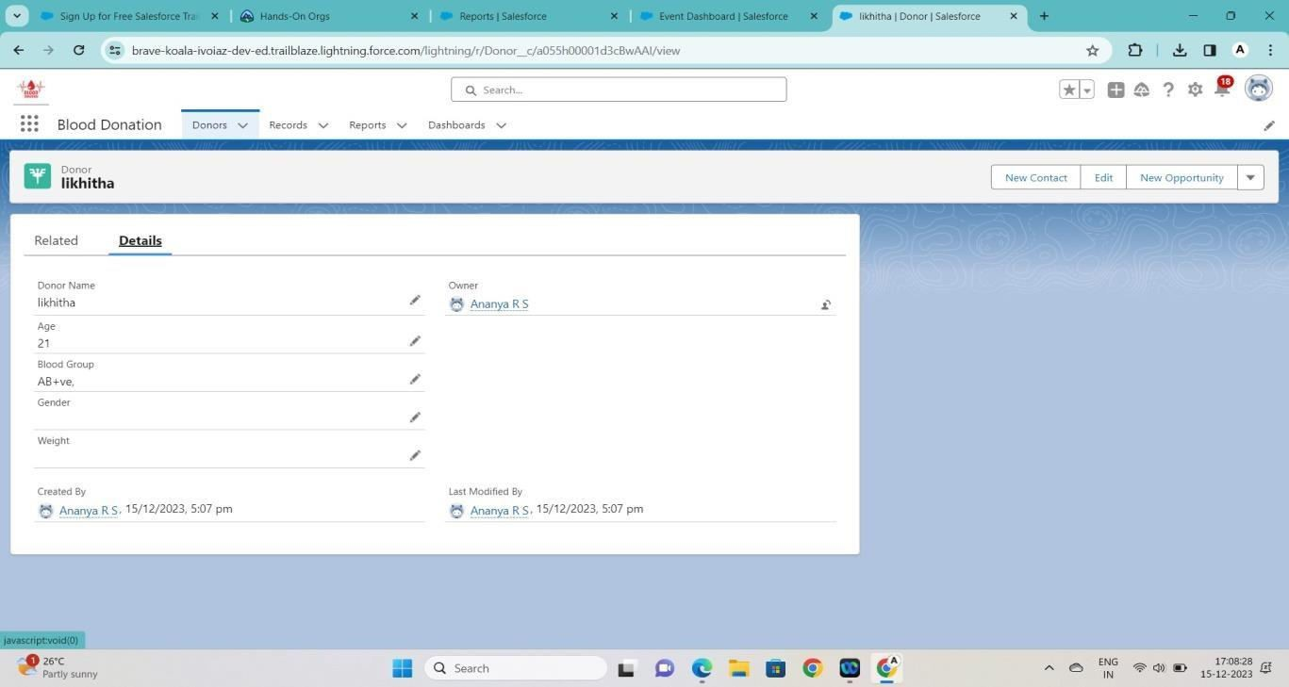

* + 1. Weight validation
       - To add a rule to the Donor Weight so that it Should be greater than 50:
       - Go to Validation Rule of Donor Object and click “New”
       - Name it as “Weight Validation”.
       - Error Condition Formula: weight c < 50.
       - Error Message: Eat more and gain your weight to 50 kgs.
       - Error Location: Field –weight.
       - Click Save.

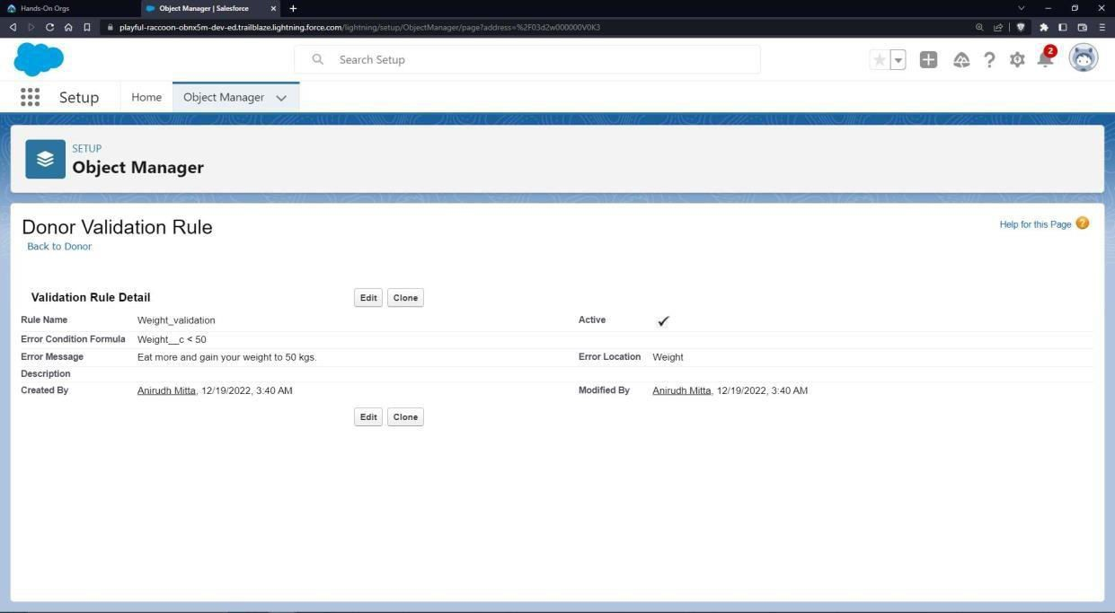

To create an application:

* 1. Go to “Setup” and type “App Manager” in Quick Find Box.
  2. Click on “New Lightning App” to create a Lightning Application.
  3. Name it as “Blood Donation”, give the description for your application.
  4. Uploading Image and changing colours are optional, then click Next.
  5. Navigation Style: Standard Navigation, click Next.
  6. Add the following Items: Donors, Records, Reports and Dashboards, click Next.
  7. Assign it to System Administrator Profile by selecting System Administrator and pressing right arrow and then click Save & Finish.
  8. Go to App Manager, select your application and select Donors and click “New” to add some details to your application.

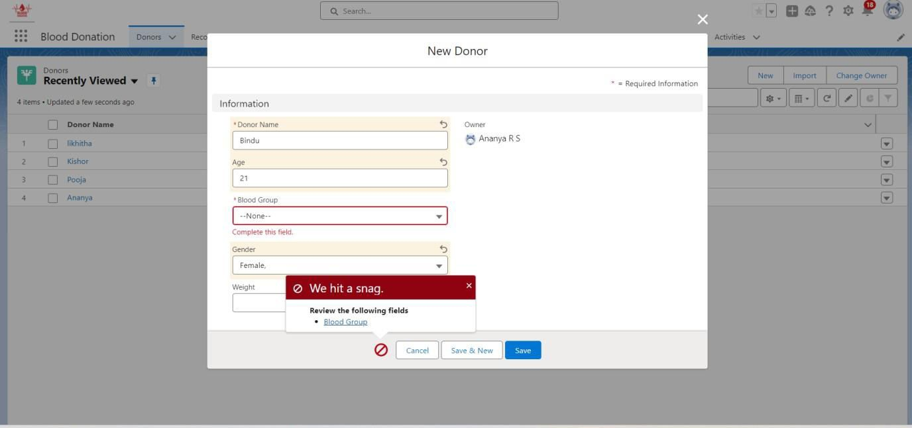

* 1. Make sure you can’t donate when your age is less than 18 years and when your weight is not 50 kgs.
  2. Create a Donor Report:
* Go to “Reports tab” Click on “New Folder” And give it any name then click on Save.
* Click on “New Report” and from search bar Search for “Donors” and then select it and then click on Continue.
* Add the required Columns to get the Complete Entered data.
* If you want the report to be grouped by any specific Fields, then Search for the field in “Add groups” otherwise it is optional.
* Click on save and name the report as “New Donor Report” and then select the folder which you have created.
* Click Save and then Click Run.

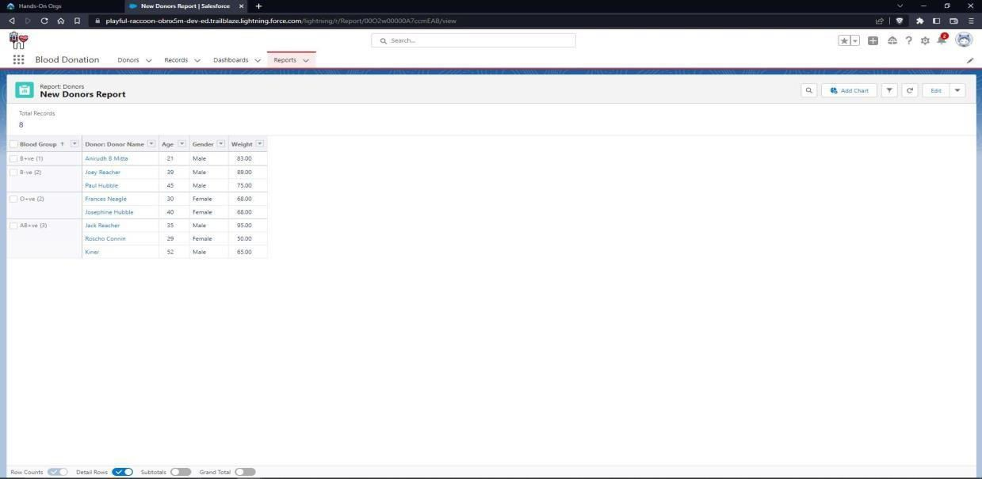

* 1. Create a records report:
* Go to “Reports tab” Click on “New Folder” And give it any name then click on Save.
* Click on “New Report” and from search bar Search for “Donors with records” and then select it and then click on Continue.
* Add the required Columns to get the Complete Entered data.
  + If you want the report to be grouped by any specific Fields, then Search for the field in “Add groups” otherwise it is optional.
  + Click on save and name the report as “New Donors with record Report” and then select the folder which you have created.
* Click Save and then Click Run.

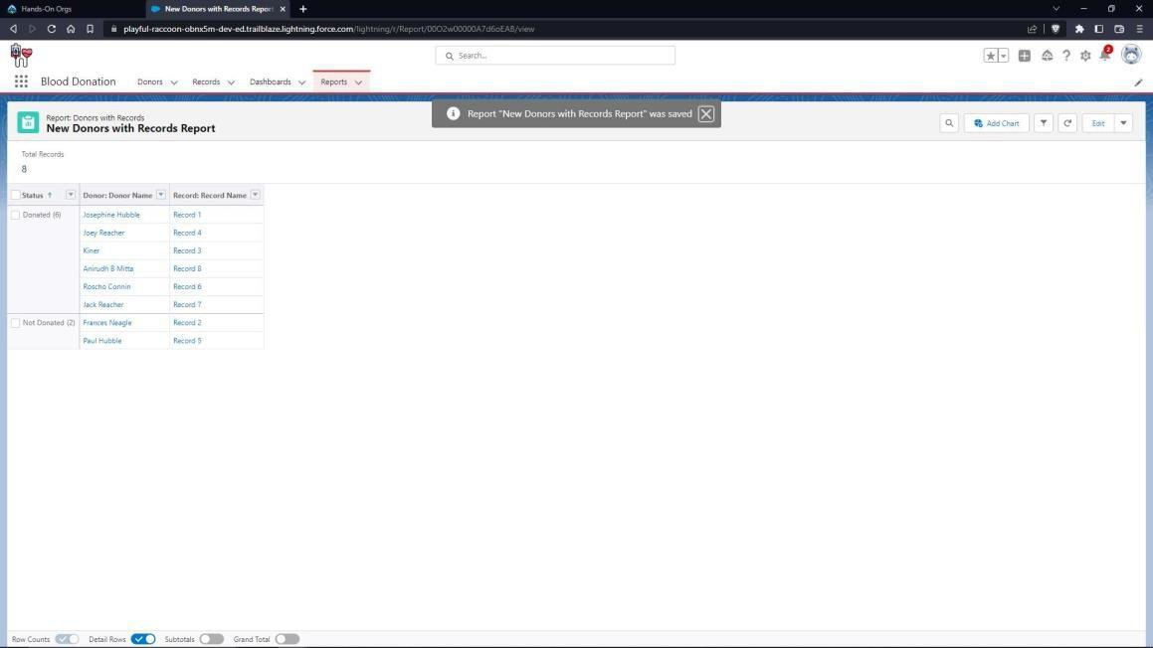

* 1. Create a dashboard
* Go to “Dashboard tab” and then click on “New Folder” and give it any Name.
* Click on “New Dashboard” and then name it as “Donors Dashboard” and select folder that you have created Click on Create.
* Click on the report that you have created of donors and click on that and click select.
* Click on the report that you have created of records and click on that and click select.
* Select any style to represent the data of donors in dashboard.
* Select any style to represent the data of records in dashboard.
* Add any filter(s), otherwise it is optional.
* Click on Save and Click Run.

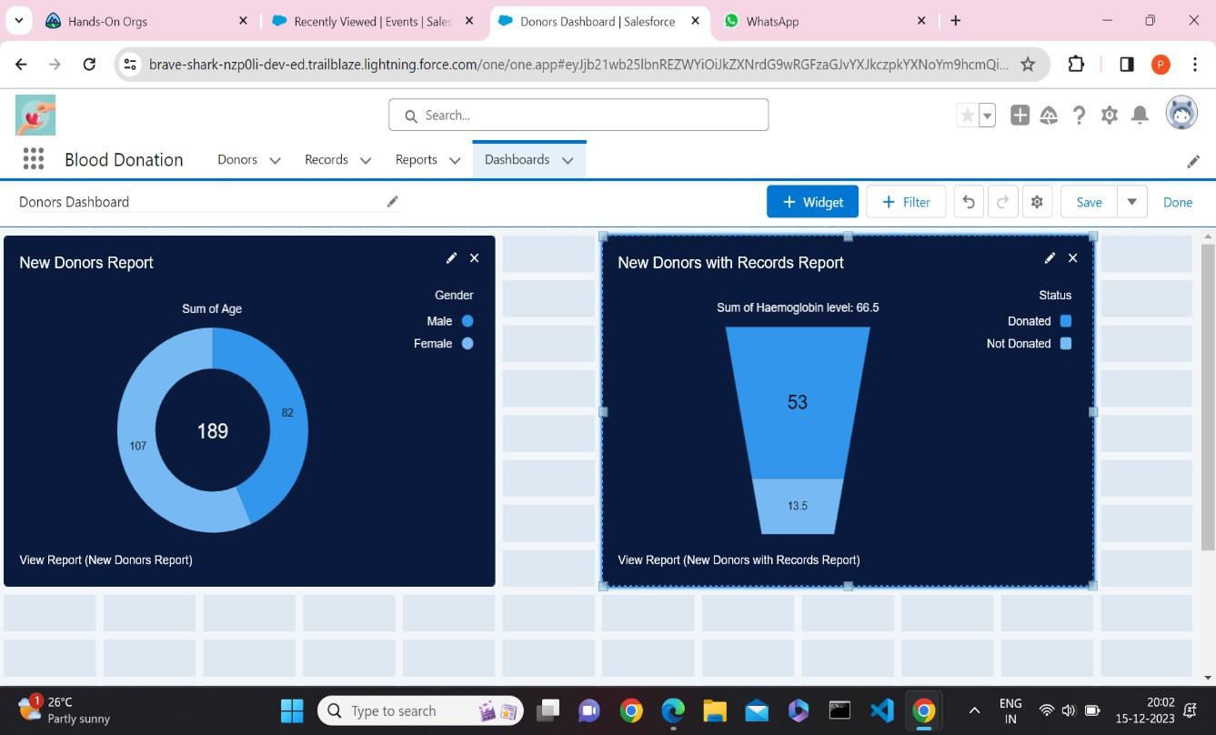

1. Develop Attendance maintenance app with an object to record student details and attendance and a provide a link to college websites' results webpage.

**Steps:**

* 1. Launch your Salesforce Trailhead Playground by opening any module and Switch to Lightning Experience if you are currently in Salesforce Classic by clicking your picture in the right top corner and then click on “Switch to Lightning Experience”
  2. Then go to Setup gear icon and click “Setup”.
  3. Click on “Object Manager” and click “Create > Custom Object” to create new Custom Object.
  4. Name the object “Student”.
  5. Allow Reports and Allow Search.
  6. Check the box in front of “Launch New Custom Tab Wizard after saving this custom object”.
  7. To create a Tab for the Object: Select any Tab Style for the object “Student”. Click Next, Next, leave the defaults and save.
  8. To add fields to the Object: Go to “Fields & Relationships” option of Student object and Click “New”.
  9. Add the following fields one after the other:
* Field Label: USN (Length 10), Data Type: Text, provide an example USN as Help Text, make it as Required Field and Don’t allow Duplicate Values and make it as Case Insensitive.
* Field Label: Technical Branches, Data Type: Picklist, click radio button in front of Enter values, with each value separated by a new line.
* Values are: CSE, ISE, TCE, EEE, EC etc.
* Make it as Required Field and Restrict the values to the values in the picklist.
* Field Label: Total Attendance %, Data Type: Percent (3,2).
* Field Label: Semester, Data Type: Picklist.

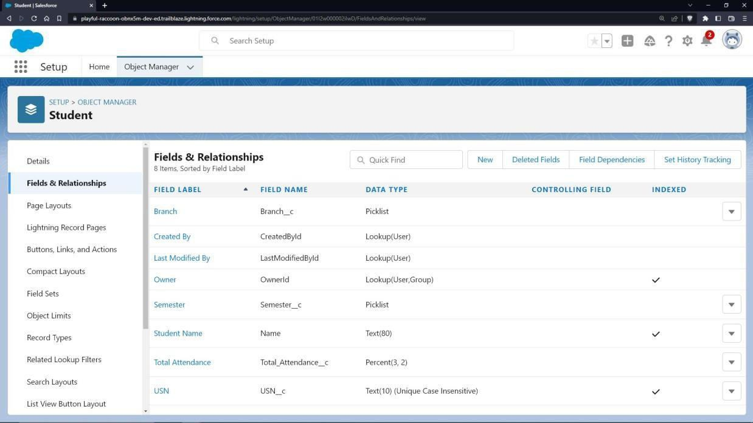

To include Custom Links:

* 1. Go to “Buttons, Links and Actions” of “Student” Object and click “New Button or Link”.
  2. Name it as “Check Details”.
  3. Select the radio button “Detail Page Link” as it is a website link.
  4. Behaviour: Display in new window.
  5. Content Source: URL.
  6. Field Type: Student.
  7. In the empty space provided, type <http://www.drait.edu.in/>

It is a link which redirects to the income tax calculation website.

* 1. Link Encoding: Unicode (UTF-8)
  2. Click Save.

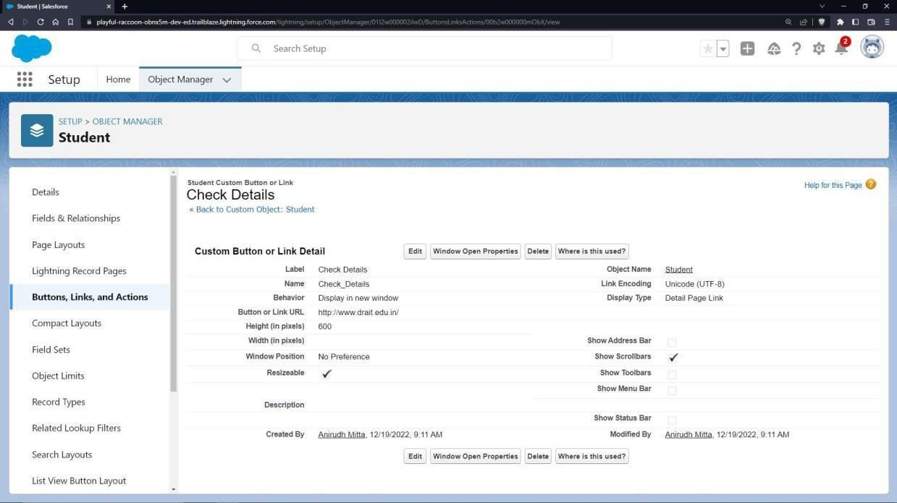

* 1. Go to Page Layout, Click Student Layout.
  2. Click Custom Links, Drag and drop the “Check Details” link in the Custom Link area.
  3. Click save.
  4. To create an application:
  5. Go to “Setup” and type “App Manager” in Quick Find Box.
  6. Click on “New Lightning App” to create a Lightning Application.
  7. Name it as “Attendance Management”, give the description for your application.
  8. Uploading Image and changing colours are optional, then click Next.
  9. Navigation Style: Standard Navigation, click Next.
  10. No need to add any Utility Bar, click Next.
  11. Add the following Items: Student, Records, Reports and Dashboards, click Next.
  12. Assign it to System Administrator Profile by selecting System Administrator and pressing right arrow and then click Save & Finish.
  13. Go to App Manager, select your application and select Student and click “New” to add some details to your application.

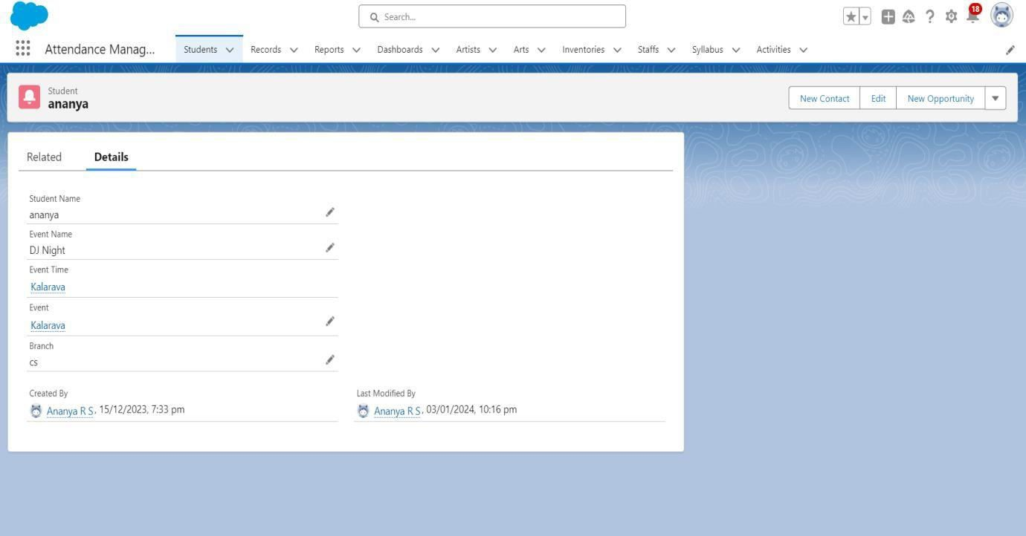

Make sure you are redirected to the college website when you click the check details link.

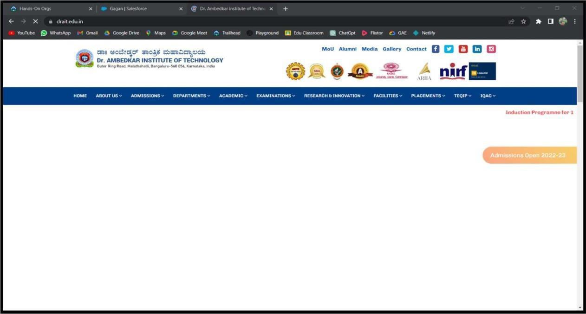

* 1. Create a student report
* Go to “Reports tab” Click on “New Folder” And give it any name then click Save.
* Click on “New Report” and from search bar Search for “Attendance Management” and then select it then click Continue.
* Add the required Columns to get the Complete Entered data.
* If you want the report to be grouped by any specific Fields, then Search for the field in “Add groups” otherwise it is optional.
* Click on save and name the report as “New Students Report” and then select the folder which you have created.
* Click Save and then Click Run.

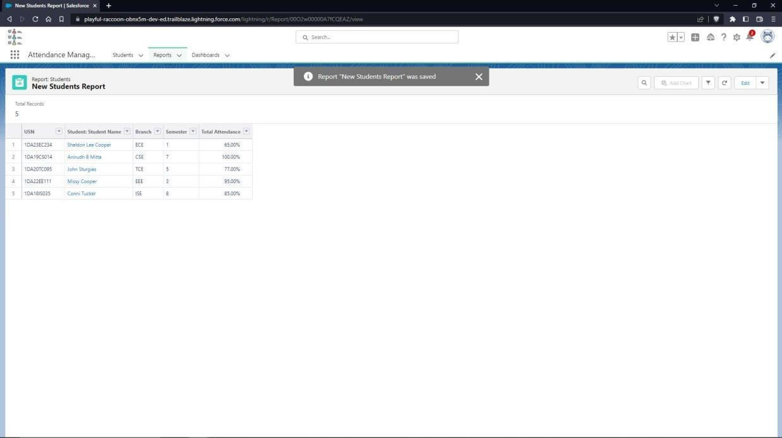

* 1. Create student dashboard
* Go to “Dashboard tab” and then click on “New Folder” and give it any Name.
* Click on “New Dashboard” and then name it as “Attendance Management” and select folder that you have created Click on Create.
* Click on the report that you have created and click on that and click select.
* Select any style to represent the data in dashboard.
* Add any filter(s), otherwise it is optional.
* Click on Save and Click Run.

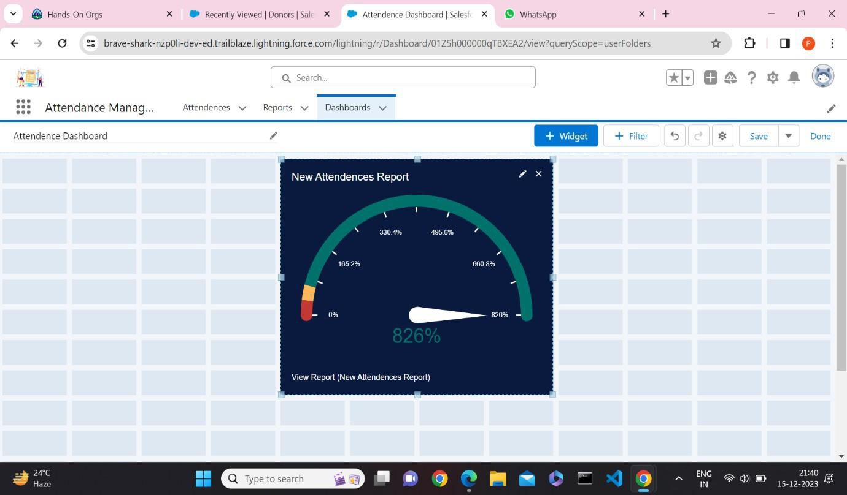

1. Create a web application with objects to maintain database of an art gallery which contains objects like artists, arts, inventory and provide a link to any of the art gallery website.

**Steps:**

* 1. Launch your Salesforce Trailhead Playground by opening any module and Switch to Lightning Experience if you are currently in Salesforce Classic by clicking your picture in the right top corner and then click on “Switch to Lightning Experience”.
  2. Then go to Setup gear icon and click “Setup”.
  3. Click on “Object Manager” and click “Create > Custom Object” to create new Custom Object.
  4. Name the object “Artist”.
  5. Allow Reports and Allow Search.
  6. Check the box in front of “Launch New Custom Tab Wizard after saving this custom object”.
  7. To create a Tab for the Object: Select any Tab Style for the object “Artist”. Click Next, Next, leave the defaults and save.
  8. To add fields to the Object: Go to “Fields & Relationships” option of Student object and Click “New”.
  9. Add the following fields one after the other:
* Field Label: ID (Length 10), Data Type: Text, provide an example ID as Help Text, make it as required Field, don’t allow Duplicate Values, make it as Case Insensitive and Set this field as the unique record identifier from an external system.
* Field Label: Art Name and Details, Data Type: Text, Make it as a required field.
* Field Label: Style, Data Type: Picklist,
* Values: Pencil Sketching, craft design, free hand, Human portrait, drawing, painting etc.
* Make it as Required Field and restrict values to the values in the picklist.

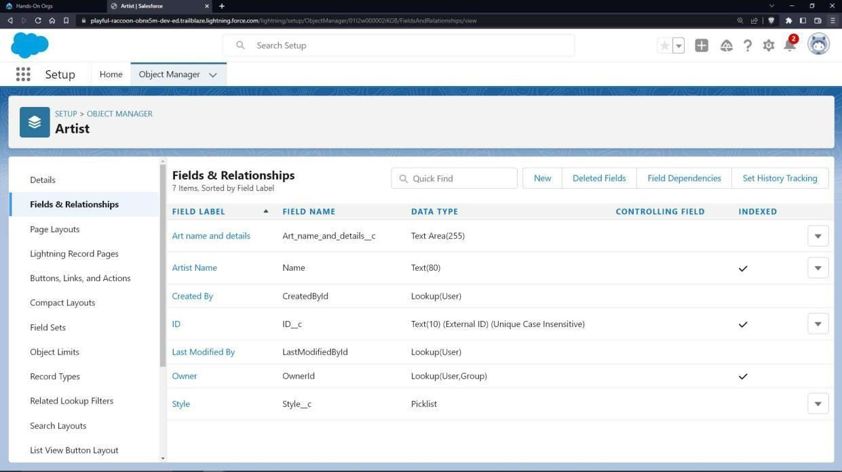

Create one more object to store Collection details:

* 1. Name the Object “Art”.
  2. Allow Reports and Allow Search
  3. Check the box in front of “Launch New Custom Tab Wizard after saving this custom object”.
  4. Create a Tab for the Object.
  5. To add fields to the Object: Go to “Fields & Relationships” option of Student object and Click “New”.
  6. Add the following fields one after the other:
* Field Label: Art Name and Details, Data Type: Master-Detail Relationship, Related to: Artist. Sharing Setting: Read-Only. Leave the defaults and save.
* Field Label: ID (Length 10), Data Type: Text, provide an example ID as Help Text, make it as required Field, don’t allow Duplicate Values, make it as Case Insensitive and Set this field as the unique record identifier from an external system.

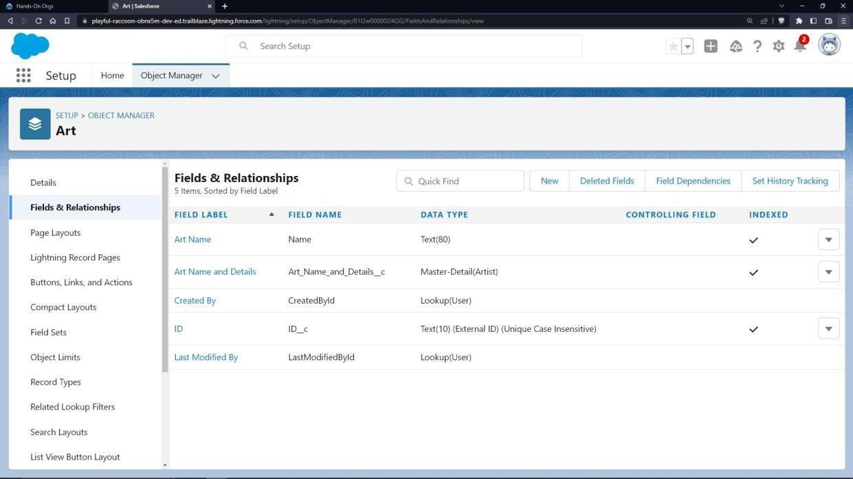

Create one more object to store inventory details:

* 1. Name the Object “Inventory”.
  2. Allow Reports and Allow Search.
  3. Check the box in front of “Launch New Custom Tab Wizard after saving this custom object”
  4. Create a Tab for the Object.
  5. To add fields to the Object: Go to “Fields & Relationships” option of Student object and Click “New”.
  6. Add the following fields one after the other:

- Field Label: Quantity, Data Type: Number. Make it as a required field.

To give a link to any art gallery website:

* 1. Go to “Buttons, Links and Actions” of Art Object and click “New Button or Link”.
  2. Name it as “Gallery”.
  3. Select the radio button “Detail Page Link” as it is a website link.
  4. Behaviour: Display in new window.
  5. Content Source: URL.
  6. Field Type: Gallery.
  7. In the empty space provided, type, https://[www.nga.gov/](http://www.nga.gov/)
  8. Link Encoding: Unicode (UTF-8).
  9. Click Save.
  10. Go to Page Layout, Click Art Layout.
  11. Click Custom Links, Drag and drop the “Gallery” link in the Custom Link area.
  12. Click save

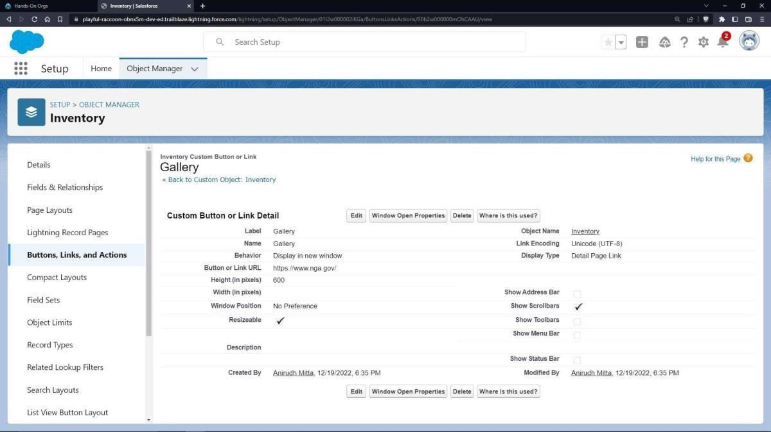

To add a rule to the Artist id so that it should take valid id:

* Go to Validation Rule of Artist Object and click “New”.
* Name it as “Artist id validation”.
* Error Condition Formula: NOT(BEGINS(ID c,’ART’)).
* Error Message: Please Enter a Valid id of an artist.
* Error Location: Field –id.
* Click Save.

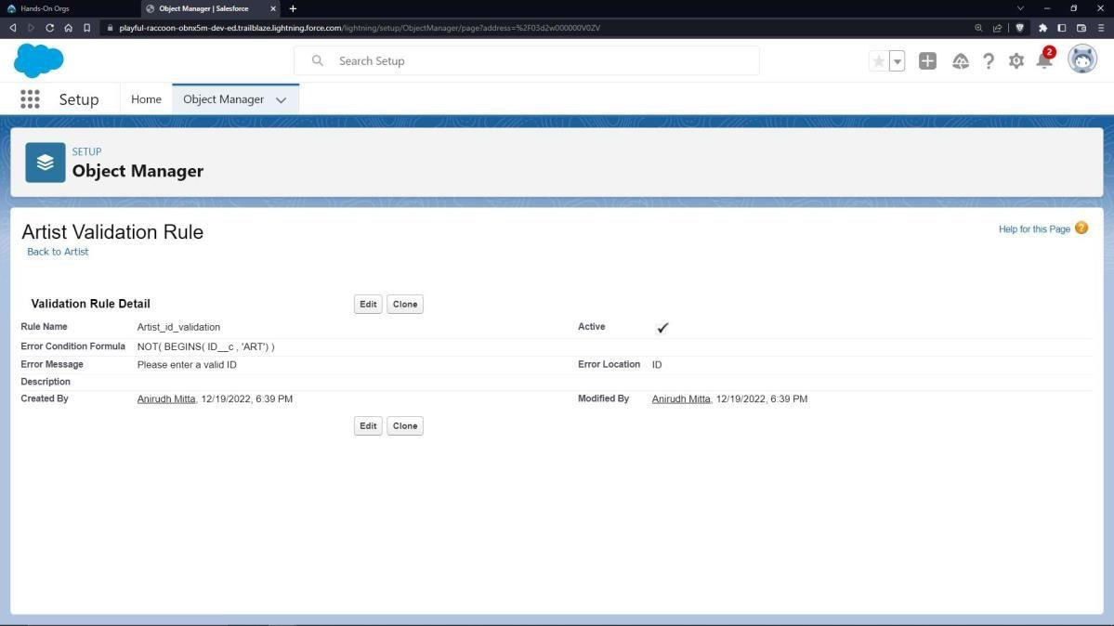

To create an application:

* 1. Go to “Setup” and type “App Manager” in Quick Find Box.
  2. Click on “New Lightning App” to create a Lightning Application.
  3. Name it as “Art Gallery Database”, give the description for your application.
  4. Uploading Image and changing colours are optional, then click Next.
  5. Navigation Style: Standard Navigation, click Next.
  6. No need to add any Utility Bar, click Next.
  7. Add the following Items: Artists, Arts, Inventories, Reports and Dashboards, click Next.
  8. Assign it to System Administrator Profile by selecting System Administrator and pressing right arrow and then click Save & Finish.

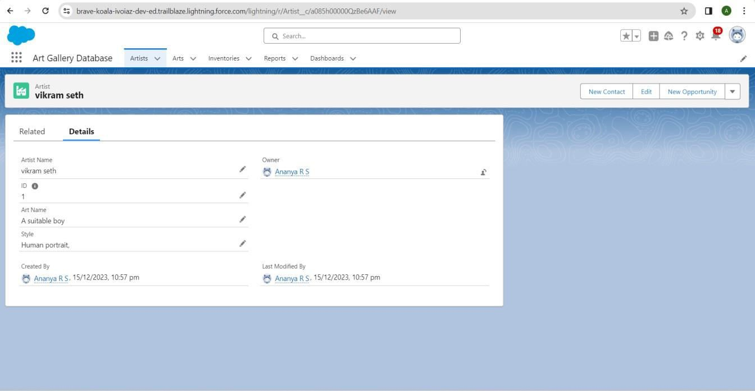

* 1. Go to App Manager, select your application and select Art gallery database and click

“New” to add some details to your application.

* 1. Click the entry you added, go to details.
  2. Press the “Gallery” link to check the details.
  3. Click OK so that it will redirect you to the website. Make sure it should an error when an invalid id is given.

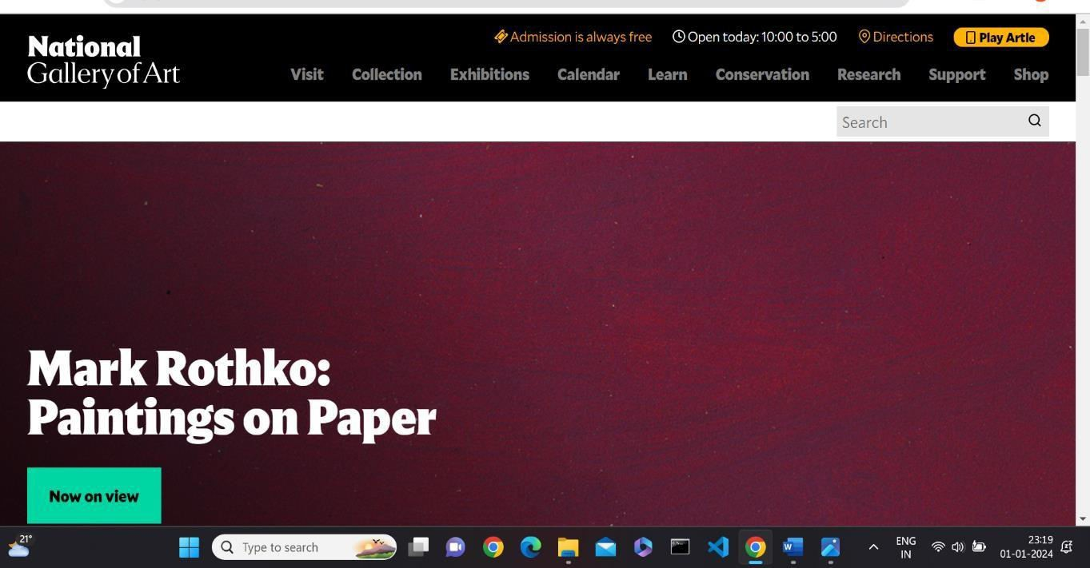

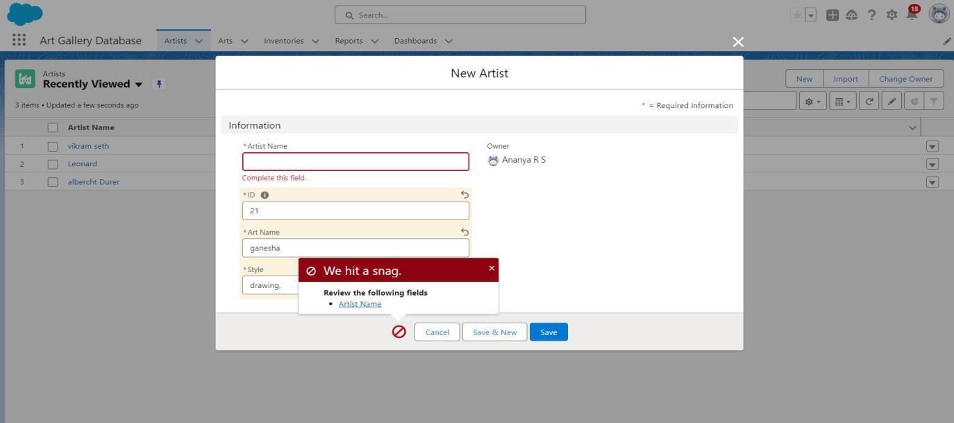

* 1. Create an Artist report
* Go to “Reports tab” Click on “New Folder” And give it any name and Click Save.
* Click on “New Report” and from search bar Search for “Artists” and then select it and then Click Continue.
* Add the required Columns to get the Complete Entered data.
* If you want the report to be grouped by any specific Fields, then Search for the field in “Add groups” otherwise it is optional.
* Click on save and name the report as “New Artists Report” and then select the folder which you have created.
* Click Save and then Click Run.

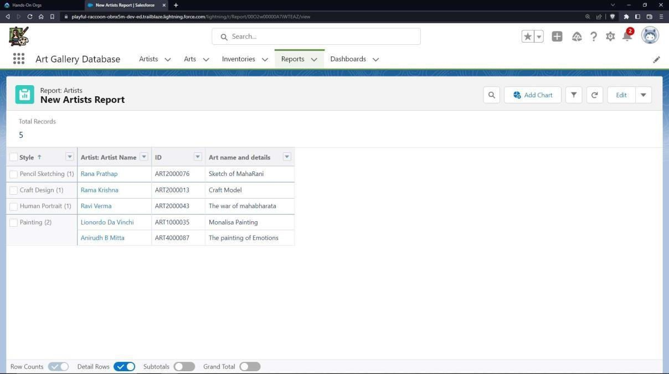

* 1. Create an Arts report
* Go to “Reports tab” Click on “New Folder” And give it any name.
* If you want the report to be grouped by any specific Fields, then Search for the field in “Add groups” otherwise it is optional.
* Click on save and name the report as “New Artists with Arts Report” and then

select the folder which you have created.

* Click Save and then Click Run.

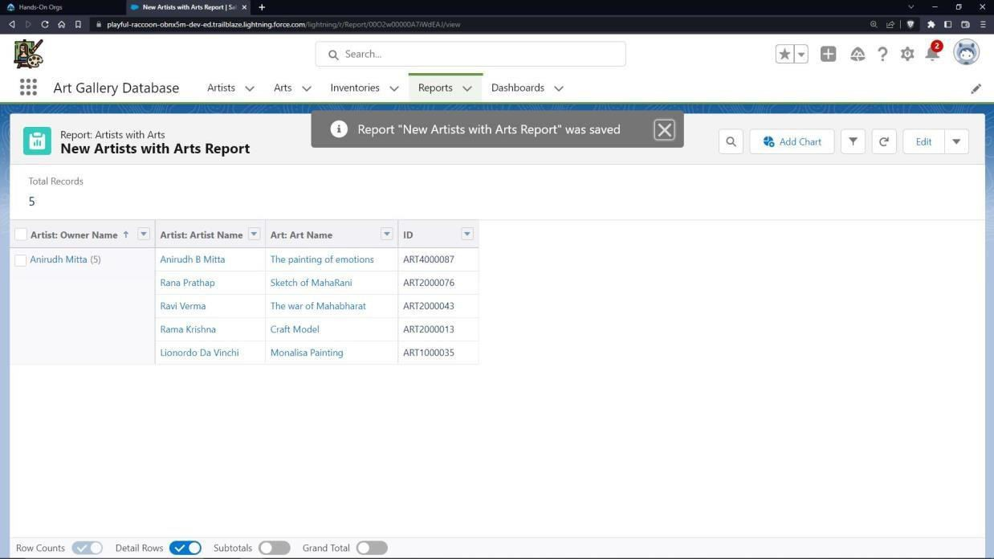

* 1. Create an Inventory report
* Go to “Reports tab” Click on “New Folder” And give it any name.
* Click on “New Report” and from search bar Search for “Inventories” and then select it.
* Add the required Columns to get the Complete Entered data.
* If you want the report to be grouped by any specific Fields, then Search for the field in “Add groups” otherwise it is optional.
* Click on save and name the report as “New Inventories Report” and then select the folder which you have created.
* Click Save and then Click Run.

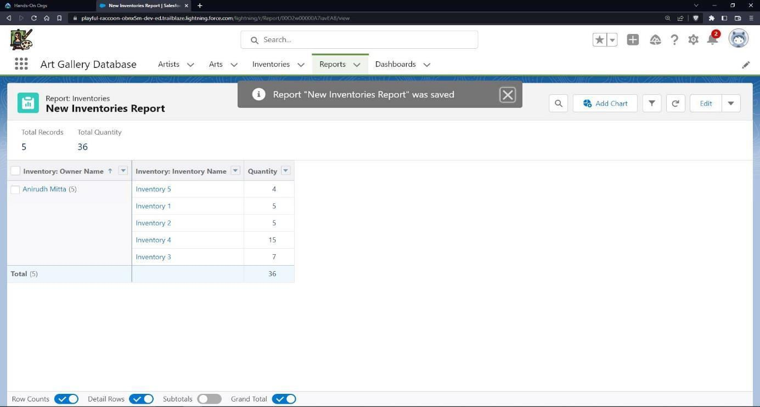

* 1. Create a Dashboard
* Go to “Dashboard tab” and then click on “New Folder” and give it any Name.
* Click on “New Dashboard” and then name it as “Art Gallery Dashboard” and select folder that you have created Click on Create.
* Click on the report that you have created on Artists and click on that and click select.
* Select any style to represent the data in dashboard.
* Click on the report that you have created on Arts and click on that and click select.
* Select any style to represent the data in dashboard.
* Click on the report that you have created on Inventory and click on that and click select.
* Select any style to represent the data in dashboard.
* Add any filter(s), otherwise it is optional.
* Click on Save and Click Run

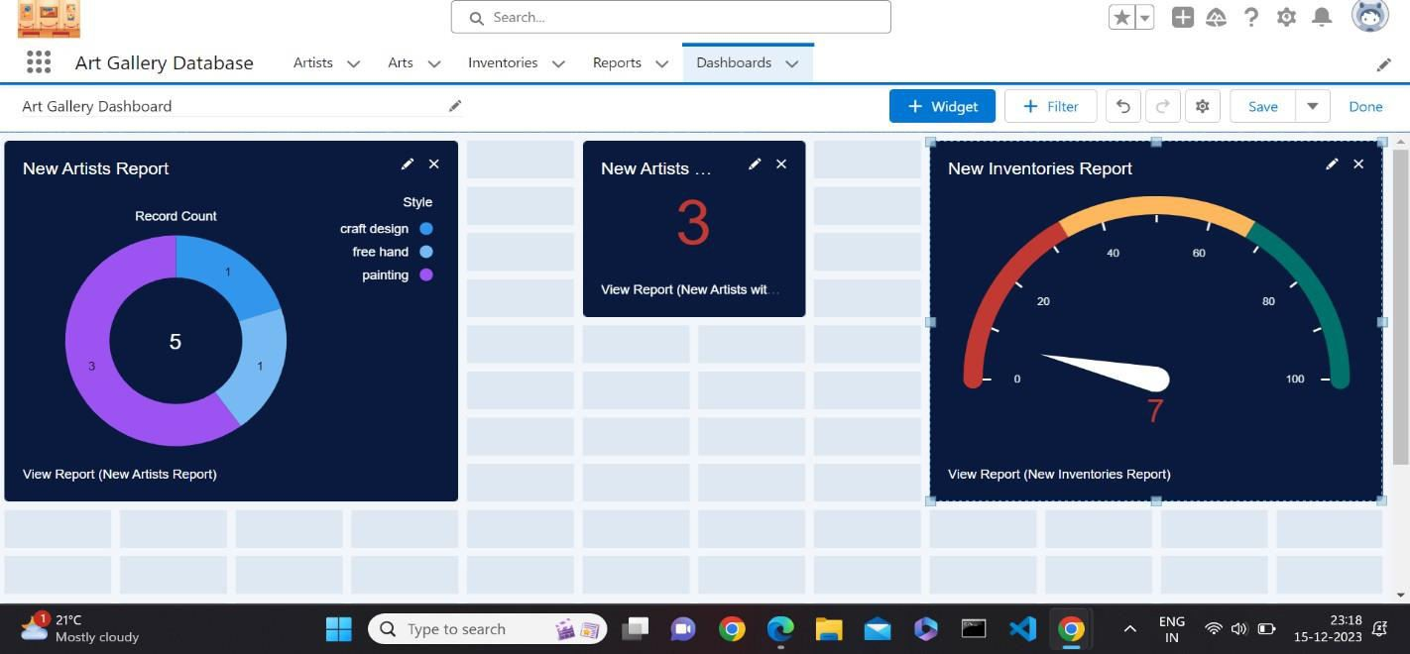

1. Create a web application with objects to record details about staff, syllabus and activities of a department and provide a link to college website from any of the objects.

**Steps:**

* 1. Launch your Salesforce Trailhead Playground by opening any module and Switch to Lightning Experience if you are currently in Salesforce Classic by clicking your picture in the right top corner and then click on “Switch to Lightning Experience”
  2. Then go to Setup gear icon and click “Setup”.
  3. Click on “Object Manager” and click “Create > Custom Object” to create new Custom Object.
  4. Name the object “Staff”.
  5. Allow Reports and Allow Search.
  6. Check the box in front of “Launch New Custom Tab Wizard after saving this custom object”.
  7. To create a Tab for the Object: Select any Tab Style for the object “Staff”. Click Next, Next, leave the defaults and save.
  8. To add fields to the Object: Go to “Fields & Relationships” option of Student object and Click “New”.
  9. Add the following fields one after the other:
* Field Label: ID (Length 10), Data Type: Text, provide an example ID as Help Text, make it as Required Field, don’t allow Duplicate Values, make it as Case Insensitive and Set this field as the unique record identifier from an external system.
* Field Label: Branch, Data Type: Text, Make it as a required field.
* Field Label: Salary, Data Type: Number, Make it as a required field.

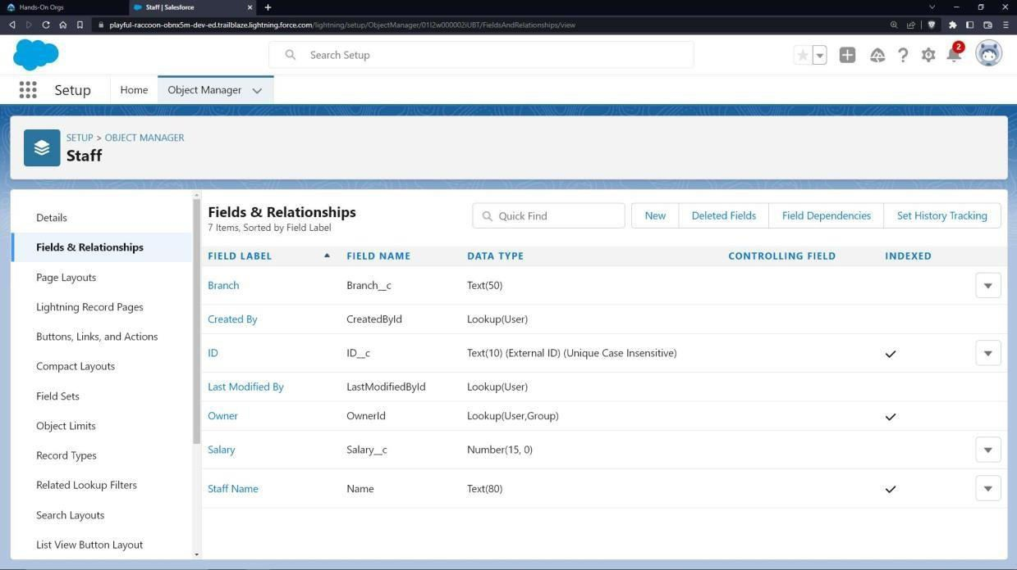

Create one more object to store Syllabus details:

* 1. Name the Object “Syllabus”.
  2. Allow Reports and Allow Search.
  3. Check the box in front of “Launch New Custom Tab Wizard after saving this custom object”
  4. Create a Tab for the Object.
  5. To add fields to the Object: Go to “Fields & Relationships” option of Student object and Click “New”.
  6. Add the following fields one after the other:
* Field Label: Subject Code, Data Type: Text.
* Field Label: Credits, Data Type: Number.

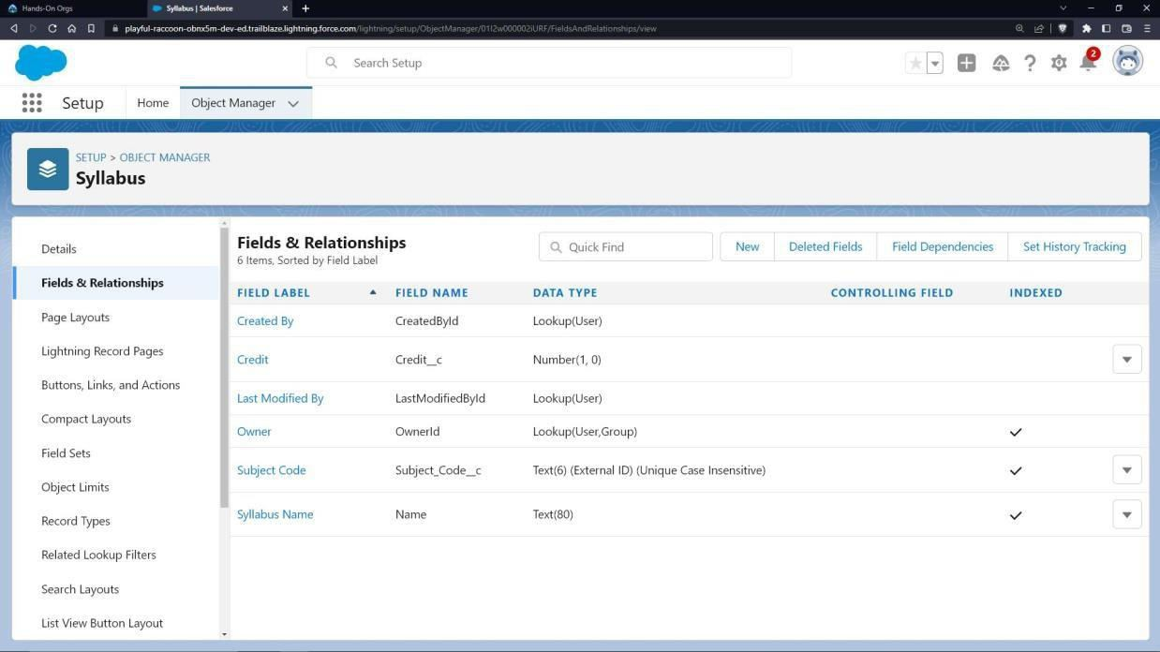

Create one more object to store department activities’ details:

* 1. Name the Object “Activities”.
  2. Allow Reports and Allow Search.
  3. Check the box in front of “Launch New Custom Tab Wizard after saving this custom object”
  4. Create a Tab for the Object.
  5. 20. To add fields to the Object: Go to “Fields & Relationships” option of Student object and Click “New”.
  6. Add the following fields one after the other:

- Field Label: Details, Data Type: Text. Make it as a required field.

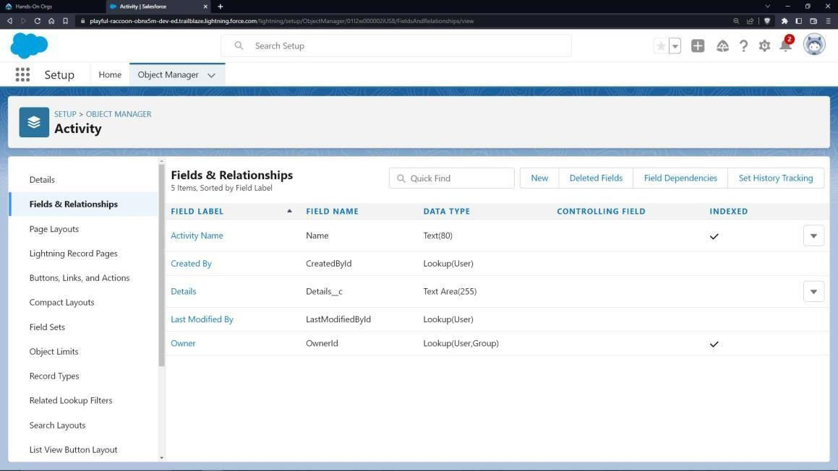

* 1. Validation rules
     1. Staff ID Validation:
        + To add a rule to the Staff is so that it should take only valid ids:
        + Go to Validation Rule of Staff Object and click “New”
        + Name it as “Staff id validation”.
        + Error Condition Formula: NOT(BEGINS(ID c,’STAFF’)).
        + Error Message: Please enter a valid staff Id.
        + Error Location: Field – ID.
        + Click Save.

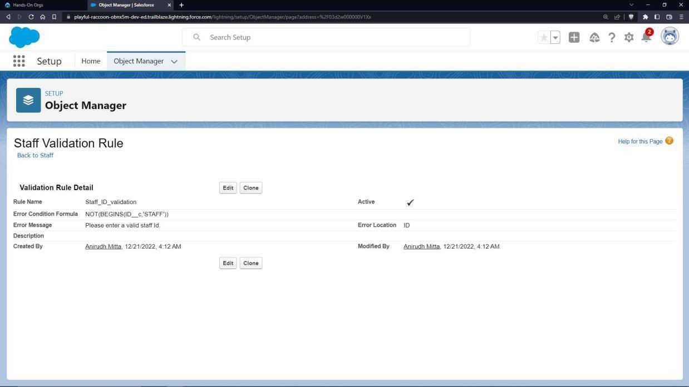

* + 1. Subject Code Validation
       - To add a rule to the Subject code so that it should not take invalid sub code:
       - Go to Validation Rule of Syllabus Object and click “New”.
       - Name it as “Sub code validation”
       - Error Condition Formula: NOT(REGEX(Subject_Codec, “*a- zA-Z]+[0-9++”)).
       - Error Message: Please Enter a valid Subject code.
       - Error Location: Field – Subject Code.
       - Click Save.

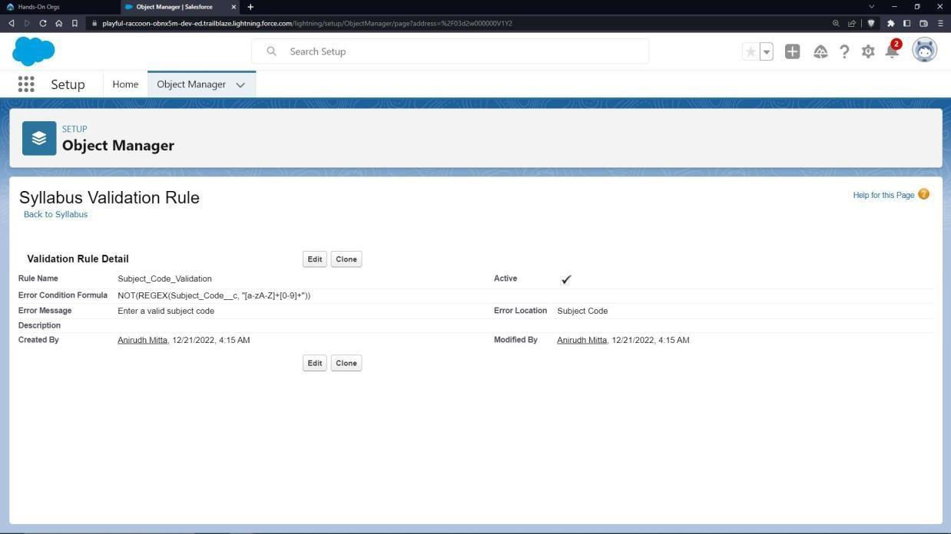

* + 1. Credits validation
       - To add a rule to the Credits so that it Should not take more than 4 credits:
       - Go to Validation Rule of Syllabus Object and click “New”.
       - Name it as “Credits validation”.
       - Error Condition Formula: OR(credits c >4 ,Credits c <=0).
       - Error Message: Please Enter the credits which is less than 4.
       - Error Location: Field –Credit.
       - Click Save.

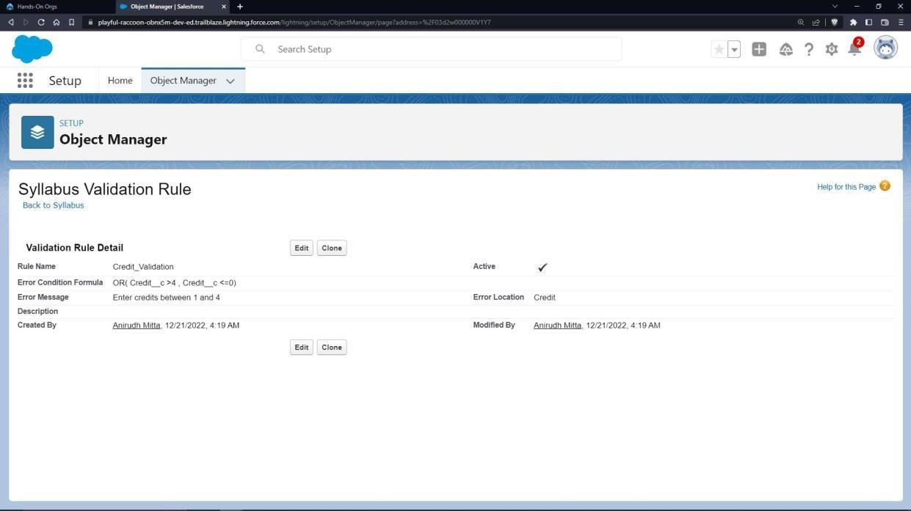

To give a link to college website:

* 1. Go to “Buttons, Links and Actions” of Art Object and click “New Button or Link”.
  2. Name it as “College”. Select the radio button “Detail Page Link” as it is a website link.
  3. Behaviour: Display in new window.
  4. Content Source: URL.
  5. Field Type: College.
  6. In the empty space provided, type <http://www.drait.edu.in/>
  7. Link Encoding: Unicode (UTF-8).
  8. Click Save.

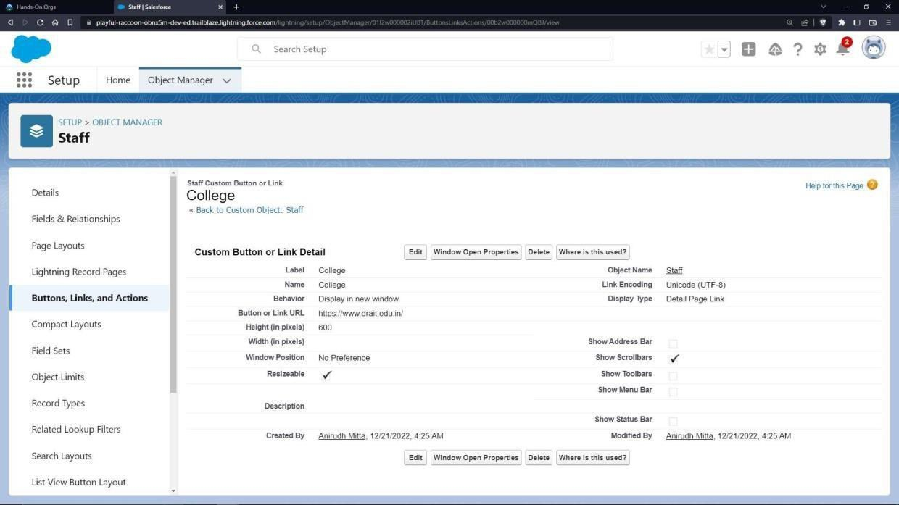

* 1. Go to Page Layout, Click Activities Layout.
  2. Click Custom Links, Drag and drop the “College” link in the Custom Link area.
  3. Click Save.

To create an application:

* 1. Go to “Setup” and type “App Manager” in Quick Find Box.
  2. Click on “New Lightning App” to create a Lightning Application.
  3. Name it as “Department Details”, give the description for your application.
  4. Uploading Image and changing colours are optional, then click Next.
  5. Navigation Style: Standard Navigation, click Next.
  6. No need to add any Utility Bar, click Next.
  7. Add the following:
  8. Items: Staff, Syllabuses, Activities, Reports and Dashboards, click Next.
  9. Assign it to System Administrator Profile by selecting System Administrator and pressing right arrow and then click Save & Finish.
  10. Go to App Manager, select your application and select Faculties and click “New” to add some details to your application.
  11. Click the entry you added, go to details.
  12. Press the “College” link to check the details.
  13. Click OK so that it will redirect you to the website.

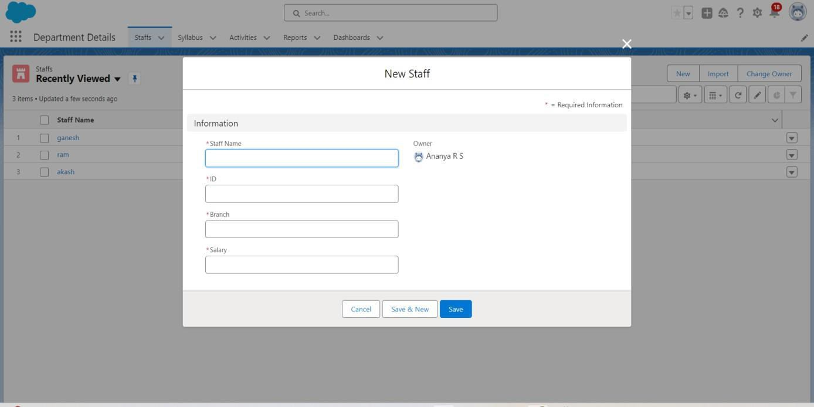

Make Sure You will get an error when u give invalid staff id, credits and Subject code.

* 1. Create a Staff Report
* Go to “Reports tab” Click on “New Folder” And give it any name then select Save.
* Click on “New Report” and from search bar Search for “Staffs” and then select it then select Continue.
* Add the required Columns to get the Complete Entered data.
* If you want the report to be grouped by any specific Fields, then Search for the field in “Add groups” otherwise it is optional.
* Click on save and name the report as “New Staffs Report” and then select the folder which you have created.
* Click Save and then Click Run.

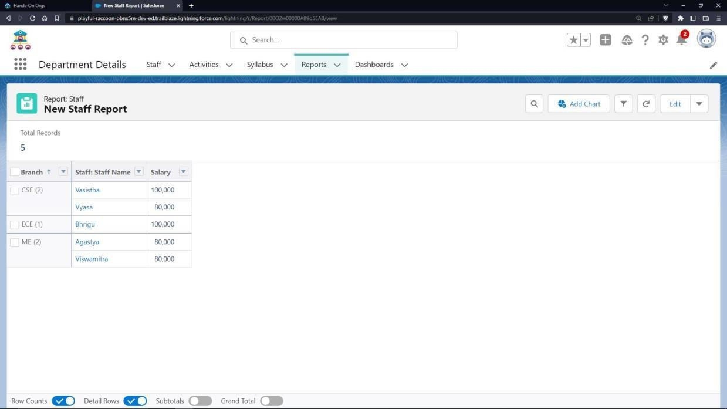

* Go to “Reports tab” Click on “New Folder” And give it any name then select Save.
* Click on “New Report” and from search bar Search for “Syllabus” and then select it then select Continue.
* Add the required Columns to get the Complete Entered data.
* If you want the report to be grouped by any specific Fields, then Search for the field in “Add groups” otherwise it is optional.
* Click on save and name the report as “New Syllabus Report” and then select the folder which you have created.
* Click Save and then Click Run

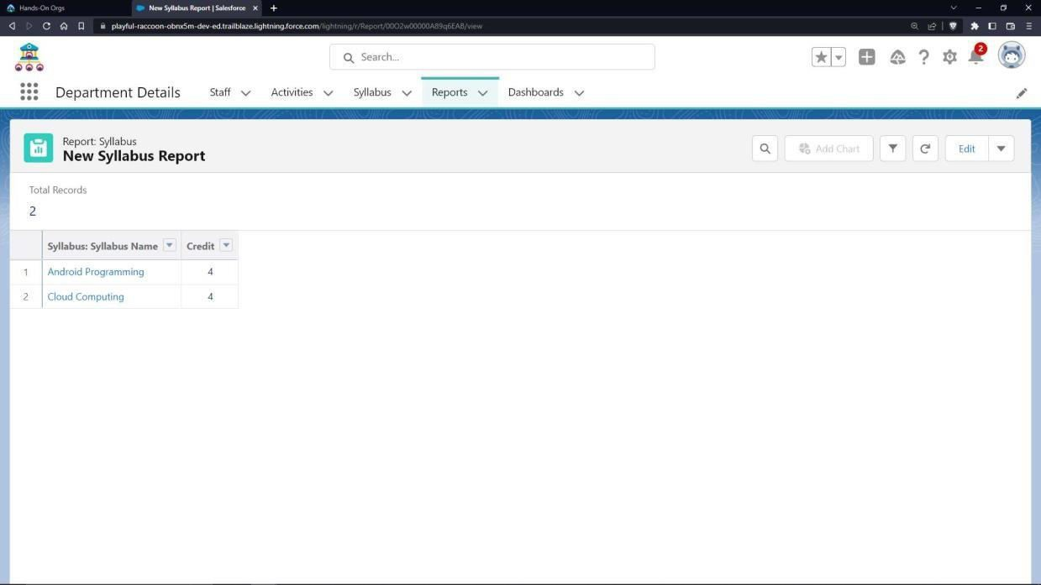

* 1. Create an activity report
* Go to “Reports tab” Click on “New Folder” And give it any name then select Save.
* Click on “New Report” and from search bar Search for “Activities” and then select it then select Continue.
* Add the required Columns to get the Complete Entered data.
* If you want the report to be grouped by any specific Fields, then Search for the field in “Add groups” otherwise it is optional.
* Click on save and name the report as “New Activities Report” and then select the folder which you have created.
* Click Save and then Click Run.

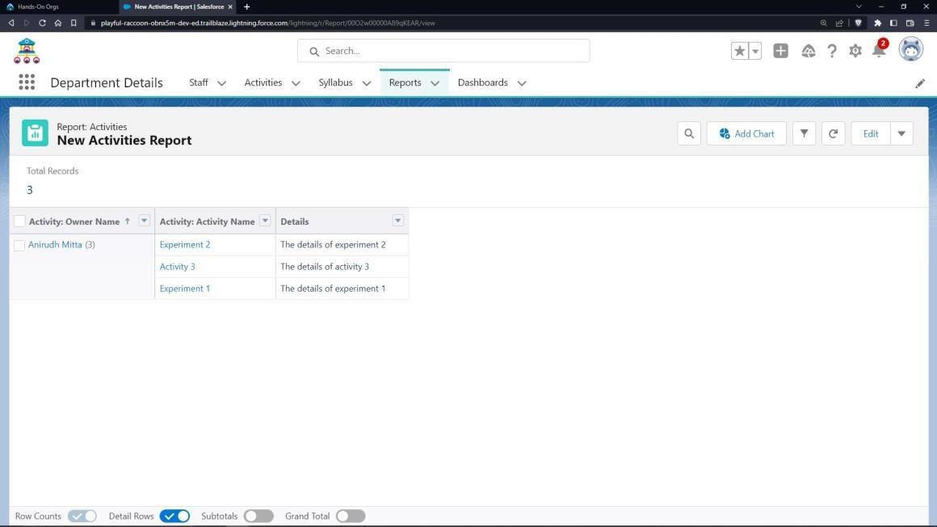

* 1. Create a dashboard
* Go to “Dashboard tab” and then click on “New Folder” and give it any Name.
* Click on “New Dashboard” and then name it as “Staff dashboard” and select folder that you have created Click on Create.
* Click on the report that you have created on staff and click on that and click select.
* Select any style to represent the data in dashboard.
* Click on the report that you have created on syllabus and click on that and click select.
* Select any style to represent the data in dashboard.
* Click on the report that you have created on activity and click on that and click select.
* Select any style to represent the data in dashboard.
* Add any filter(s), otherwise it is optional.
* Click on Save and Click Run.

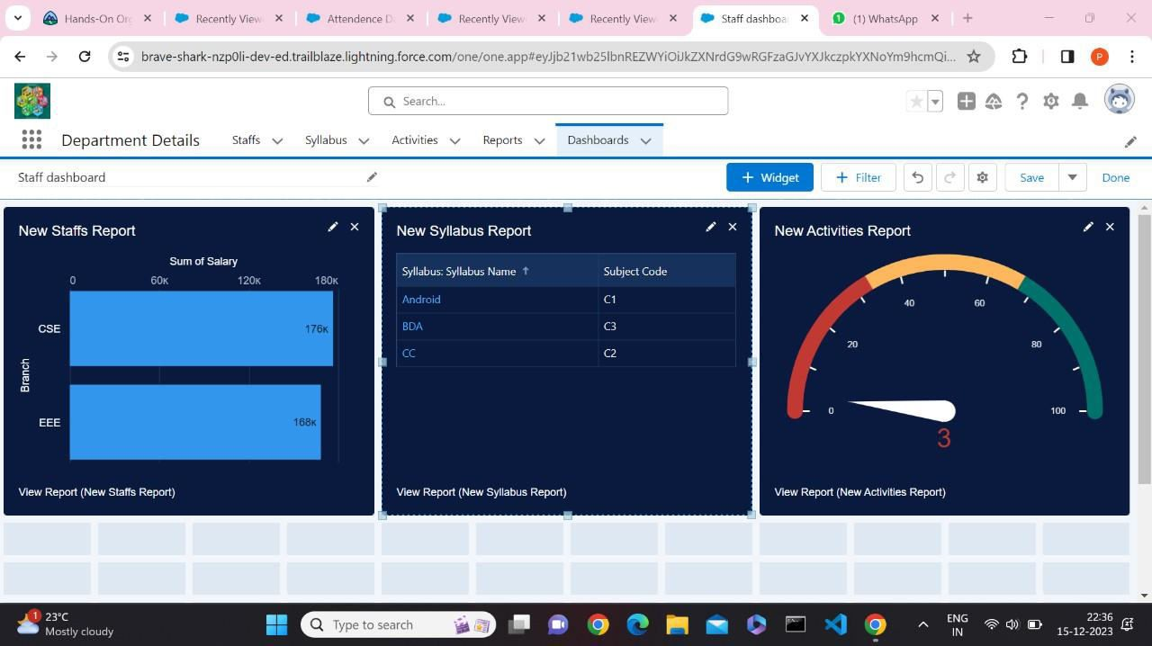

## CLOUD ANALYST

**Cloud** **Analyst**

Cloud Analyst is a tool developed at the University of Melbourne whose goal is to support evaluation of social networks tools according to geographic distribution of users and data centers. In this tool, communities of users and data centers supporting the social networks are characterized and, based on their location; parameters such as user experience while using the social network application and load on the data centre are obtained/logged.

Cloud Analyst is developed by Bhathiya Wickremasinghe et al. at the CLOUDS Laboratory. It is built on top of CloudSim and separates the simulation experimentation from a programming task enabling one to concentrate on the simulation parameters rather than the technicalities of programming. Simulation in Cloud Analyst involves the following steps:

1. Defining and configuration of User Bases.
2. Defining and configuring Data Centers
3. Allocating of Virtual Machines in Data Centers.
4. Review and Adjustment of various other parameters such as Packet size, Number of packets, Bandwidth, and Load balancing policies.

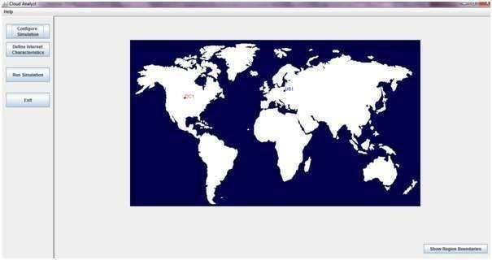

The Cloud Analyst enables us to model different scenarios of CSPs and User Bases, and provides a comprehensive output detailing the response time, Data Center processing time and total cost involved in the communication and computation.

Installing and Running Cloud Analyst:

* 1. Download Cloud Analyst
  2. Extract the files from the zip file which will give following folder structure.
  3. Click on run.bat file.
  4. The user can then configure the simulation which includes
     + Simulation Duration
     + Number of User Bases
     + Service broker policy
     + Data Center Configuration
     + Load Balancing Policy
  5. To run the simulation, click on Run Simulation.

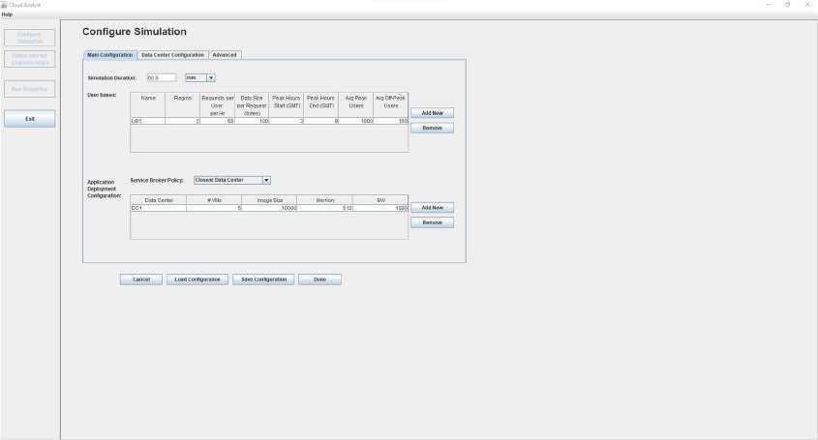

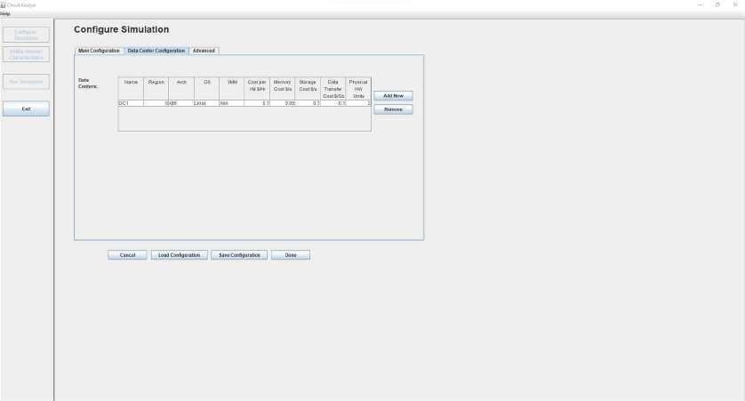

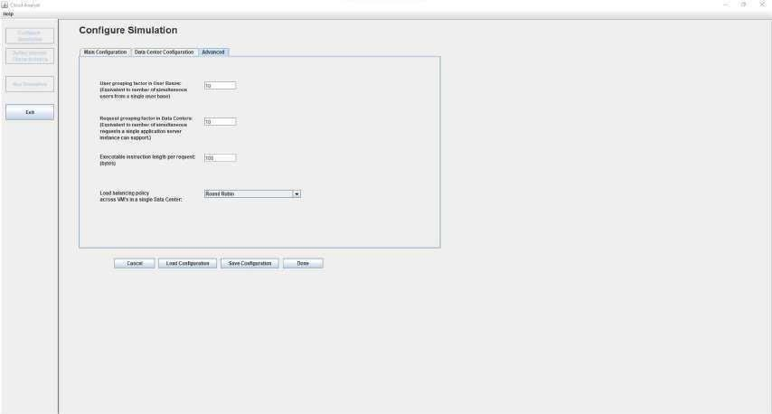

## CLOUD ANALYST SIMULATIONS

##### 1)

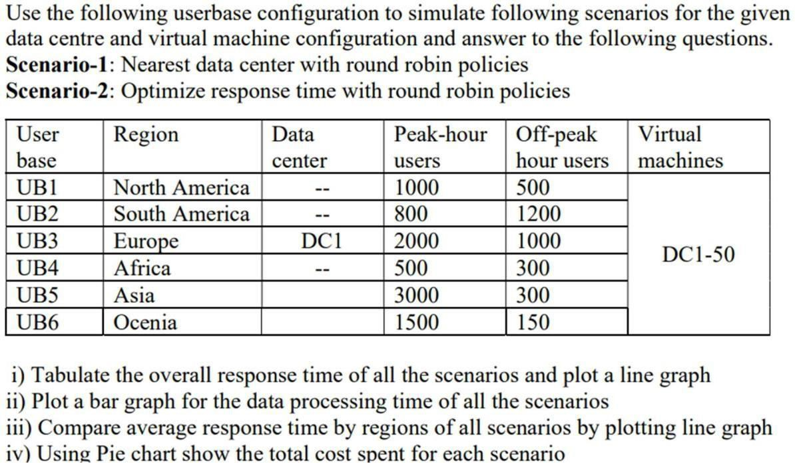

Closest

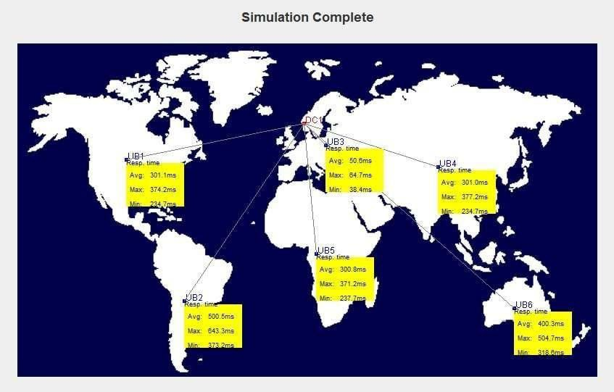

Optimized

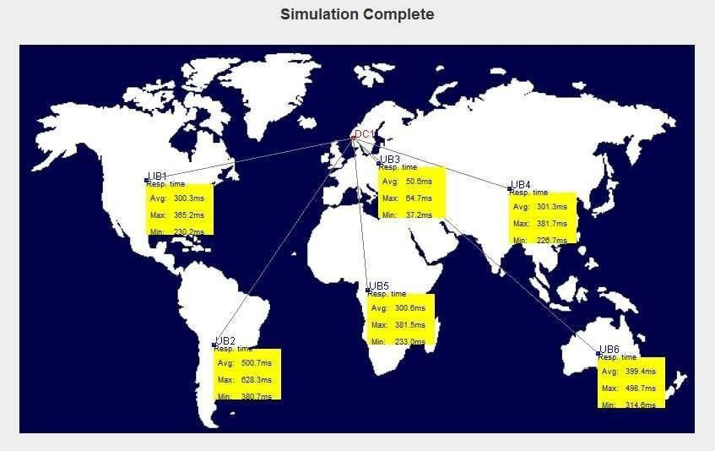

ss

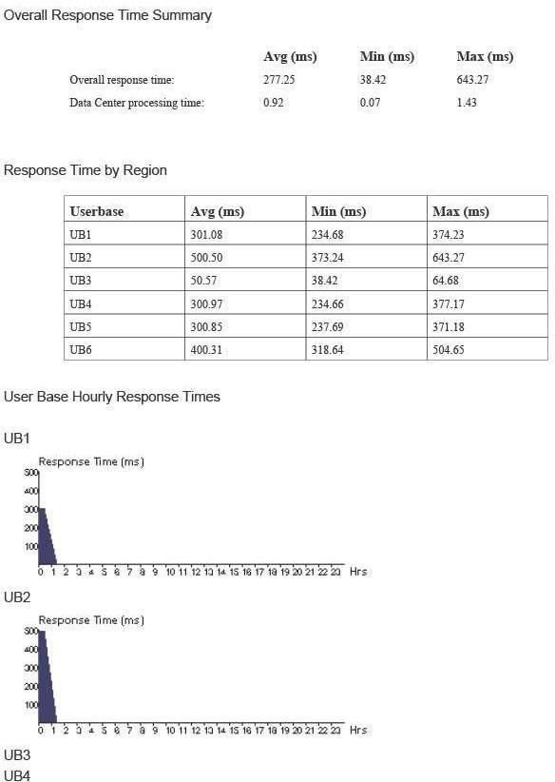

67

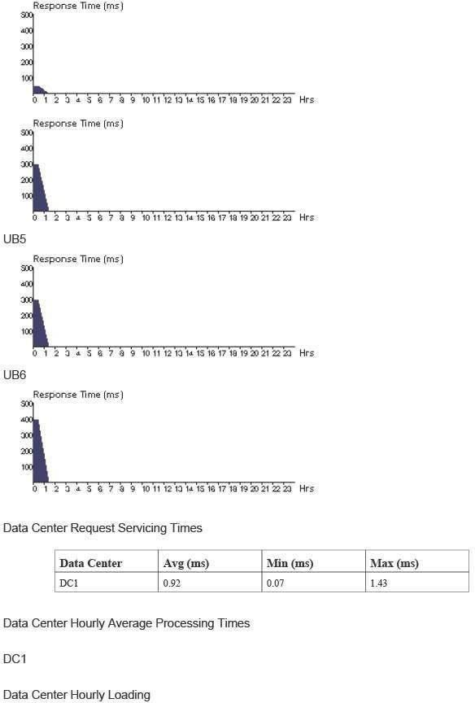

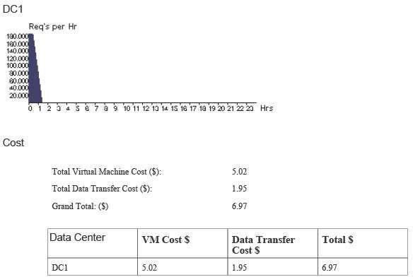

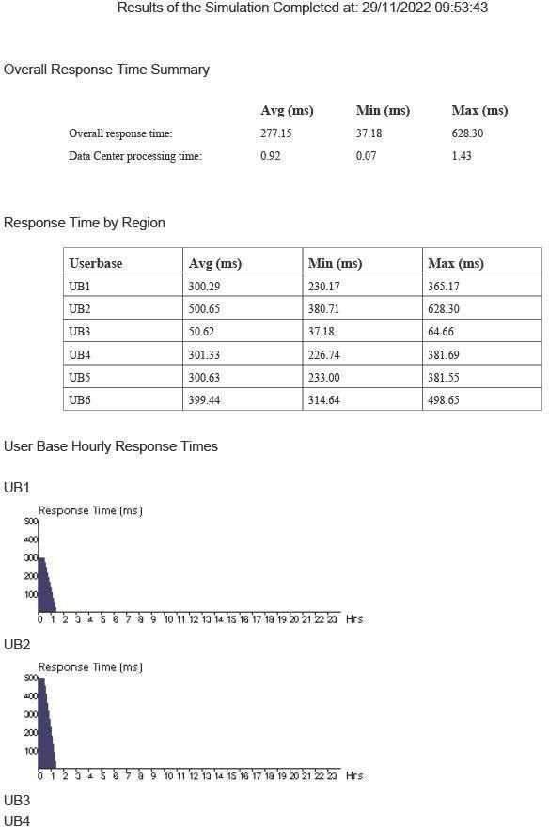

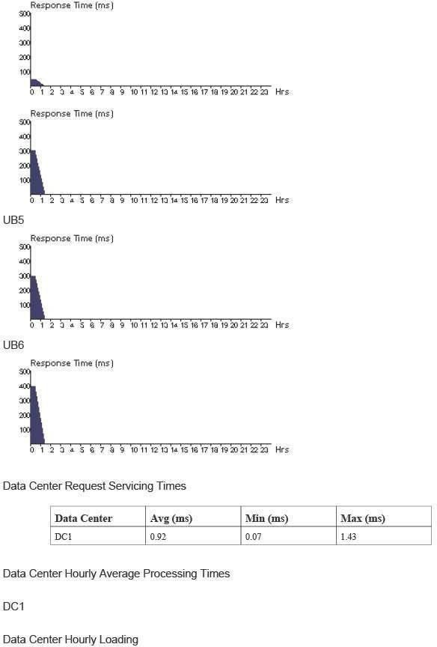



* Compare average response time by regions of all scenarios by plotting line graphGraph plotted for UB1,UB2,UB6 is higher for scenario 1 while average time by region for UB3,UB4,UB5 is higher for scenario 2.

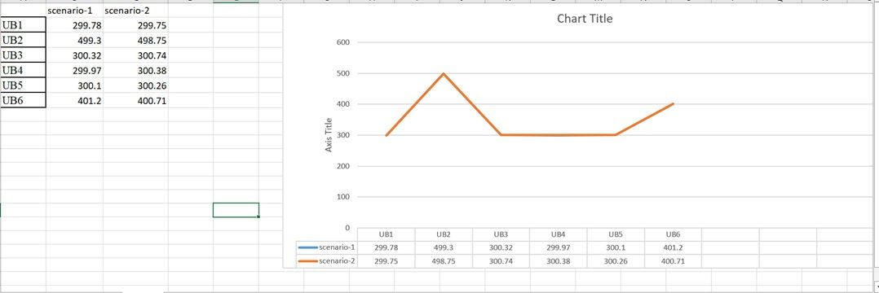

* Using Pie chart show the total cost spent for each scenario
* The pie chart indicates that total cost spent in both scenario are equal.

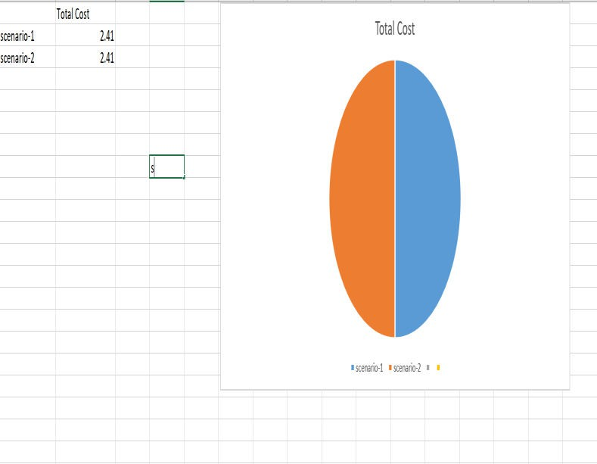

* Plot a bar graph for the data processing time of all the scenarios .
* Scenario 1 is higher than that of scenario 2 while minimum data processing time of scenario 2 is higher

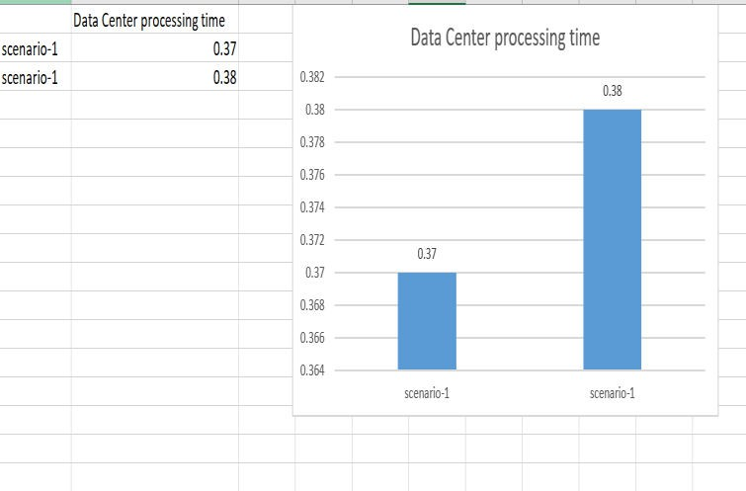

* Tabulate the overall response time of all the scenarios and plot a line graph
* The overall response time of scenario 1 is higher than scenario 2.

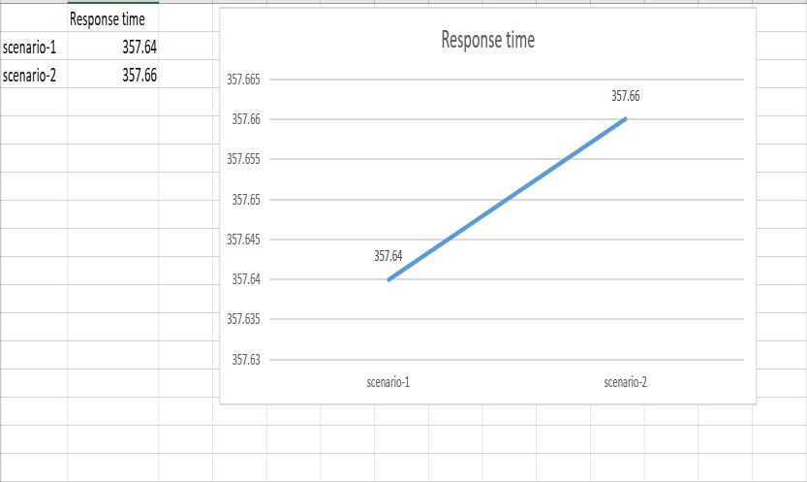

2)

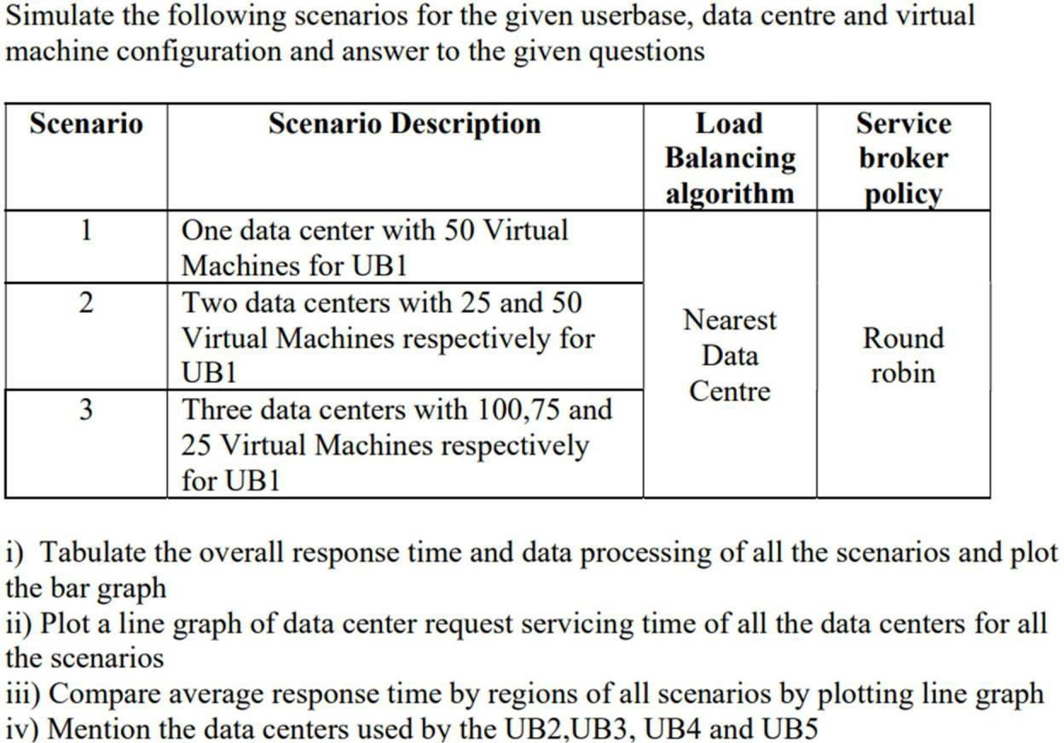

Scenario 1

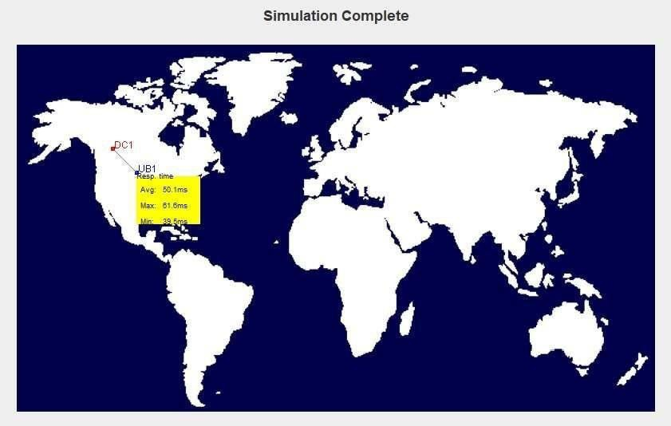

Scenario 2

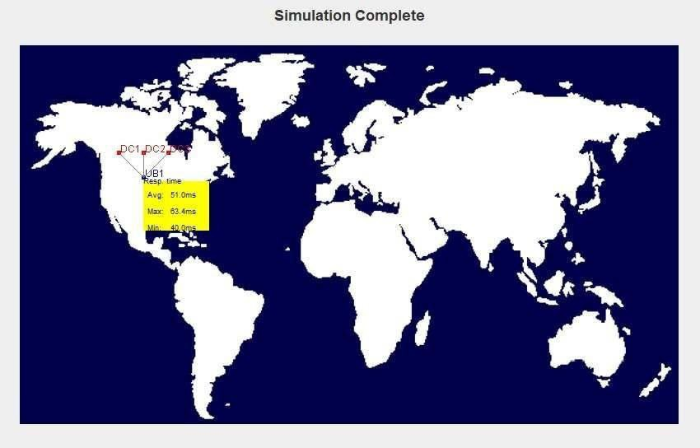

Scenario 3

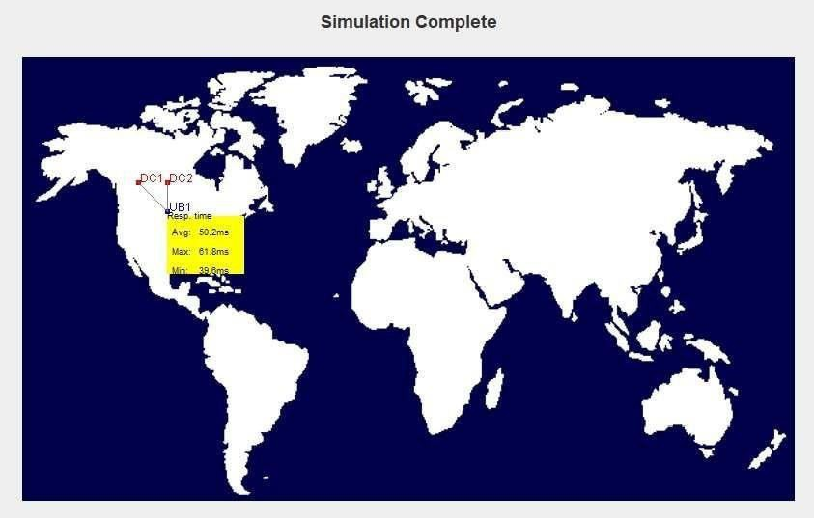

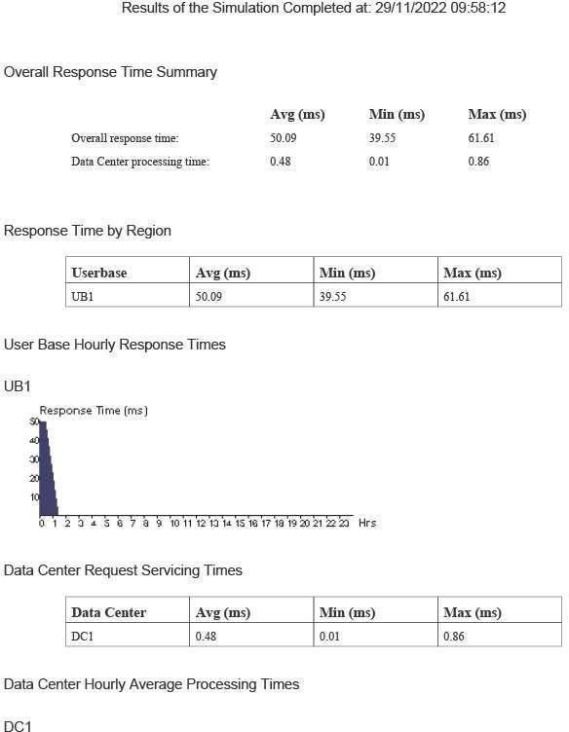

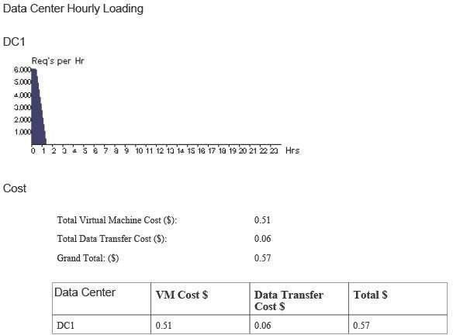

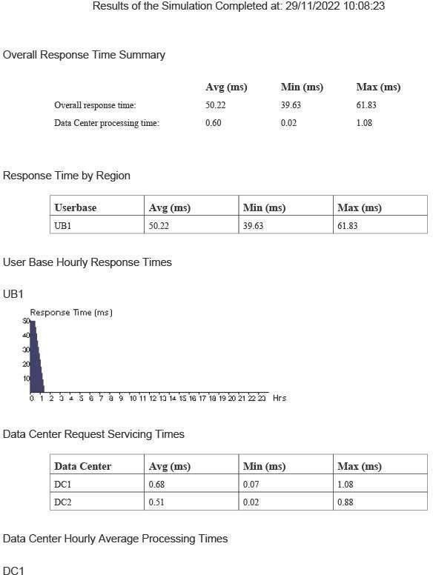

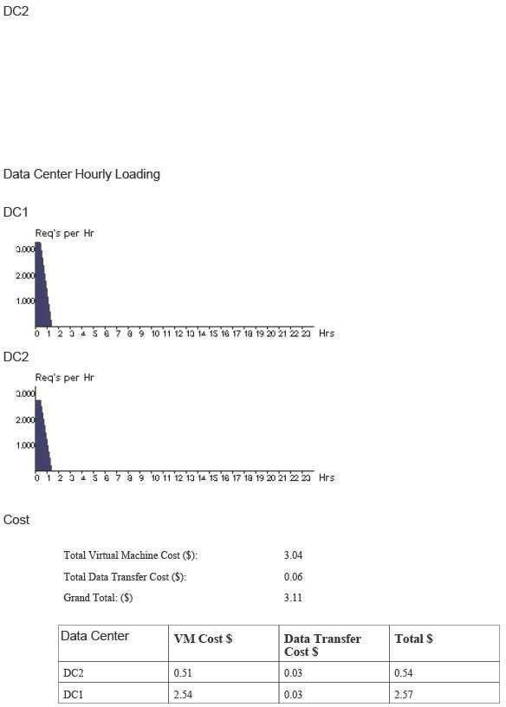

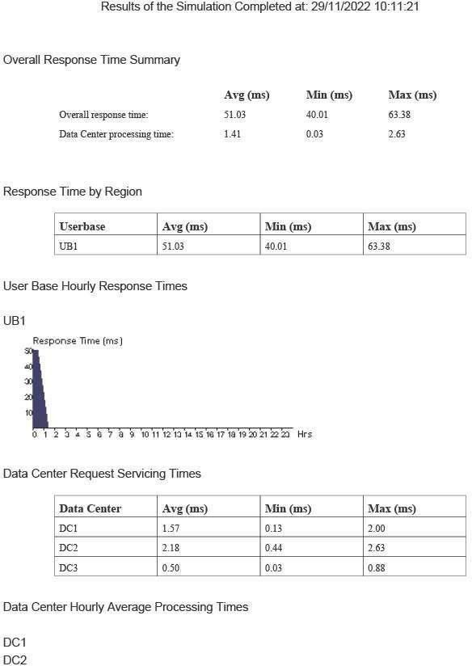

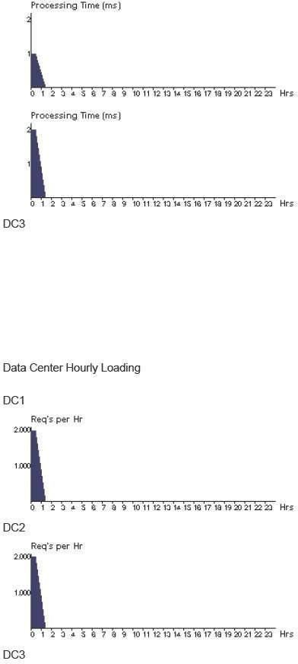

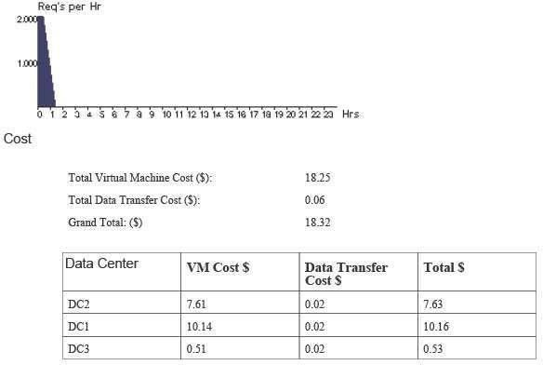

* Tabulate the overall response time and data processing of all the scenarios and plot the bar graph
* Scenario 3 has highest average and maximum data processing time.

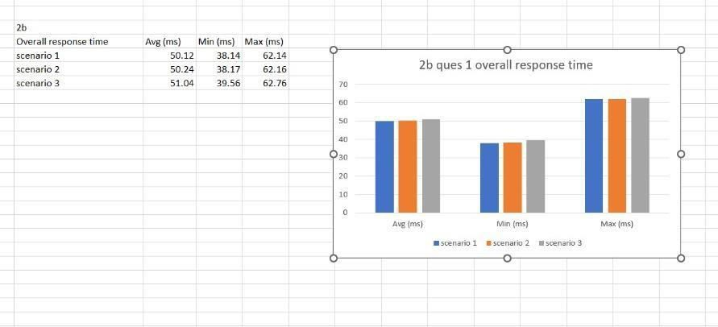

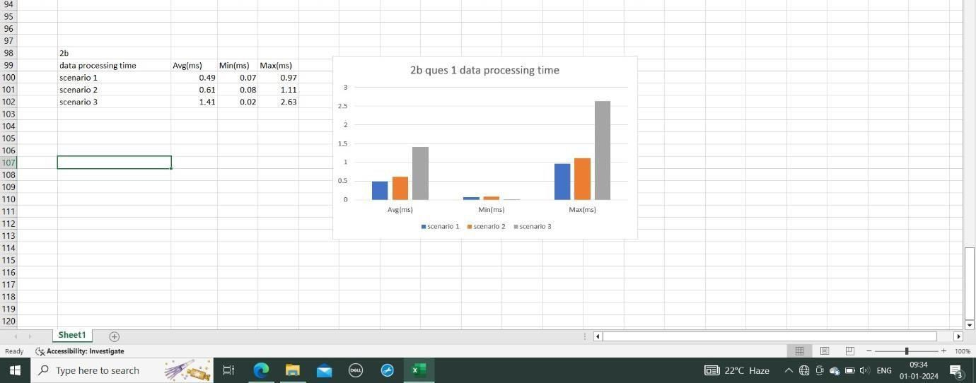

* Compare average response time by regions of all scenarios by plotting line graph
* The average response time by region is least in scenario 1 and highest in scenario 2.

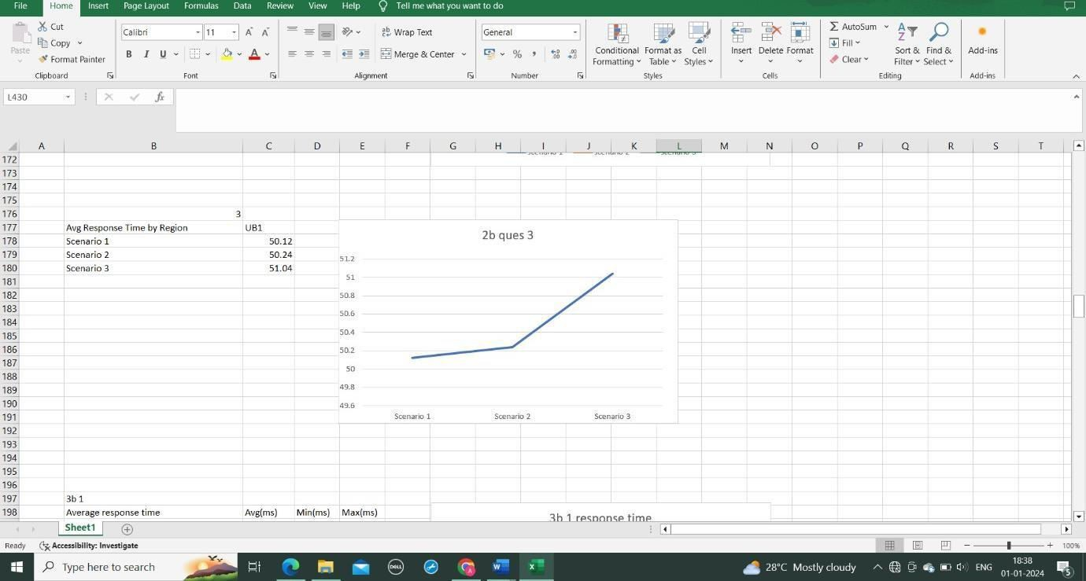

* Plot a line graph of data center request servicing time of all the data centers for all the scenarios
* Data center DC1 has the least data center request servicing time .

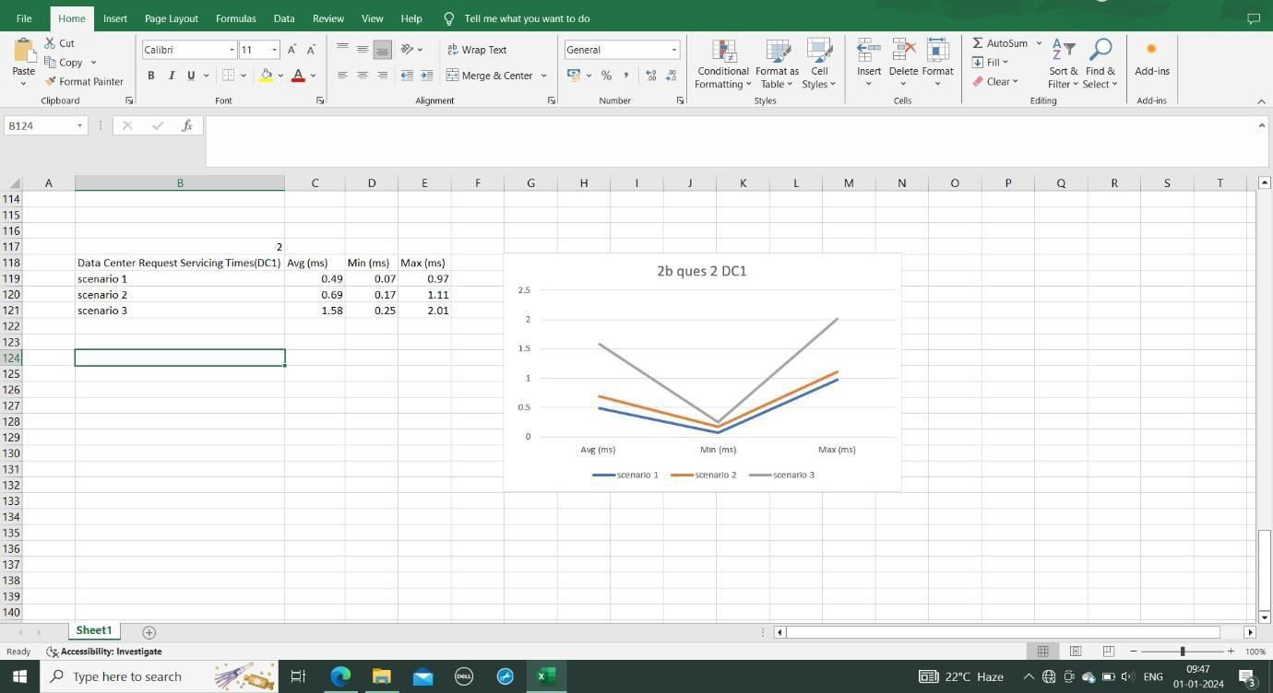

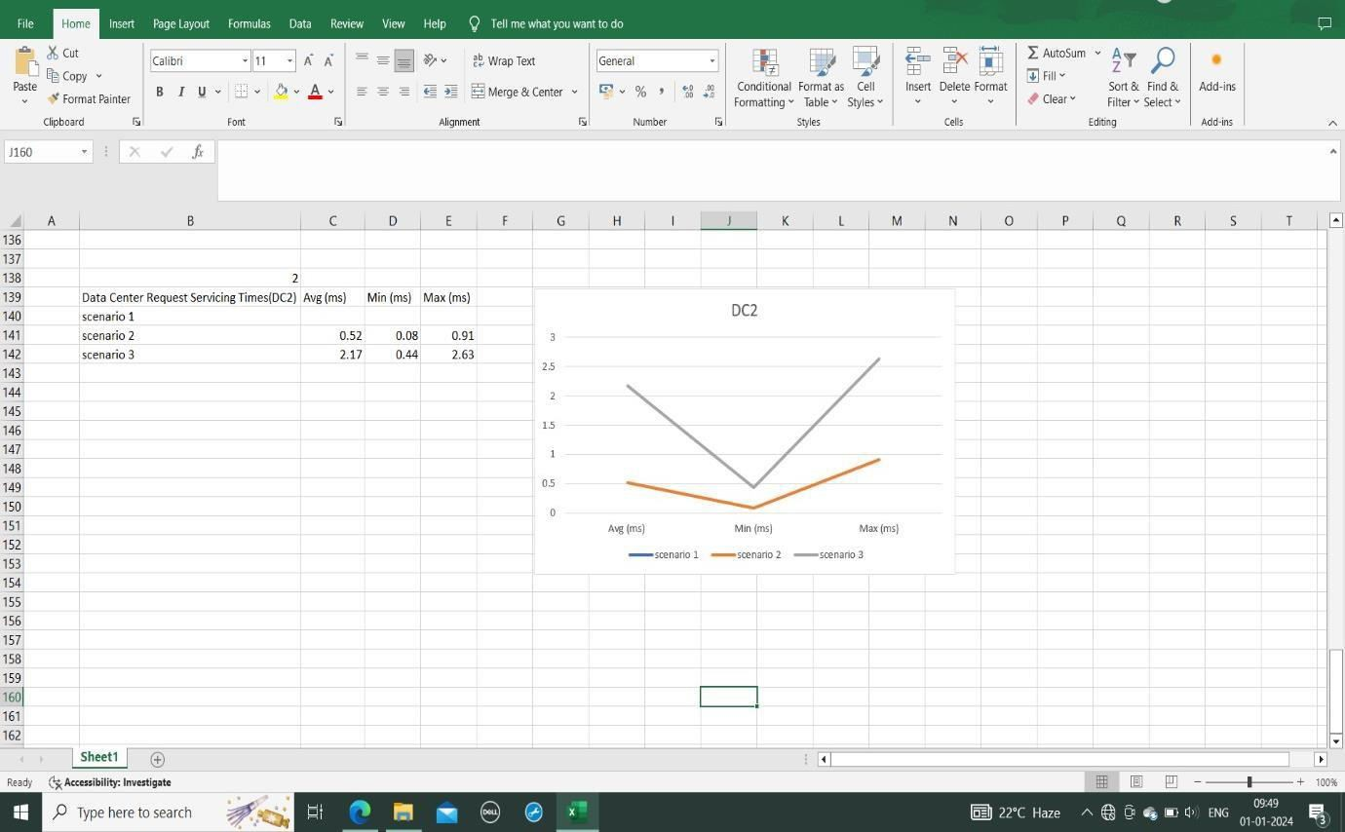

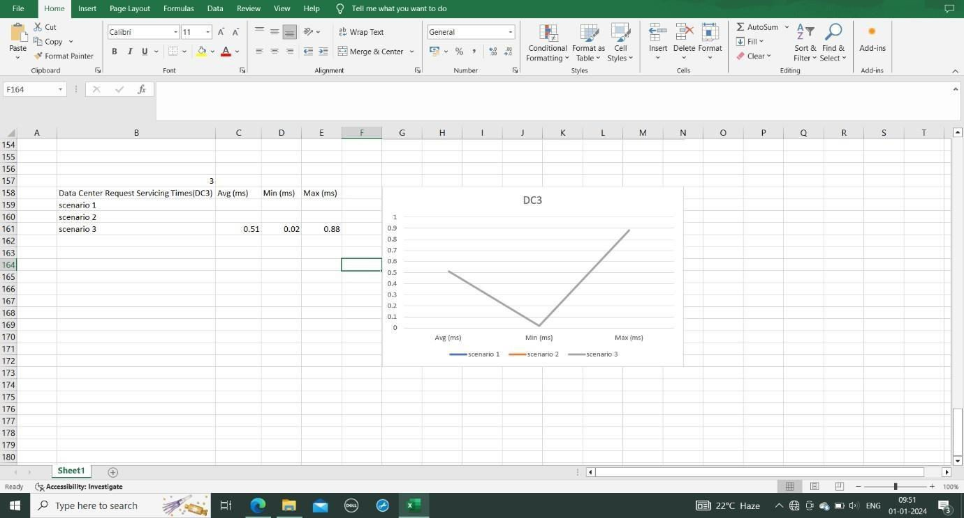

3)

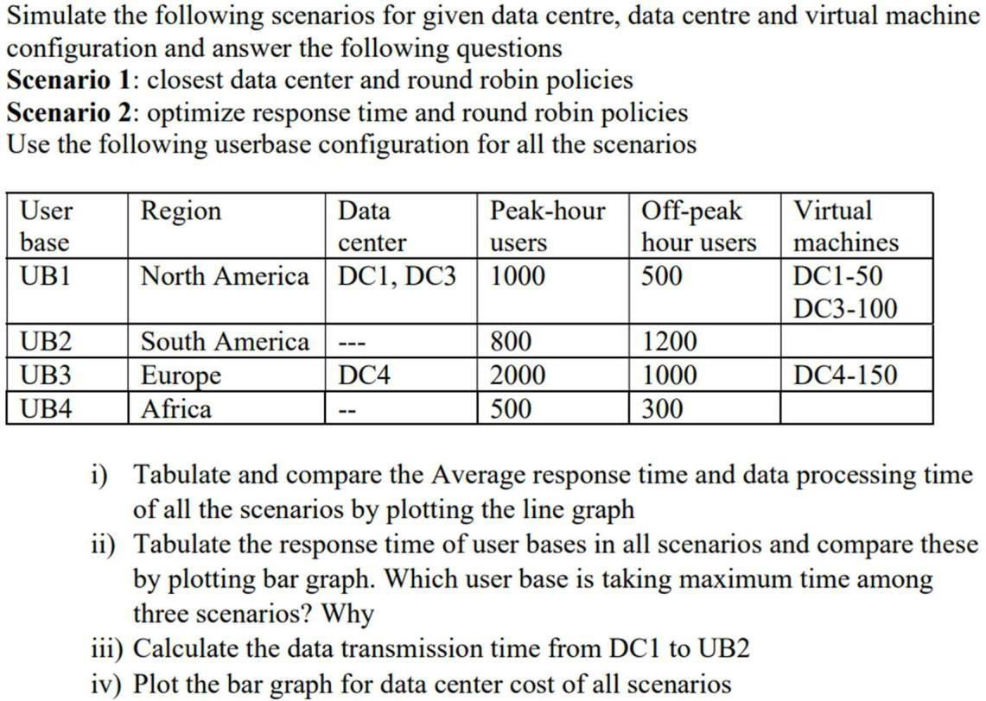

Closest

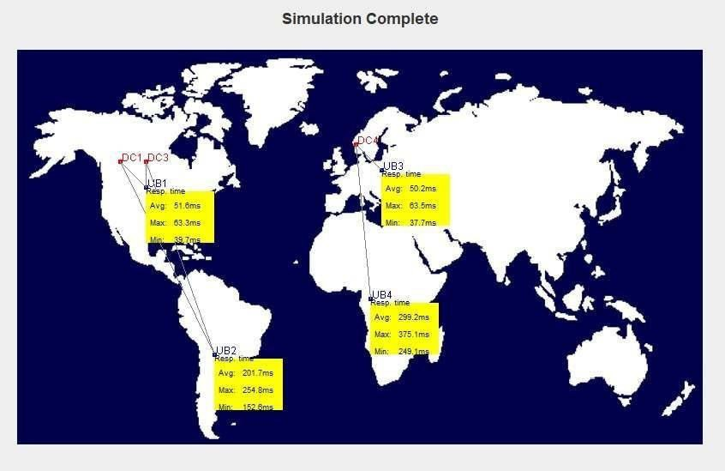

Optimized

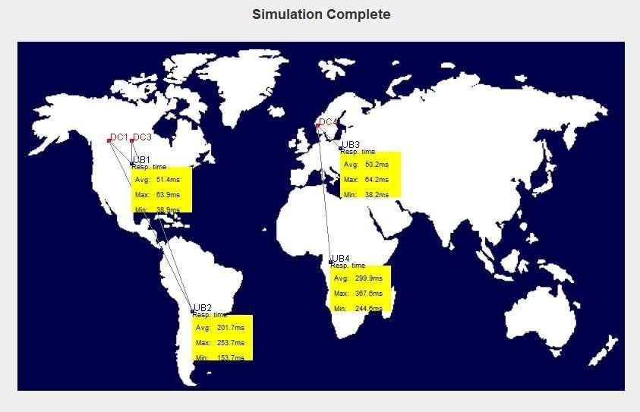

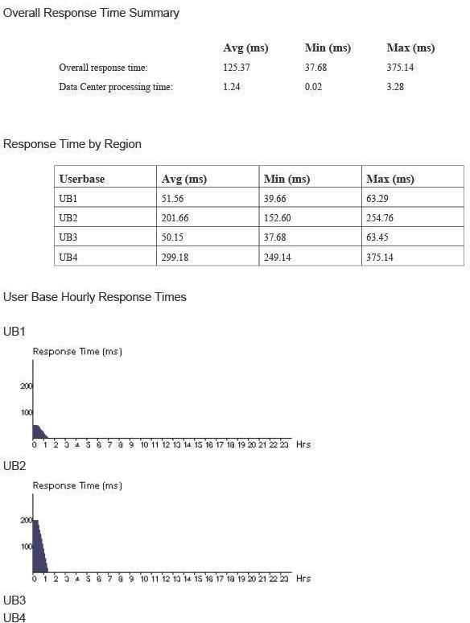

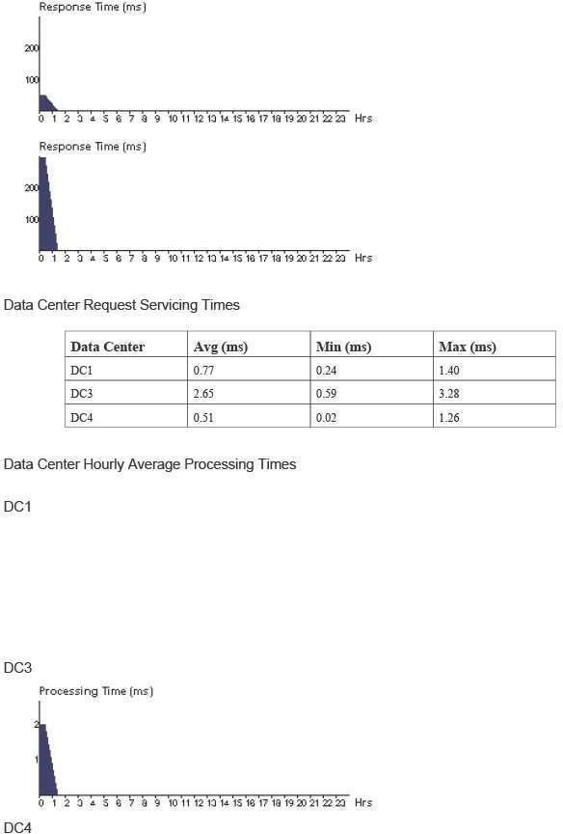

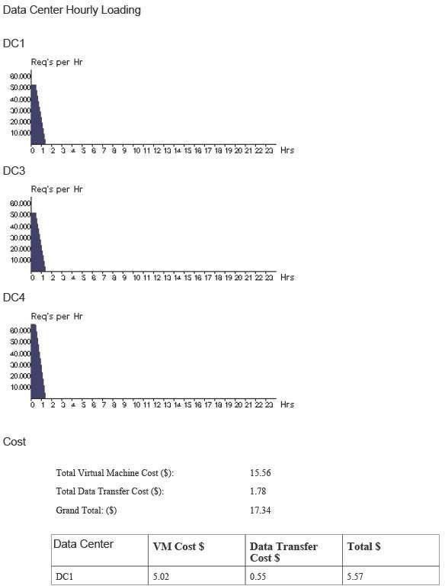

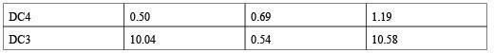

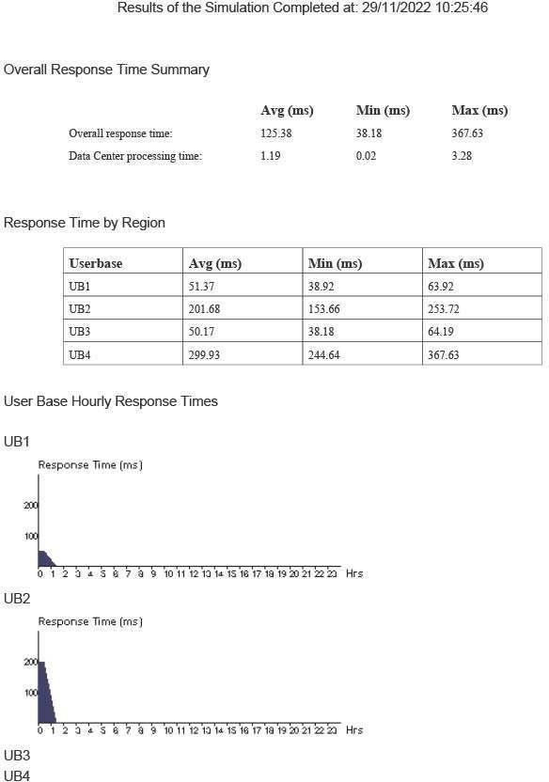

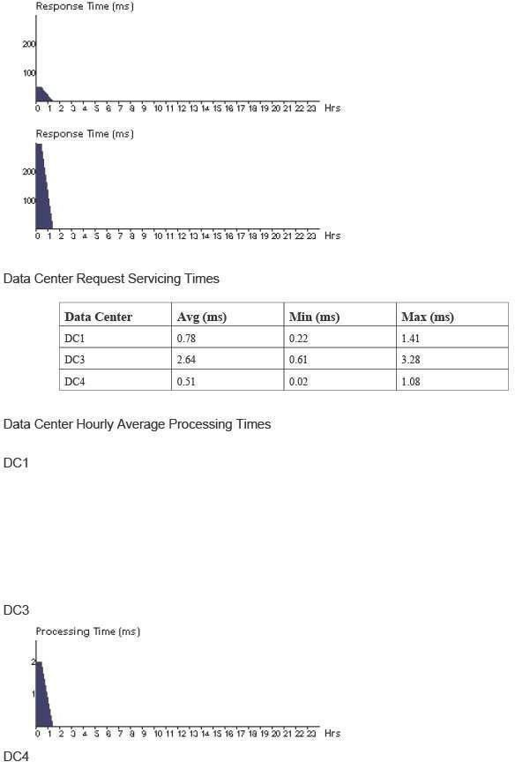

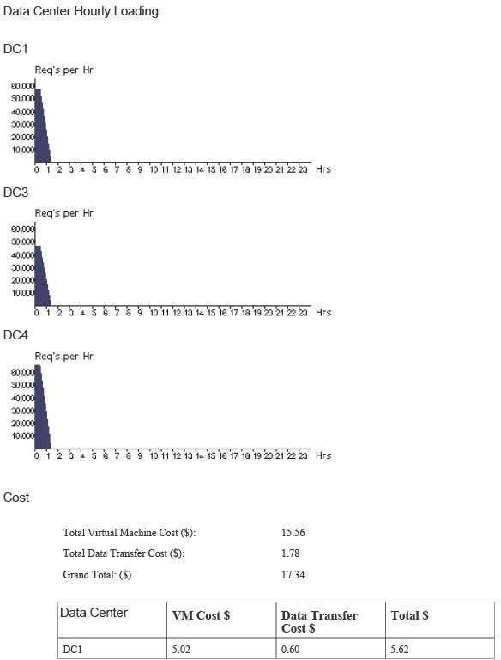

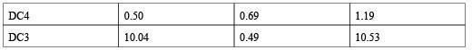

* Tabulate and compare the Average response time and data processing time of all the scenarios by plotting the line graph The average response time of scenario 2 is higher than scenario 1.

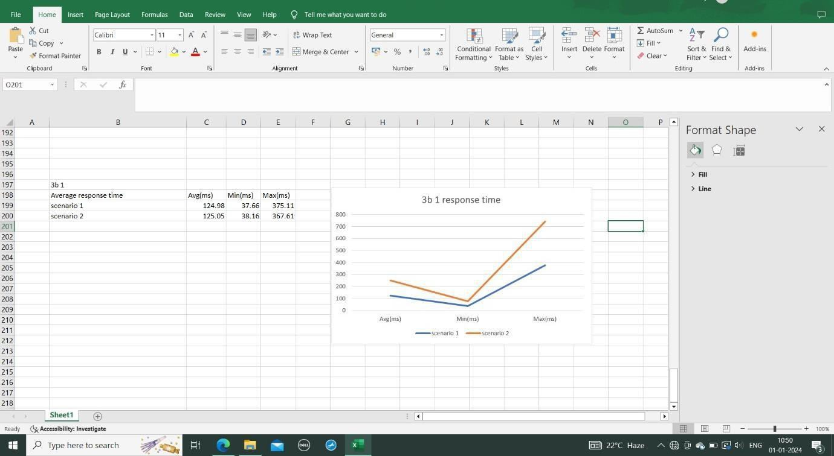

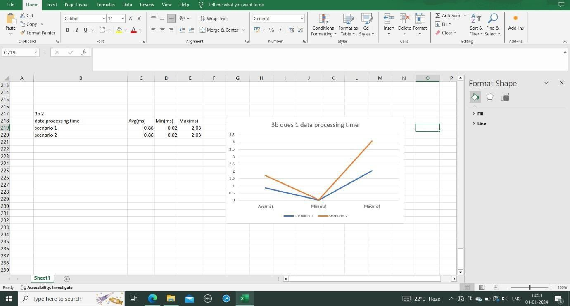

* Tabulate the response time of user bases in all scenarios and compare these by plotting bar graph. Which user base is taking maximum time among two scenarios? Why
* UB4 user base is taking maximum time among two scenarios because it has less users at the peak hours .

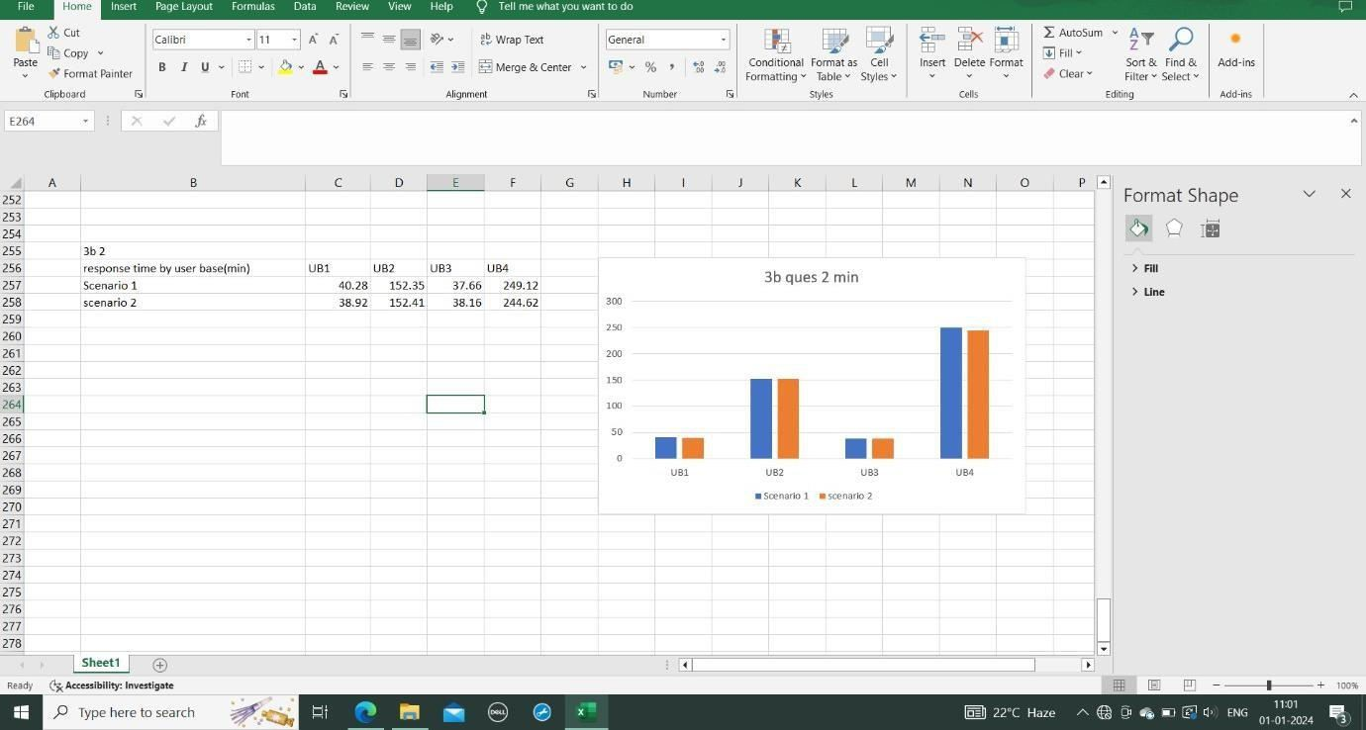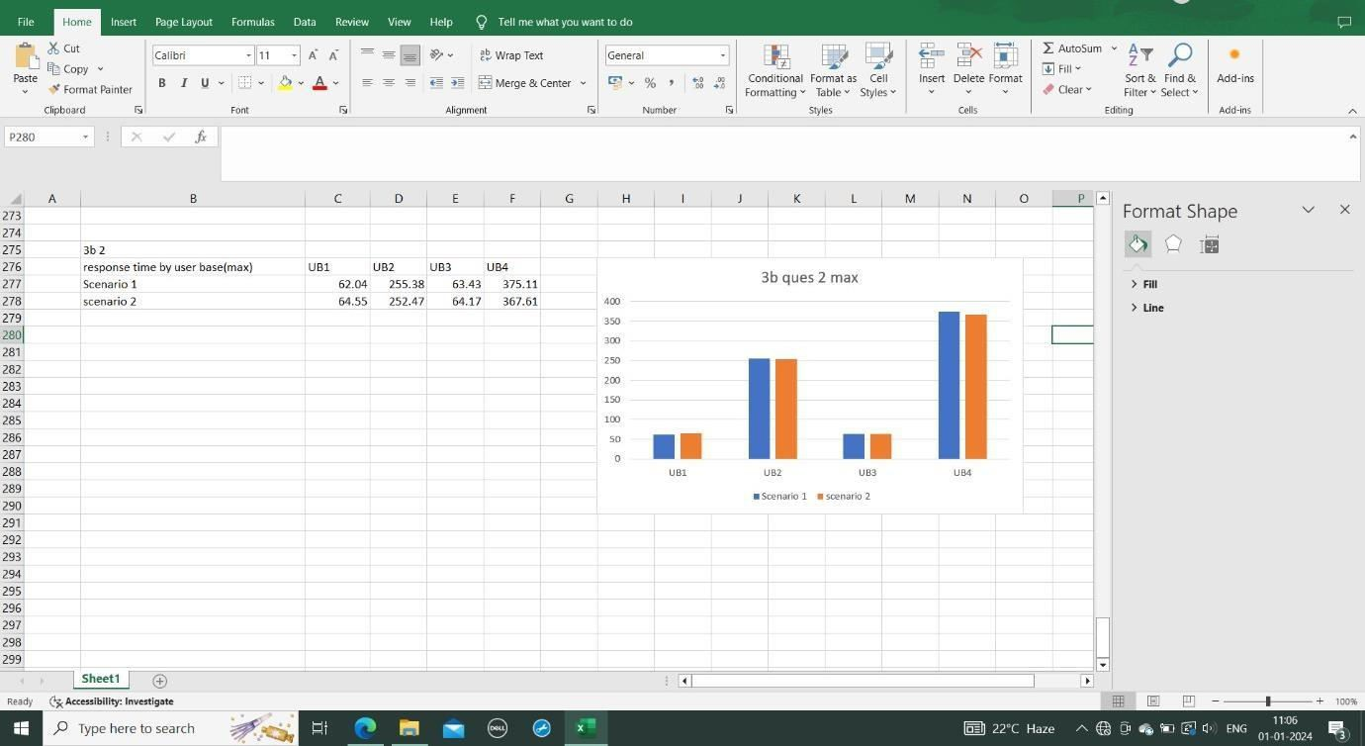

* Calculate the data transmission time from DC1 to UB2 Plot the bar graph for data center cost of all scenarios The data center cost for all data centers DC1,DC4,DC3 are same for the both scenarios

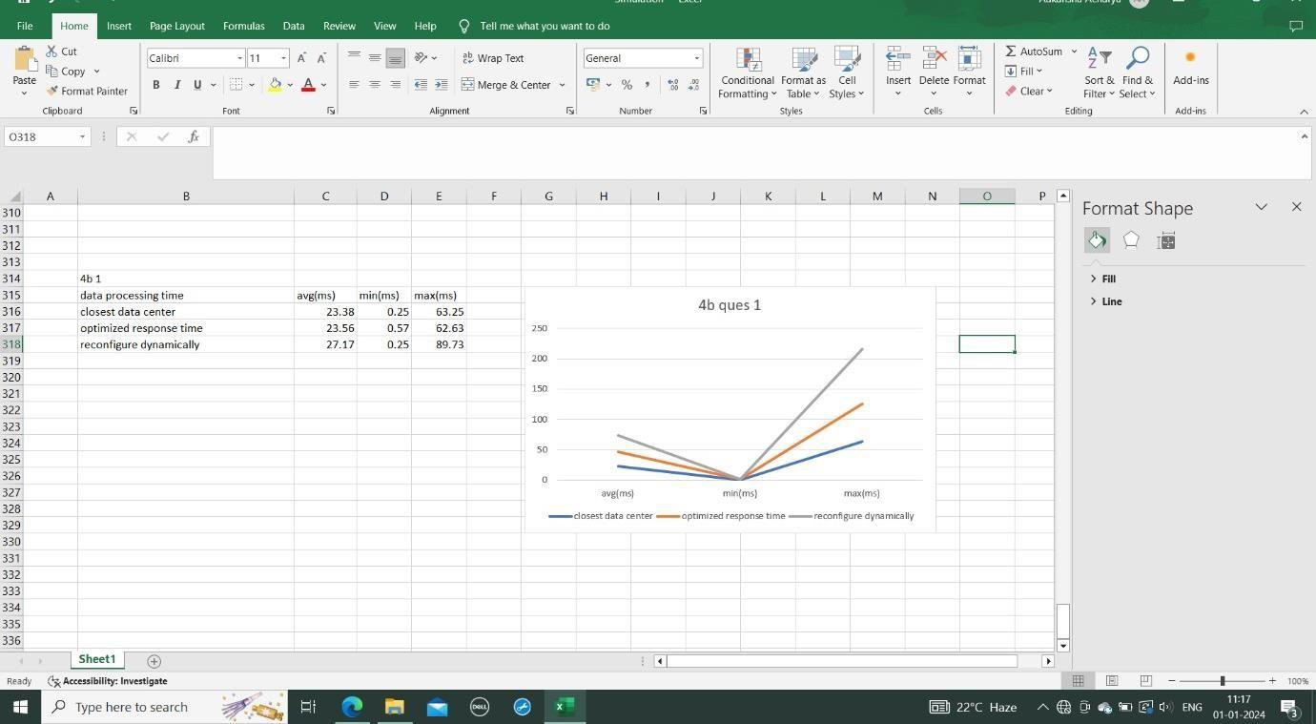

.

4)

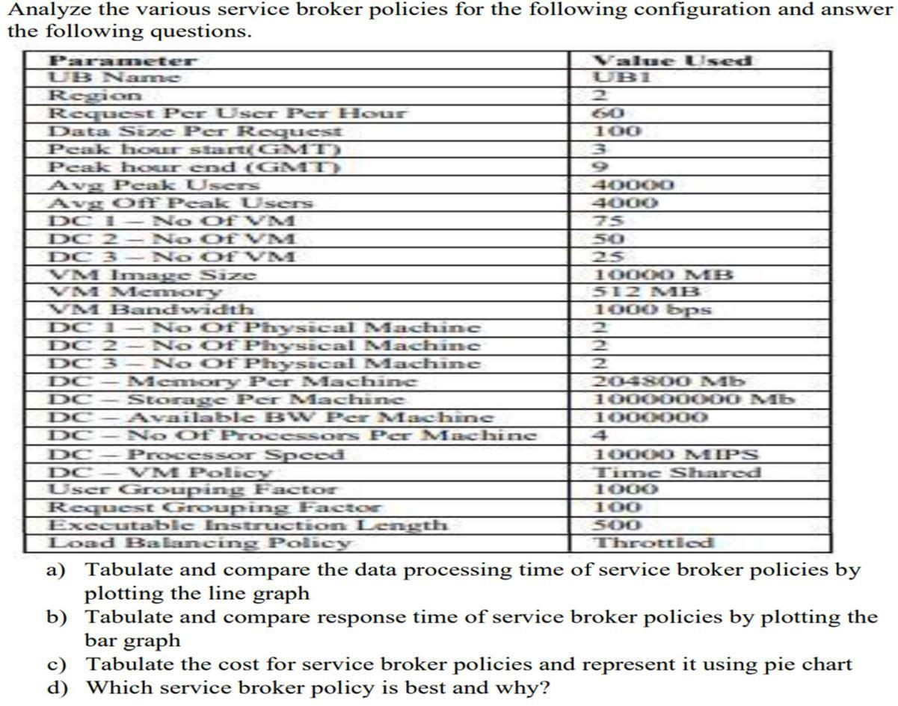

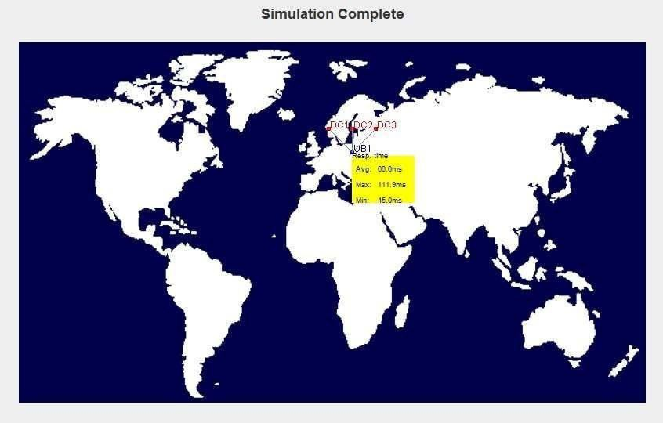

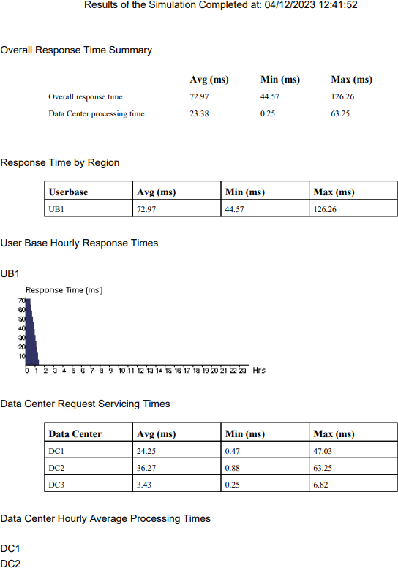

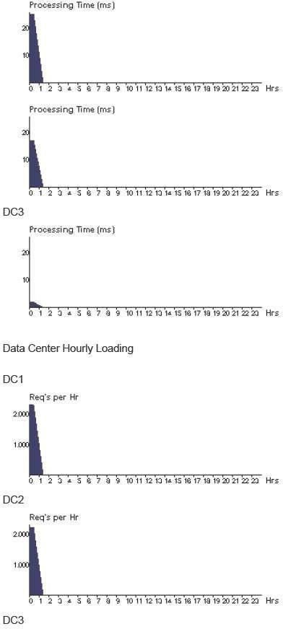

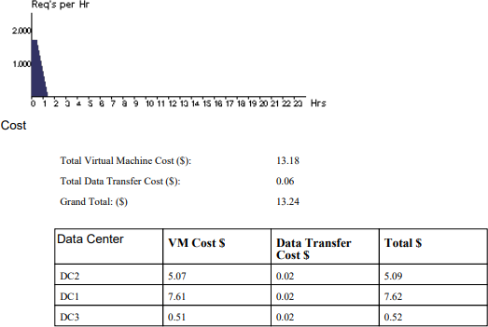

Optimized response time

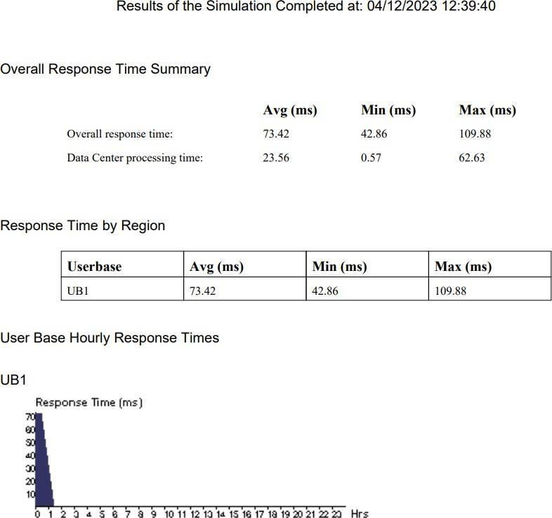

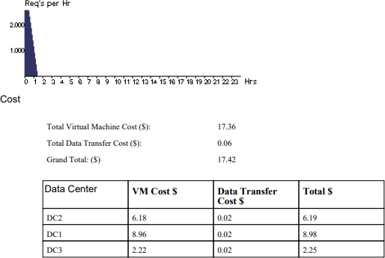

* Tabulate the cost for service broker policies and represent it using pie chart
* The cost for service broker policies is higher for scenario 1.

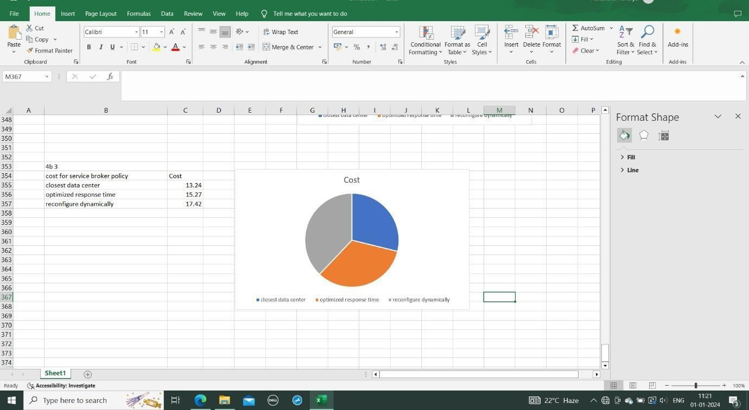

* + Tabulate and compare response time of service broker policies by plotting the bar graph The average response time is highest for scenario 3

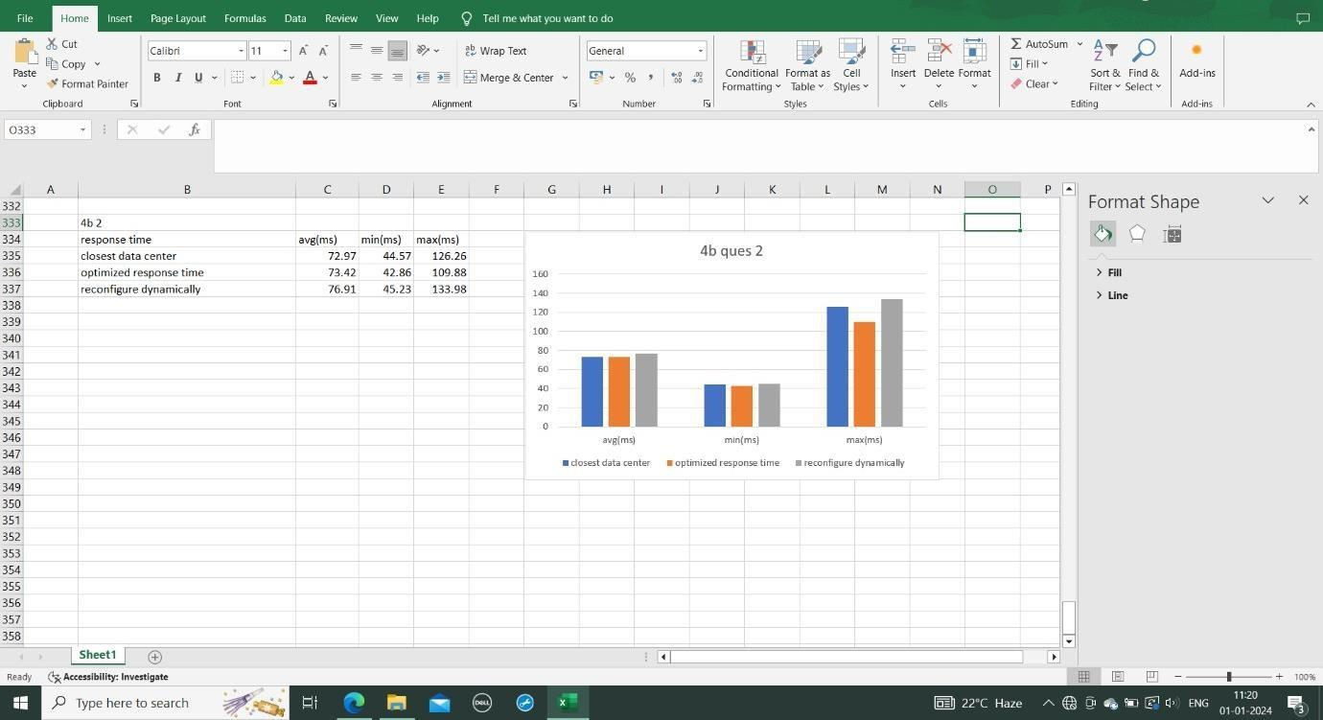

* + Tabulate and compare the data processing time of service broker policies by plotting the line graph The line graph indicates that average data processing time is higher in scenario 1.

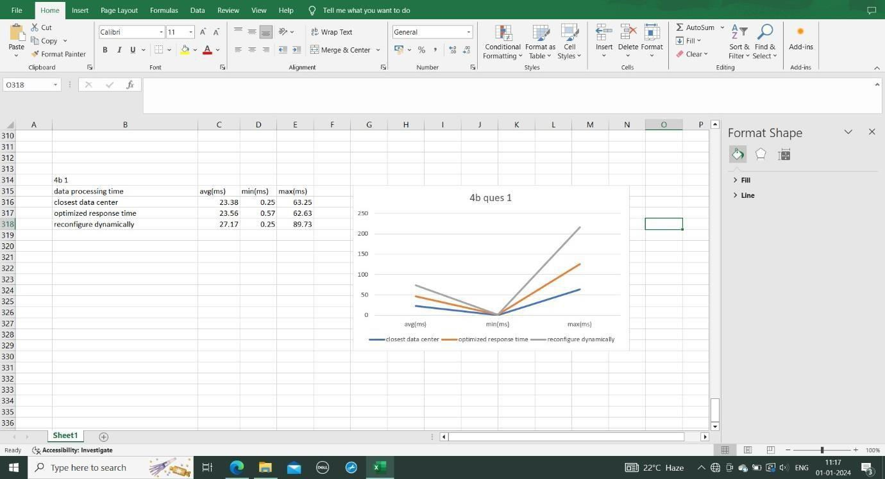

5)

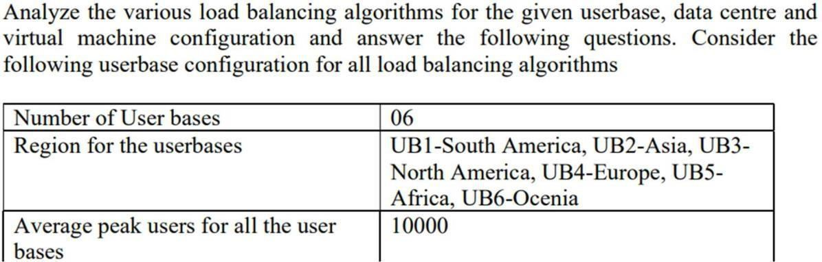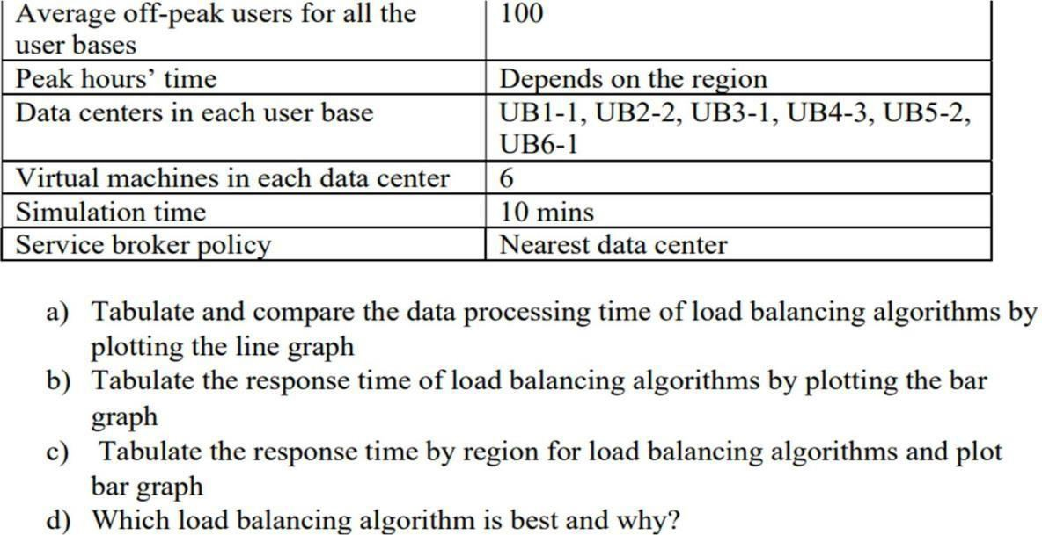

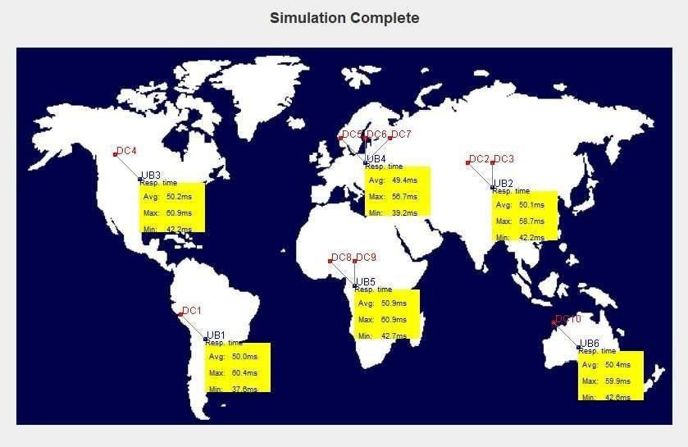

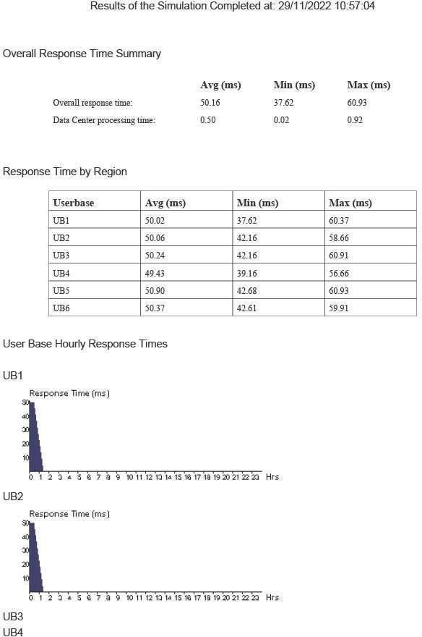

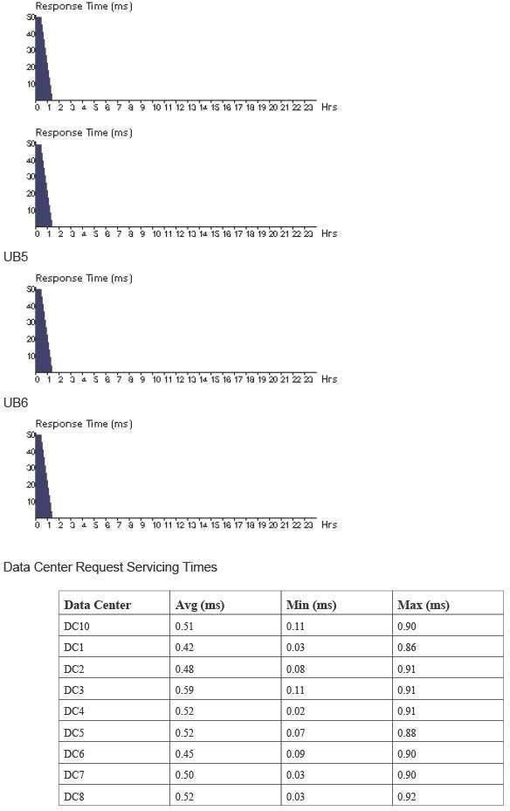

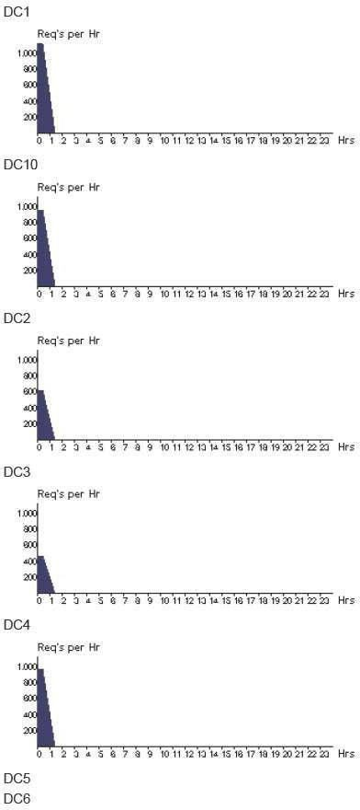

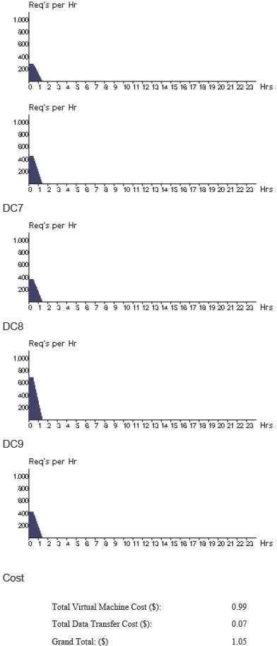

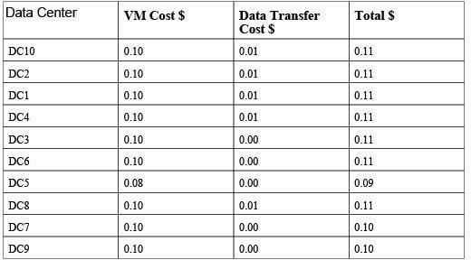

* Tabulate and compare the data processing time of load balancing algorithms by plotting the line graph.
* Data processing time of load balancing algorithm is same in all the scenarios.

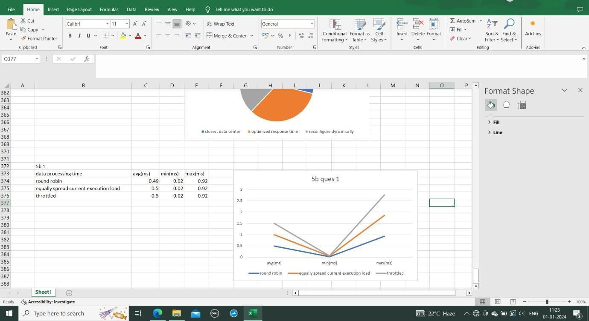

* Tabulate the response time of load balancing algorithms by plotting the bar graph
* Response time of load balancing algorithm is same in all the scenarios.

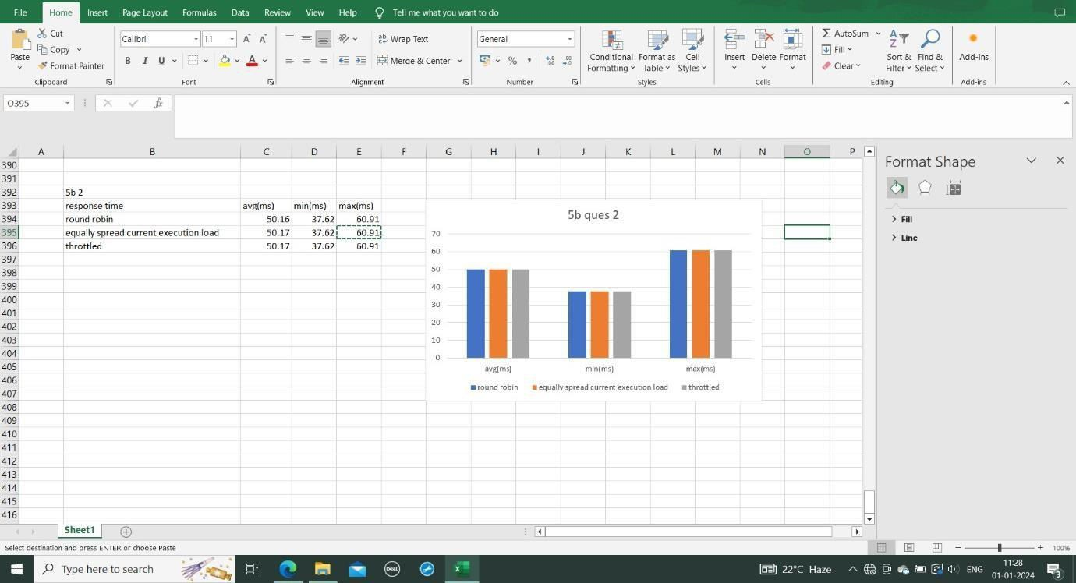

* Tabulate the response time by region for load balancing algorithms and plot bar graph AThe bar graph indicates that average response time is higher for UB1.

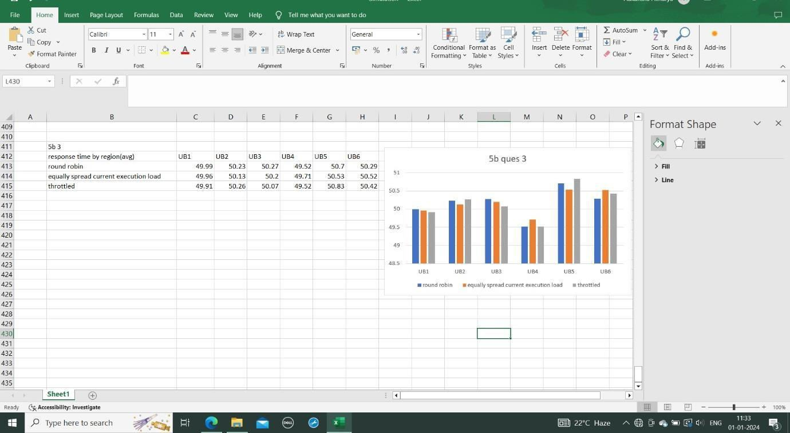

## GOOGLE APP ENGINE

Google App Engine (often referred to as GAE or simply App Engine) is a cloud computing platform as a service for developing and hosting web applications in Google-managed data centers. Applications are sandboxed and run across multiple servers. App Engine offers automatic scaling for web applications—as the number of requests increases for an application, App Engine automatically allocates more resources for the web application to handle the additional demand. The service is free up to a certain level of consumed resources and only in standard environment but not in flexible environment. Fees are charged for additional storage, bandwidth, or instance hours required by the application. It was first released as a preview version in April 2008 and came out of preview in September 2011.

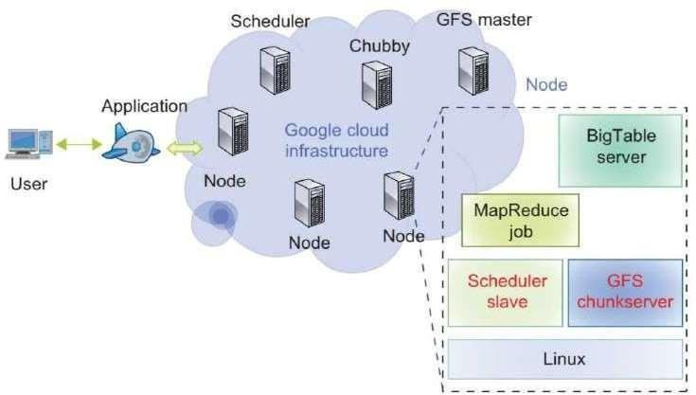

Google App Engine primarily supports Go, PHP, Java, Python, Node.js, .NET, and Ruby applications, although it can also support other languages via "custom runtimes”. Python web frameworks that run on Google App Engine include Django, CherryPy, Pyramid, Flask, web2py and webapp2, as well as a custom Google-written webapp framework and several others designed specifically for the platform that emerged since the release. Any Python framework that supports the WSGI using the CGI adapter can be used to create an application; the framework can be uploaded with the developed application. Third-party libraries written in pure Python may also be uploaded.

Google App Engine supports many Java standards and frameworks. Core to this is the servlet

2.5 technology using the open-source Jetty Web Server, along with accompanying technologies such as JSP. Java Server Faces operates with some workarounds. A newer release of App Engine Standard Java in Beta supports Java8, Servlet 3.1 and Jetty9.Though the integrated database, Google Cloud Datastore, may be unfamiliar to programmers, it is accessed and supported with JPA, JDO, and by the simple low-level API. There are several alternative libraries and frameworks you can use to model and map the data to the database such as Objectify, Slim3 and Jello framework. The Spring Framework works with GAE. However, the Spring Security module (if used) requires workarounds. Apache Struts 1 is supported, and Struts 2 runs with workarounds. The Django web framework and applications running on it can be used on App Engine with modification. Django-nonrel aims to allow Django to work with non-relational databases and the project includes support for App Engine.

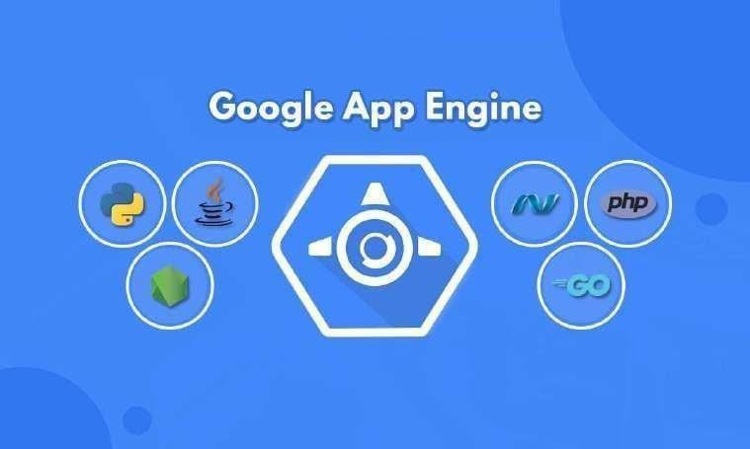

**Reliability** **and** **support**

* All billed App Engine applications have a 99.95% uptime SLA.
* App Engine is designed in such a way that it can sustain multiple datacentre outages without any downtime. This resilience to downtime is shown by the statistic that the High Replication Datastore saw 0% downtime over a period of a year.
* Paid support from Google engineers is offered as part of Premier Accounts

**Bulk** **downloading**

SDK version 1.2.2 adds support for bulk downloads of data using Python. The open-source Python projects gaebar, approcket, and gawsh also allow users to download and back up App Engine data. No method for bulk downloading data from GAE using Java currently exists.

Restrictions

* Developers have read-only access to the filesystem on App Engine. Applications can use only virtual filesystems, like gae-filestore.
* App Engine can only execute code called from an HTTP request (scheduled background tasks allow for self-calling HTTP requests).
* Users may upload arbitrary Python modules, but only if they are pure-Python; C and Pyrex modules are not supported.
* Java applications may only use a subset (The JRE Class White List) of the classes from the JRE standard edition. This restriction does not exist with the App Engine Standard Java8 runtime.
* A process started on the server to answer a request can't last more than 60 seconds (with the 1.4.0 release, this restriction does not apply to background jobs anymore).
* Does not support sticky sessions (a.k.a. session affinity), only replicated sessions are supported including limitation of the amount of data being serialized and time for session serialization.

App Engine provides more infrastructure to make it easy to write scalable applications, but can only run a limited range of applications designed for that infrastructure. App Engine's infrastructure removes many of the system administration and development challenges of building applications to scale to hundreds of requests per second and beyond. Google handles deploying code to a cluster, monitoring, failover, and launching application instances as necessary. While other services let users install and configure nearly any *NIX compatible software, App Engine requires developers to use only its supported languages, APIs, and frameworks. Current APIs allow storing and retrieving data from the document-oriented Google Cloud Datastore database; making HTTP requests; sending e-mail; manipulating images; and caching. Google Cloud SQL can be used for App Engine applications requiring a relational MySQL compatible database backend. Per-day and per-minute quotas restrict bandwidth and CPU use, number of requests served, number of concurrent requests, and calls to the various APIs, and individual requests are terminated if they take more than 60 seconds or return more than 32MB of data.

Google App Engine's integrated Google Cloud Datastore database has a SQL-like syntax called "GQL" (Google Query Language). GQL does not support the Join statement. Instead, one-to- many and many-to-many relationships can be accomplished using ReferenceProperty (). Google Firestore is the successor to Google Cloud Datastore and replaces GQL with a document-based query method that treats stored objects as collections of documents.

Google App Engine Features:

* Blob store for serving large data objects;
* GAE Cloud Storage for storing data objects;
* Page Speed Service for automatically speeding up webpage load times;
* URL Fetch Service to issue HTTP requests and receive responses for efficiency and scaling; and
* Memcache for a fully managed in-memory data store.

**Benefits** **of** **GAE**

* Ease of setup and use. GAE is fully managed, so users can write code without considering IT operations and back-end infrastructure. The built-in APIs enable users to build different types of applications. Access to application logs also facilitates debugging and monitoring in production.
* Pay-per-use pricing. GAE's billing scheme only charges users daily for the resources they use. Users can monitor their resource usage and bills on a dashboard.
* Scalability. Google App Engine automatically scales as workloads fluctuate, adding and removing application instances or application resources as needed.
* Security. GAE supports the ability to specify a range of acceptable Internet Protocol (IP) addresses. Users can allow list specific networks and services and blocklist specific IP addresses.

**GAE** **challenges**

* Lack of control. Although a managed infrastructure has advantages, if a problem occurs in the back-end infrastructure, the user is dependent on Google to fix it.
* Performance limits. CPU-intensive operations are slow and expensive to perform using GAE. This is because one physical server may be serving several separate, unrelated app engine users at once who need to share the CPU.
* Limited access. Developers have limited, read-only access to the GAE filesystem.
* Java limits. Java apps cannot create new threads and can only use a subset of the Java runtime environment standard edition classes.

Install Google App Engine. Create hello world app and other simple web applications using python/java

**Step** **1**: Create an account on Google App Engine.

**Step** **2**: Log in to your Google App Engine Account.

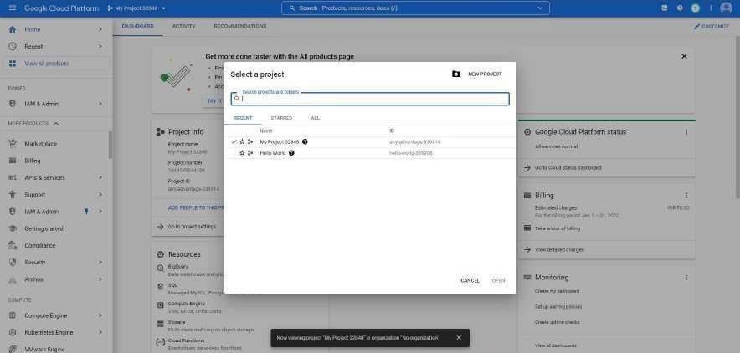

**Step** **3**: Create a New Project and give a Project Name and click on create.

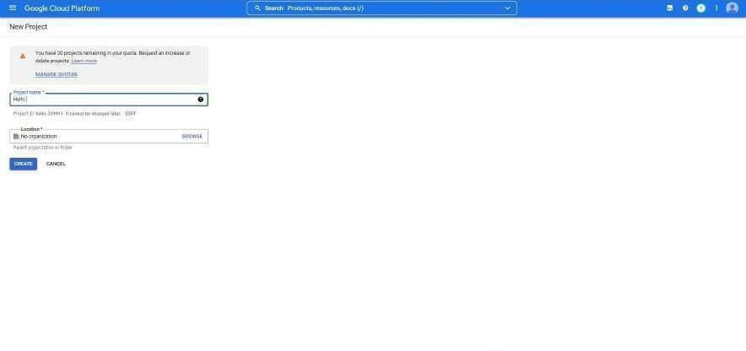

**Step** **4**: Once the project is created click on Activate Cloud Shell on the top right corner.

**Step** **5**: Once the cloud shell gets activated type the following command in the terminal and

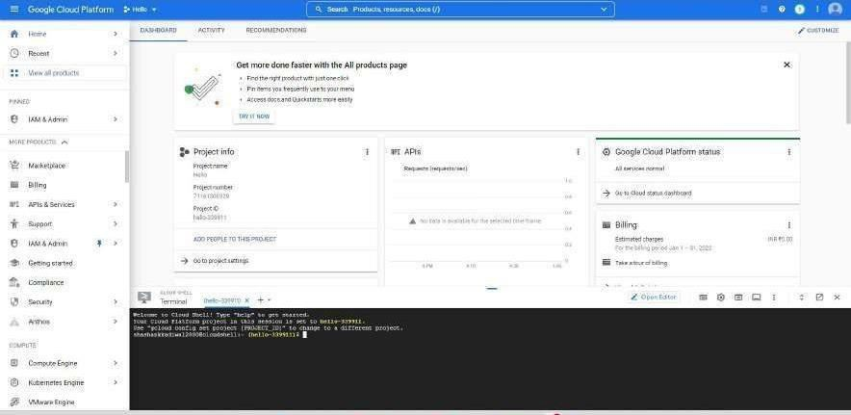

choose the region as South Asia

gcloud app create Click on Open Editor.

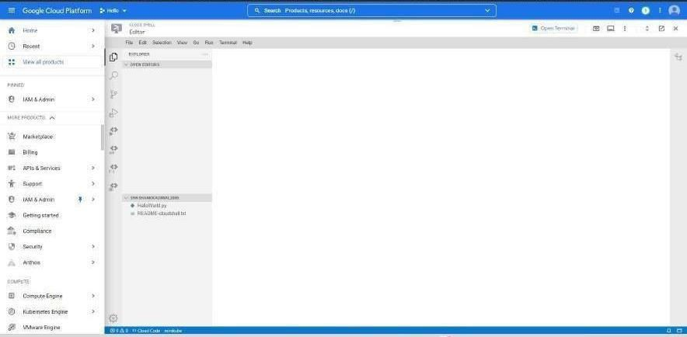

**Step** **6**: Click on File and New File.

**Step** **7**: Name the File as main.py and type the following code: ***from*** ***flask*** ***import*** ***Flask*** ***app*** ***=*** ***Flask(*** ***name*** ***)*** ***@app.route('/')*** ***def*** ***index():***

return 'Hello World' app.run(host='127.0.0.1', port=80)

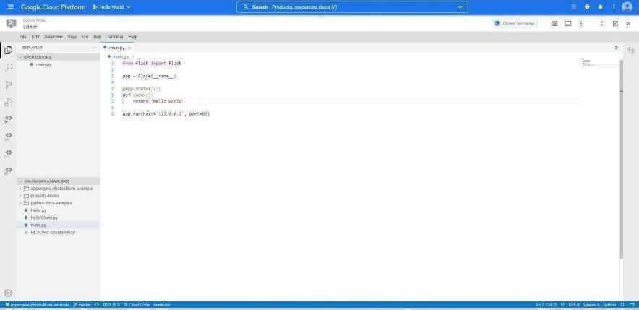

**Step8**: Create a **app.yaml** file

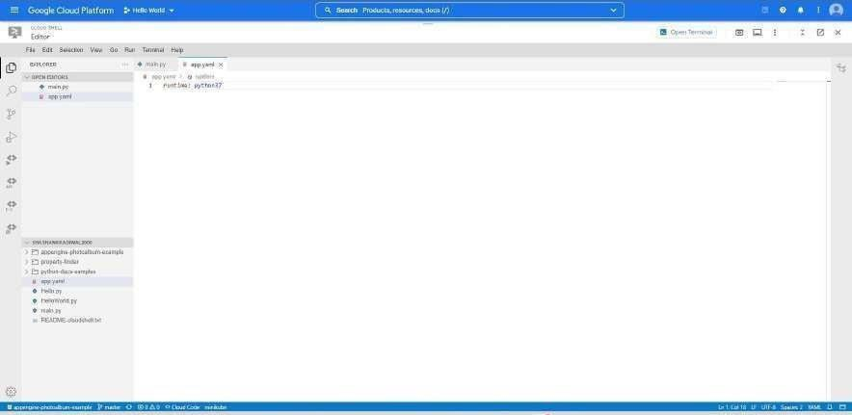

**Step** **9**: Go to terminal and type the following command

python main.py

**Note**: If Flask is not installed, please use the following command

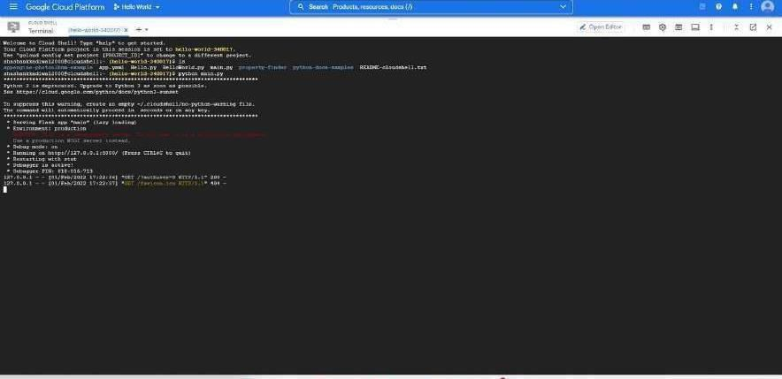

pip install flask

**Step** **10**: Open the https link

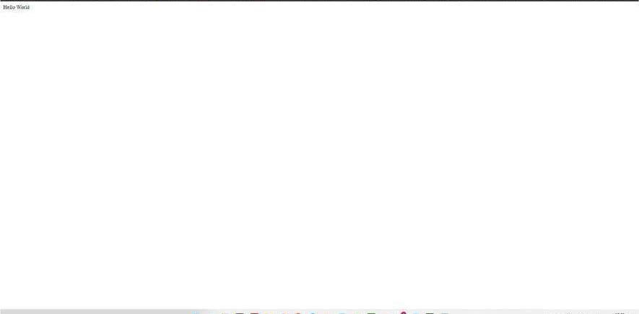

## AMAZON WEB SERVICES

Amazon Web Services, Inc. (AWS) is a subsidiary of Amazon providing on- demand cloud computing platforms and APIs to individuals, companies, and governments, on a metered pay- as-you-go basis. These cloud computing web services provide a variety of basic abstract technical infrastructure and distributed computing building blocks and tools. One of these services is Amazon Elastic Compute Cloud (EC2), which allows users to have at their disposal a virtual cluster of computers, available all the time, through the Internet. AWS's virtual computers emulate most of the attributes of a real computer, including hardware central processing units (CPUs) and graphics processing units (GPUs) for processing; local/RAM memory; hard-disk/SSD storage; a choice of operating systems; networking; and pre-loaded application software such as web servers, databases, and customer relationship management (CRM).

The AWS technology is implemented at server farms throughout the world, and maintained by the Amazon subsidiary. Fees are based on a combination of usage (known as a "Pay-as-you- go" model), hardware, operating system, software, or networking features chosen by the subscriber required availability, redundancy, security, and service options. Subscribers can pay for a single virtual AWS computer, a dedicated physical computer, or clusters of either. As part of the subscription agreement, Amazon provides security for subscribers' systems. AWS operates from many global geographical regions including 6 in North America.

Amazon markets AWS to subscribers as a way of obtaining large scale computing capacity more quickly and cheaply than building an actual physical server farm. All services are billed based on usage, but each service measures usage in varying ways. As of 2017, AWS owns 33% of all cloud (IaaS, PaaS) while the next two competitors Microsoft Azure and Google Cloud have 18%, and 9% respectively, according to Synergy Group.

As of 2021, AWS comprises over 200 products and services including computing, storage, networking, database, analytics, application services, deployment, management, machine learning, mobile, developer tools, RobOps and tools for the Internet of Things. The most popular include Amazon Elastic Compute Cloud (EC2), Amazon Simple Storage Service (Amazon S3), Amazon Connect, and AWS Lambda (a serverless function enabling serverless ETL e.g., between instances of EC2 & S3).

Most services are not exposed directly to end users, but instead offer functionality through APIs for developers to use in their applications. Amazon Web Services' offerings are accessed over HTTP, using the REST architectural style and SOAP protocol for older APIs and exclusively JSON for newer ones

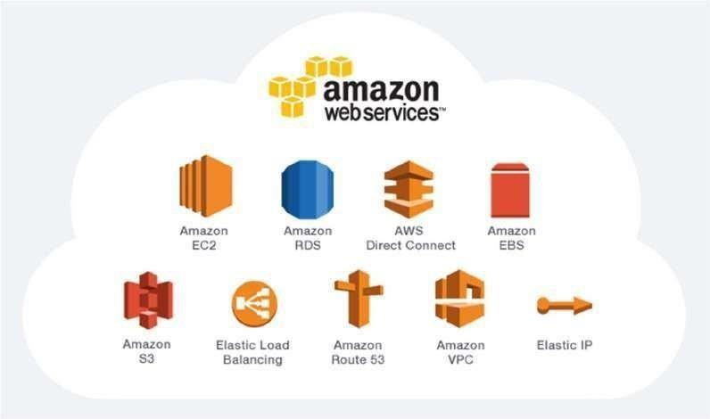

Applications of AWS services

Amazon Web services are widely used for various computing purposes like:

* Web site hosting
* Application hosting/SaaS hosting
* Media Sharing (Image/ Video)
* Mobile and Social Applications
* Content delivery and Media Distribution
* Storage, backup, and disaster recovery
* Development and test environments
* Academic Computing
* Search Engines
* Social Networking

**RELATIONAL** **DATABASES**

Amazon Relational Database Service (Amazon RDS) makes it easy to set up, operate, and scale a relational database in the cloud. It provides cost-efficient and resizable capacity while automating time-consuming administration tasks, such as hardware provisioning, database setup, patching, and backups. It frees you to focus on your applications so you can give them the fast performance, high availability, security, and compatibility they need.

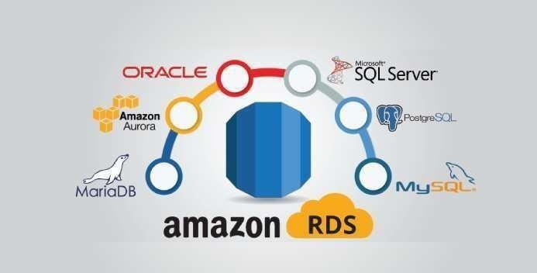Amazon RDS is available on several database instance types - optimized for memory, performance, or I/O - and provides you with six familiar database engines to choose from, including Amazon Aurora, PostgreSQL, MySQL, MariaDB, Oracle Database, and SQL Server. You can use the AWS Database Migration Service to easily migrate or replicate your existing databases to Amazon RDS.

Benefits of Amazon RDS

* Easy to Administer

Amazon RDS makes it easy to go from project conception to deployment. Use the Amazon RDS Management Console, the AWS RDS Command-Line Interface, or simple API calls to access the capabilities of a production-ready relational database in minutes. No need for infrastructure provisioning, and no need for installing and maintaining database software.

* Highly Scalable

You can scale your database's compute and storage resources with only a few mouse clicks or an API call, often with no downtime. Many Amazon RDS engine types allow you to launch one or more Read Replicas to offload read traffic from your primary database instance.

* Available and Durable

Amazon RDS runs on the same highly reliable infrastructure used by other Amazon Web Services. When you provision a Multi-AZ DB Instance, Amazon RDS synchronously replicates the data to a standby instance in a different Availability Zone (AZ). Amazon RDS has many other features that enhance reliability for critical production databases, including automated backups, database snapshots, and automatic host replacement.

* Fast

Amazon RDS supports the most demanding database applications. You can choose between two SSD-backed storage options: one optimized for high- performance OLTP applications, and the other for cost-effective general-purpose use. In addition, Amazon Aurora provides performance on par with commercial databases at 1/10th the cost.

* Secure

Amazon RDS makes it easy to control network access to your database. Amazon RDS also lets you run your database instances in Amazon Virtual Private Cloud (Amazon VPC), which enables you to isolate your database instances and to connect to your existing IT infrastructure through an industry-standard encrypted IPsec VPN. Many Amazon RDS engine types offer encryption at rest and encryption in transit.

* Inexpensive

You pay very low rates and only for the resources you actually consume. In addition, you benefit from the option of On-Demand pricing with no up-front or long-term commitments or even lower hourly rates via our Reserved Instance pricing.

**VPC**

Amazon Virtual Private Cloud (Amazon VPC) enables you to launch AWS resources into a virtual network that you've defined. This virtual network closely resembles a traditional network that you'd operate in your own data centre, with the benefits of using the scalable infrastructure of AWS.Amazon VPC is the networking layer for Amazon EC2.

The following are the key concepts for VPCs:

* Virtual private cloud (VPC) — A virtual network dedicated to your AWS account.
* Subnet — A range of IP addresses in your VPC.
* CIDR block —Classless Inter-Domain Routing. An internet protocol address allocation and route aggregation methodology. For more information, see Classless Inter-Domain Routing in Wikipedia.
* Route table — A set of rules, called routes, that are used to determine where network traffic is directed.
* DHCP options sets: Configuration information (such as domain name and domain name server) passed to EC2 instances when they are launched into VPC subnets.
* Internet gateway — A gateway that you attach to your VPC to enable communication between resources in your VPC and the internet.
* Egress-only internet gateways: A type of internet gateway that allows an EC2 instance in a subnet to access the internet but prevents resources on the internet from initiating communication with the instance.
* VPC endpoint — Enables you to privately connect your VPC to supported AWS services and VPC endpoint services powered by PrivateLink without requiring an internet gateway, NAT device, VPN connection, or AWS Direct Connect connection. Instances in your VPC do not require public IP addresses to communicate with resources in the service.
* NAT gateway: A managed AWS service that allows EC2 instances in private subnets to connect to the internet, other VPCs, or on-premises networks.
* NAT instance: An EC2 instance in a public subnet that allows instances in private subnets to connect to the internet, other VPCs, or on-premises networks.
* Carrier gateways: For subnets in Wavelength Zones, this type of gateway allows inbound traffic from a telecommunication carrier network in a specific location and outbound traffic to a telecommunication carrier network and the internet.
* Prefix lists: A collection of CIDR blocks that can be used to configure VPC security groups, VPC route tables, and AWS Transit Gateway route tables and can be shared with other AWS accounts using Resource Access Manager (RAM).
* Security groups: Acts as a virtual firewall to control inbound and outbound traffic for an AWS resource, such as an EC2 instance. Each VPC comes with a default security group, and you can create additional security groups. A security group can be used only in the VPC for which it's created.

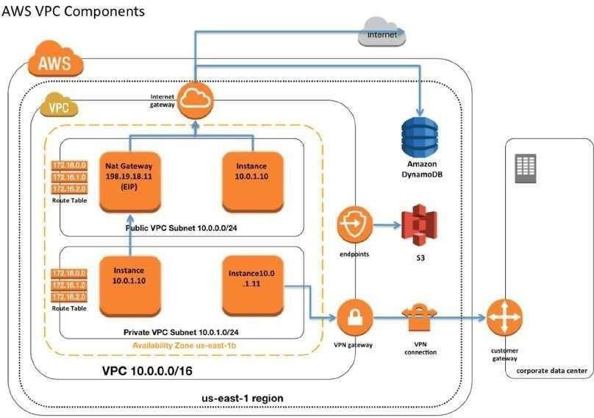

##### Create a RDS and launch in your custom VPC network

**Step** **1**: Open “AWS Management Console”. Click on “VPC” service.

**Step** **2**: Click “Subnets” on the left panel.

**Step** **3**: Now you can see there is one subnet group (Public Subnet) created in your VPC (Your VPC id/11.0.0.0/16). Now Click on “Create Subnet” button

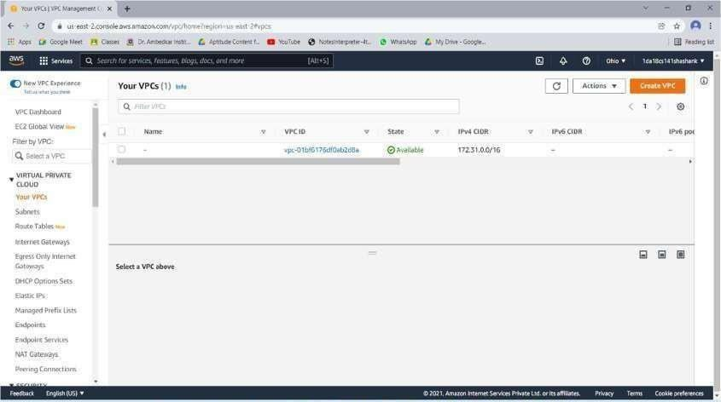

**Step** **4**: Give a Name to the subnet and select you own VPC from the “VPC drop down”. Select an “availability zone” (Which is not used by “Public Subnet” of your VPC). Give CIDR block range. Click on “Yes, Create” button.

**Step** **5**: Now you can see the subnet is created in your VPC.

**Step** **6**: Click on “Services”. Click on “RDS” service.

**Step** **7**: Click on “Subnet Groups” on the left panel. (Note: Before creating the subnet groups you need to note down your VPC ID and subnets for that VPC).

**Step** **8**: Click on “Create DB Subnet Group” button.

**Step** **9**: Give a name to the “Subnet”. Select your own “VPC ID”. Select the “Availability Zone” and “subnet”. Click on “Add” button.

**Step** **10**: Now select another “Availability Zone” and “Subnet”. Click on “Yes, Create” button. (Note: Before clicking on “Yes, create” check that two subnets are added or not)

**Step** **11**: Now you can see that “DB subnet group” is created.

**Step** **12**: Click on “RDS Dashboard” on the left panel. Click on “Get Started” button

**Step** **13**: Select your desired “Database Engine” from the list and click on “Select” button.

**Step** **14**: If you want multi-AZ Deployment, select the “first radio button” otherwise select the

“second radio button”. Click on “Next” button.

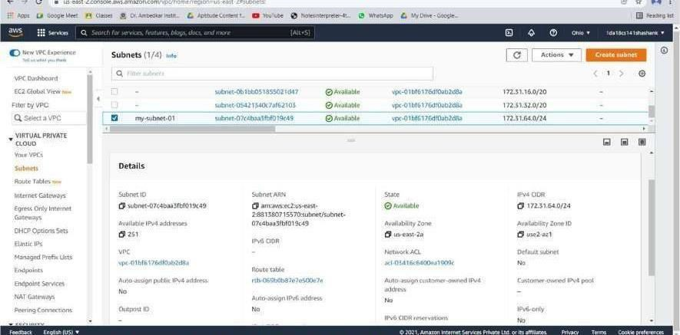

**Step** **15**: Select your desired DB instance from the “DB Instance Class” drop down. Select Multi-AZ option from the drop down. Select the storage type from the drop down and give 95 your desired storage space range. Enter the Details (DB instance Identifier, Master user name, password and confirm password). Click on “Next” button.

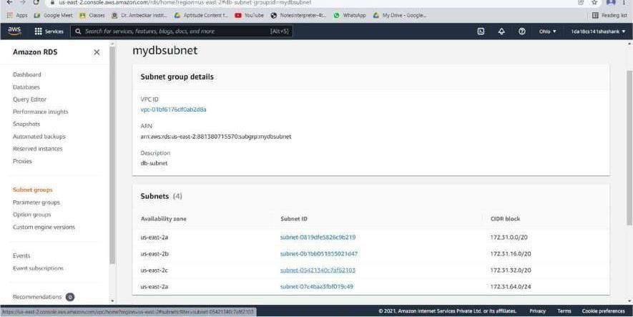

**Step** **16**: Select your own VPC ID from the “VPC Dropdown”. Select the “public accessibility” from the dropdown. Select your desired Availability Zone from the dropdown. Give a name to your Database and check the database port is and mention the “Backup retention period” as per your needs and if you want a Time frame for your backup, configure the time frame from “Backup Window” Dropdown. Click on “Launch DB Instance” button.

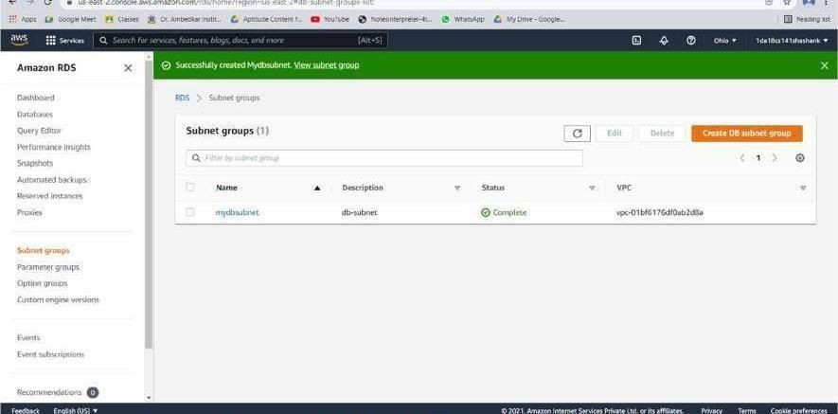

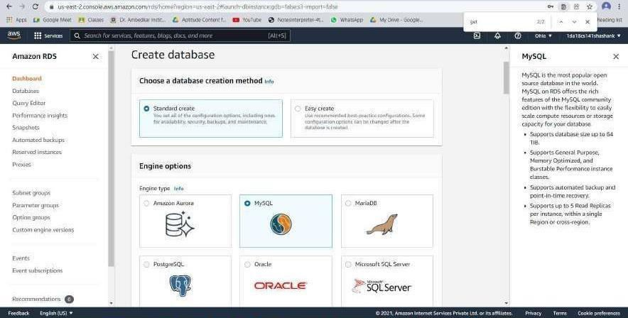

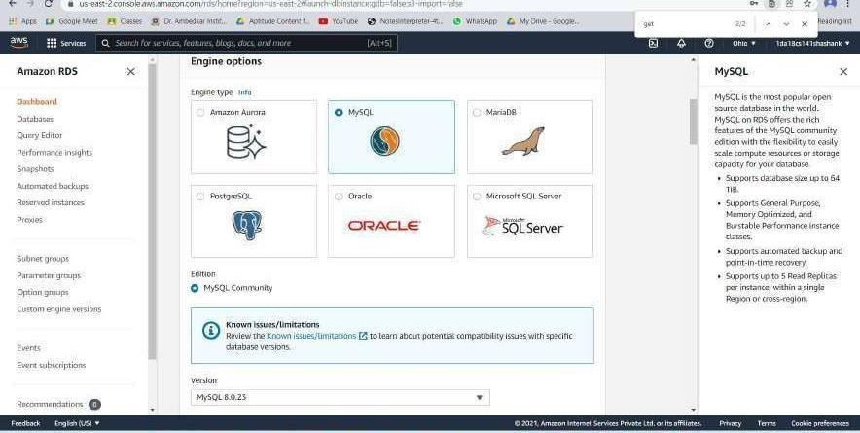

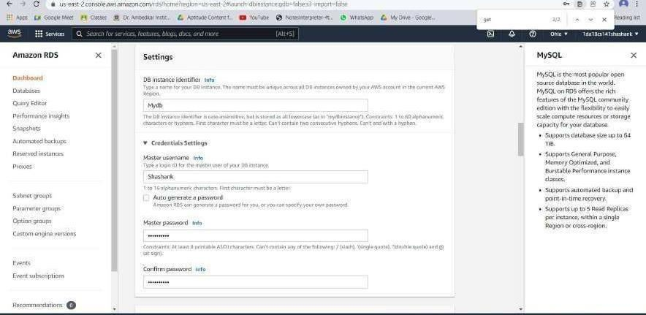

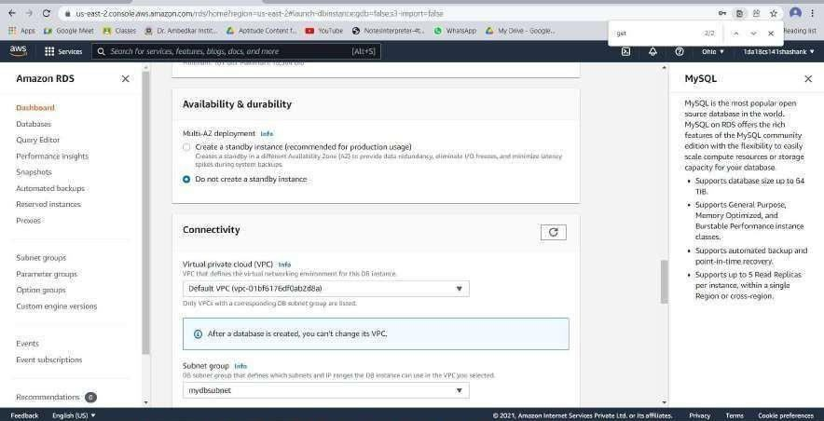

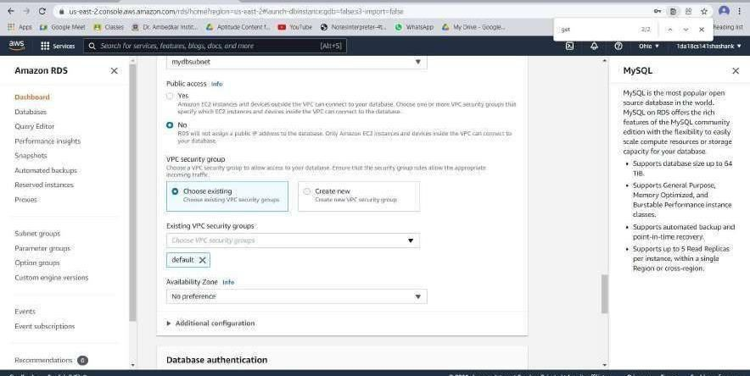

**Step** **17**: Click on “Close” button.

**Step** **18**: Now you can see one DB instance is created. (It will take 5-10min to create the database instance). You will have the DB name, VPC ID, End Point (which is used to connect to the DB Instance from your EC2 instance) and etc…

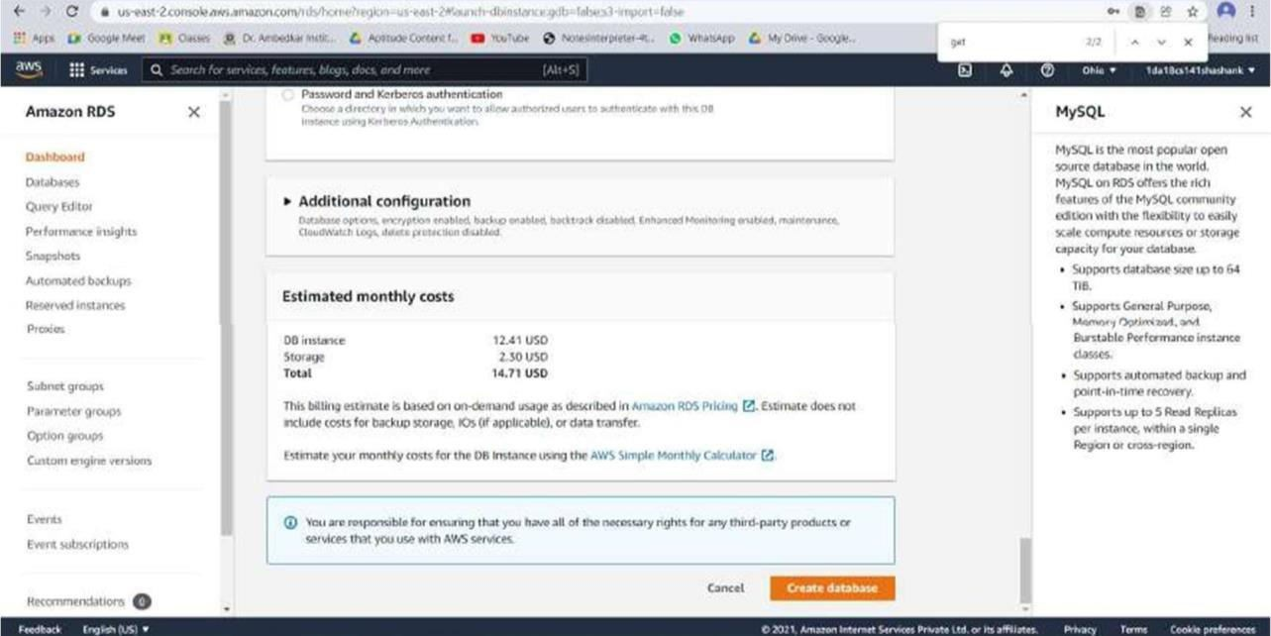

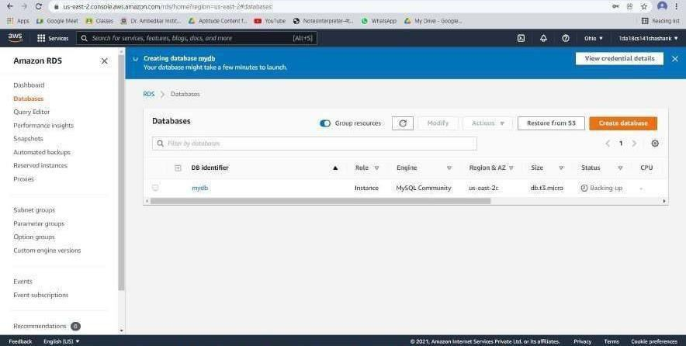

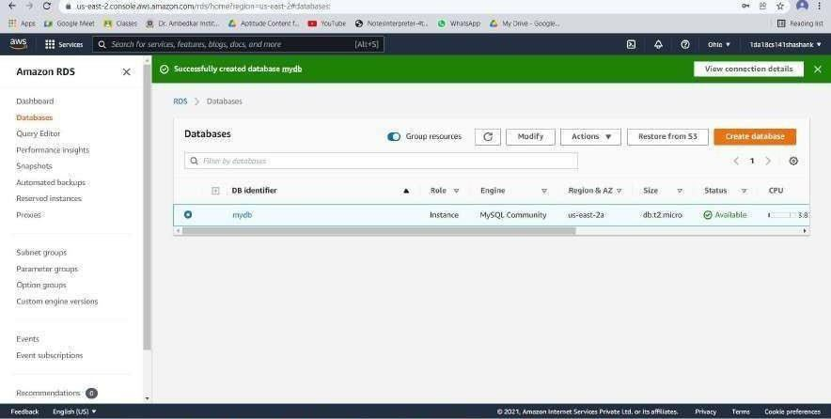

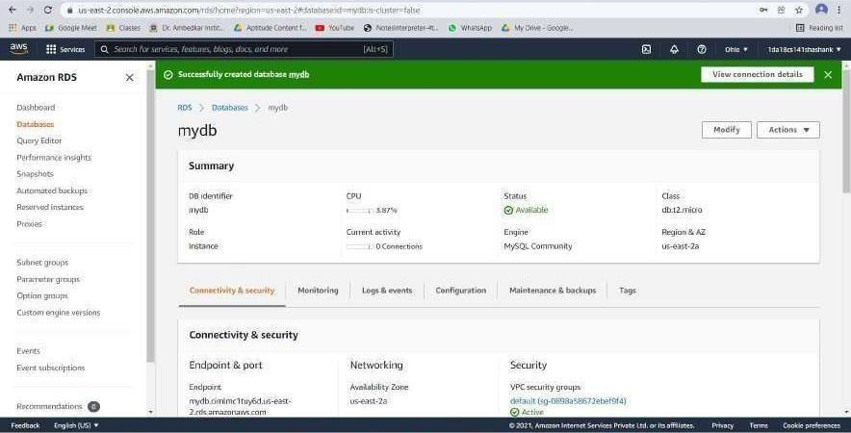

Note: To connect to the Database from your Ec2 Instance, you need the following.

* RDS end point.
* Database Name.
* Master username.
* Master Password.
* Port Number.

## VM WARE, VIRTUAL BOX AND GUEST OS

**Virtual** **Box**

VirtualBox is a powerful x86 and AMD64/Intel64 virtualization product for enterprise as well as home use. Not only is VirtualBox an extremely feature rich, high-performance product for enterprise customers, it is also the only professional solution that is freely available as Open- Source Software under the terms of the GNU General Public License (GPL) version 2. See "About VirtualBox" for an introduction.

Presently, VirtualBox runs on Windows, Linux, Macintosh, and Solaris hosts and supports a large number of guest operating systems including but not limited to Windows (NT 4.0, 2000, XP, Server 2003, Vista, Windows 7, Windows 8, Windows 10), DOS/Windows 3.x, Linux (2.4, 2.6, 3.x and 4.x), Solaris and Open Solaris, OS/2, and OpenBSD.

VirtualBox is being actively developed with frequent releases and has an ever- growing list of features, supported guest operating systems and platforms it runs on. VirtualBox is a community effort backed by a dedicated company: everyone is encouraged to contribute while Oracle ensures the product always meets professional quality criteria.

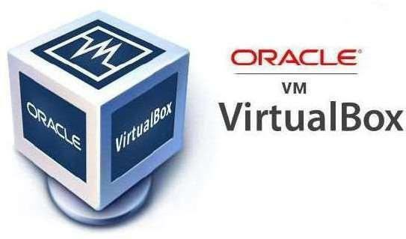

History:

VirtualBox was first offered by Innotek GmbH from Weinstadt, Germany, under a proprietary software license, making one version of the product available at no cost for personal or evaluation use, subject to the VirtualBox Personal Use and Evaluation License (PUEL). In January 2007, based on counsel by LiSoG, Innotek GmbH released VirtualBox Open-Source Edition (OSE) as free and open-source software, subject to the requirements of the GNU General Public License (GPL), version 2. Innotek GmbH also contributed to the development of OS/2 and Linux support in virtualization and OS/2 ports of products from Connectix which were later acquired by Microsoft. Specifically, Innotek developed the "additions" code in both Windows Virtual PC and Microsoft Virtual Server, which enables various host–guest OS interactions like shared clipboards or dynamic viewport resizing.

Sun Microsystems acquired Innotek in February 2008.Following the acquisition of Sun Microsystems by Oracle Corporation in January 2010, the product was re- branded as "Oracle VM VirtualBox”. In December 2019, VirtualBox started supporting only hardware-assisted virtualization, dropping support for Software- based one.

Features:

* Snapshots of the RAM and storage that allow reverting to a prior state.
* Screenshots and screen video capture
* "Host key" for releasing the keyboard and mouse cursor to the host system if captured (coupled) to the guest system, and for keyboard shortcuts to features such as configuration, restarting, and screenshot. By default, it is the right-side CTRL key.
* Mouse pointer integration, meaning automatic coupling and uncoupling of mouse cursor when moved inside and outside the virtual screen, if supported by guest operating system.
* Seamless mode – the ability to run virtualized applications side by side with normal desktop applications
* Shared clipboard
* Shared folders through "guest additions" software
* Special drivers and utilities to facilitate switching between systems
* Ability to specify amount of shared RAM, video memory, and CPU execution cap
* Ability to emulate multiple screens
* Command line interaction (in addition to the GUI)
* Public API (Java, Python, SOAP, XPCOM) to control VM configuration and execution
* Nested paging for AMD-V and Intel VT (only for processors supporting SLAT and with SLAT enabled)
* Limited support for 3D graphics acceleration (including OpenGL up to (but not including) 3.0 and Direct3D 9.0c via Wine's Direct3D to OpenGL translation)
* SMP support (up to 32 virtual CPUs per virtual machine), since version 3.0
* Teleportation (aka Live Migration)
* 2D video output acceleration (not to be mistaken with video decoding acceleration), since version 3.1
* EFI has been supported since version 3.1 (Windows 7 guests are not supported).

VM Ware

VMware, Inc. is an American cloud computing and virtualization technology company with headquarters in California. VMware was the first commercially successful company to virtualize the x86 architecture. VMware’s desktop software runs on Microsoft Windows, Linux, and macOS, while its enterprise software hypervisor for servers, VMware ESXi, is a bare-metal hypervisor that runs directly on server hardware without requiring an additional underlying operating system. VMware's most notable products are its hypervisors. VMware became well known for its first type 2 hypervisor known as GSX. This product has since evolved into two hypervisor product lines: VMware's type 1 hypervisors running directly on hardware and their hosted type 2 hypervisors. VMware software provides a completely virtualized set of hardware to the guest operating system. VMware software virtualizes the hardware for a video adapter, a network adapter, and hard disk adapters. The host provides pass-through drivers for guest USB, serial, and parallel devices. In this way, VMware virtual machines become highly portable between computers, because every host looks nearly identical to the guest. In practice, a system administrator can pause operations on a virtual machine guest, move or copy that guest to another physical computer, and their resume execution exactly at the point of suspension. Alternatively, for enterprise servers, a feature called vMotion allows the migration of operational guest virtual machines between similar but separate hardware hosts sharing the same storage (or, with vMotion Storage, separate storage can be used, too). Each of these transitions is completely transparent to any users on the virtual machine at the time it is being migrated.

VMware's products predate the virtualization extensions to the x86 instruction set, and do not require virtualization-enabled processors. On newer processors, the hypervisor is now designed to take advantage of the extensions. However, unlike many other hypervisors, VMware still supports older processors. In such cases, it uses the CPU to run code directly whenever possible (as, for example, when running user-mode and virtual 8086 mode code on x86). When direct execution cannot operate, such as with kernel-level and real-mode code, VMware products use binary translation (BT) to re-write the code dynamically. The translated code gets stored in spare memory, typically at the end of the address space, which segmentation mechanisms can protect and make invisible. For these reasons, VMware operates dramatically faster than emulators, running at more than 80% of the speed that the virtual guest operating system would run directly on the same hardware. In one study VMware claims a slowdown over native ranging from 0–6 percent for the VMware ESX Server.

Products:

**Desktop** **software**

* VMware Workstation, introduced in 1999, was the first product launched by VMware. This software suite allows users to run multiple instances of x86 or x86-64 -compatible operating systems on a single physical personal computer. Workstation Pro version

15.5.1 was released in Nov 2019

* VMware Fusion provides similar functionality for users of the Intel Mac platform, along with full compatibility with virtual machines created by other VMware products.
* VMware Workstation Player is freeware for non-commercial use, without requiring a license, and available for commercial use with permission. It is similar to VMware Workstation, with reduced functionality.

Server software

* VMware ESXi, an enterprise software product, can deliver greater performance than the freeware VMware Server, due to lower system computational overhead. VMware ESXi, as a "bare-metal" product, runs directly on the server hardware, allowing virtual servers to also use hardware more or less directly. In addition, VMware ESXi integrates into VMware vCenter, which offers extra services.

Cloud management software

* VMware vRealize Suite – a cloud management platform purpose-built for a hybrid cloud.
* VMware Go is a web-based service to guide users of any expertise level through the installation and configuration of VMware vSphere Hypervisor.
* VMware Cloud Foundation – Cloud Foundation provides an easy way to deploy and operate a private cloud on an integrated SDDC system.
* VMware Horizon View is a virtual desktop infrastructure (VDI) product.

Application management

* The VMware Workspace Portal was a self-service app store for workspace management.

Storage and availability

VMware's storage and availability products are composed of two primary offerings:

* VMware vSAN (previously called VMware Virtual SAN) is software-defined storage that is embedded in VMware's ESXi hypervisor. The vSphere and vSAN software run on industry-standard x86 servers to form a hyper- converged infrastructure (or HCI). However, network operators need to have servers from HCL (Hardware Compatibility List) to put one into production. The first release, version 5.5, was released in March 2014. The 6th generation, version 6.6, was released in April 2017.New features available in VMware vSAN 6.6 include native data at rest encryption, local protection for stretched clusters, analytics, and optimized solid-state drive performance. The VMWare 6.7 version was released in April 2018, Users now have improved monitoring tools and new workflows, it is closer to feature parity. The vCenter Server Appliance architecture is moving around to an easy deployment method.
* VMware Site Recovery Manager (SRM) automates the failover and failback of virtual machines to and from a secondary site using policy-based management.

Networking and security products

* VMware NSX is VMware's network virtualization product marketed using the term software-defined data centre (SDDC). The technology included some acquired from the 2012 purchase of Nicira. Software Defined Networking (SDN) allows the same policies that govern Identity and Access Management (IAM) to dictate levels of access to applications and data through a totally converged infrastructure not possible with legacy network and system access methods.

Other products

* Workspace ONE allows mobile users to access apps and data.
* The VIX (Virtual Infrastructure eXtension) API allows automated or scripted management of a computer virtualized using either VMware's vSphere, Workstation, Player, or Fusion products. VIX provides bindings for the programming languages C, Perl, Visual Basic, VBscript and C#.
* Herald is an communications protocol from VMware for more reliable Bluetooth communication and range finding across for mobile devices. Herald code is available under an Open-source license and was implemented in the Australian Government's COVID Safe app for contact tracing on 19 December 2020.

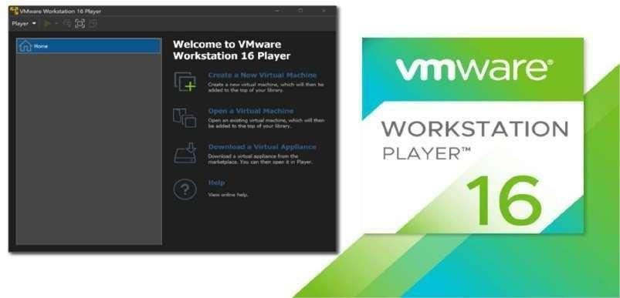

**Guest** **OS**

A guest operating system (guest OS) is an operating system (OS) that is secondary to the OS originally installed on a computer, which is known as the host operating system. The guest OS is either part of a partitioned system or part of a virtual machine (VM) setup. A guest OS provides an alternative OS for a device.

In disk partitioning, a guest OS is simply another instance of the same operating system that can boot up for controlling a certain partitioned memory set. A virtual machine (VM) process is much different, in that a guest OS can be a different OS alternative. In VM setups, a guest OS is delivered through a virtual machine environment through a tool called a hypervisor. Again, the machine will typically have a host OS, where the guest OS will operate "within" the host OS. This can lead to limitations on file saving and other operations within the guest OS, depending on whether the guest OS is said to be "persistent."

Part of the emergence of guest operating systems in VM systems has to do with the benefits provided by virtualization. These revolutions in computing coincide with the more general concept of cloud computing, where resources are delivered, rather than hosted, in physical local hardware setups. In addition, a guest OS often takes advantage of a lean OS build, where memory requirements are further alleviated. VM setups can help with licensing issues, system requirements and more, making these an attractive part of an outsourced computing service.

##### Install VirtualBox/VMware Workstation with different flavors of Linux and execute some C/C++ programs

**Step** **1**: To download and install the VMware product visit the official website of VMware. https://[www.vmware.com/in/products/workstation-](http://www.vmware.com/in/products/workstation-) pro/workstationproevaluation.html

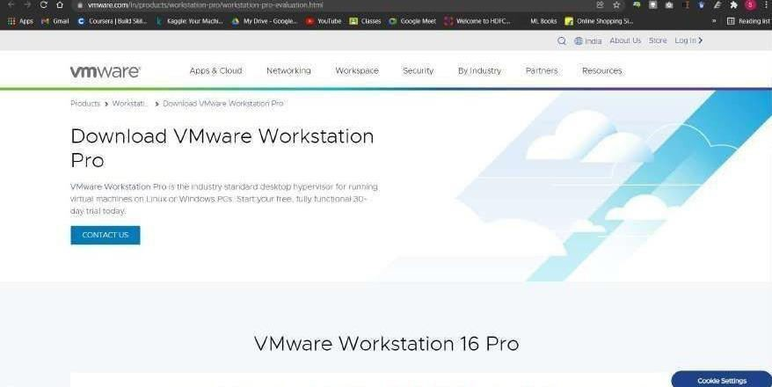

**Step** **2**: Click on Download VM WorkStation for Windows.

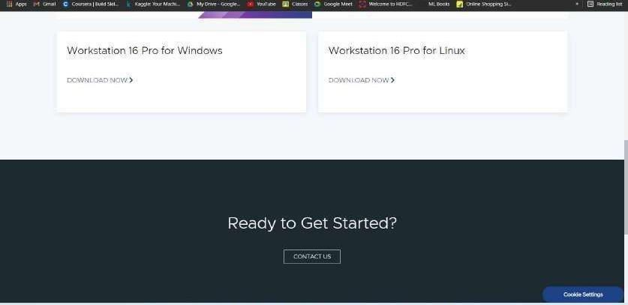

The installation file gets downloaded in the specified location and is now ready for installation.

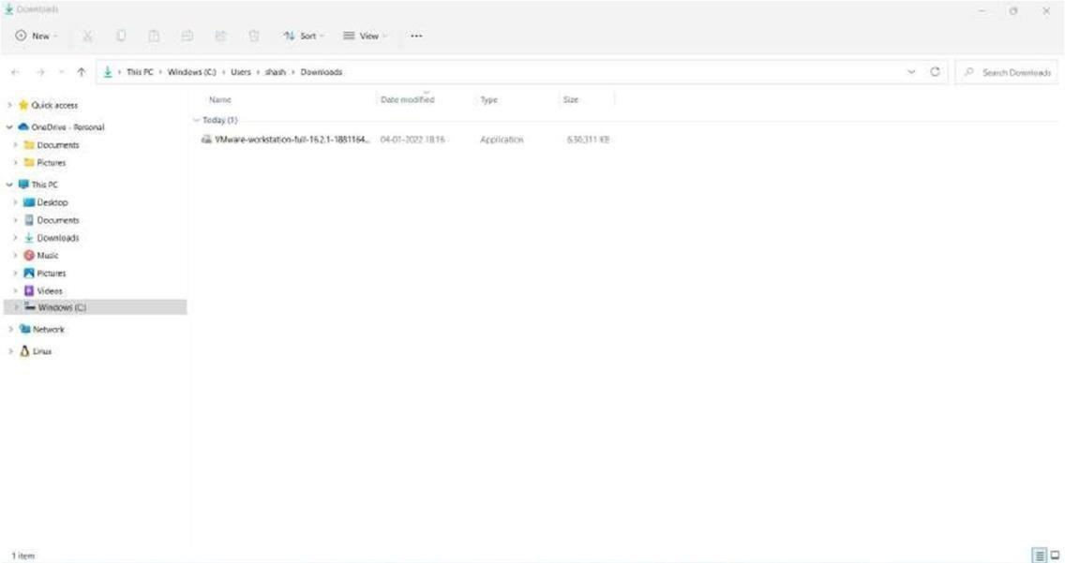

**Step** **3**: Click on the download file to install the VMWare Workstation 16 Pro. Popup will appear

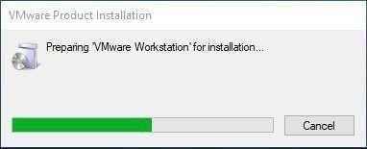

**Step** **4**: Once the initialization gets completed, Click Next

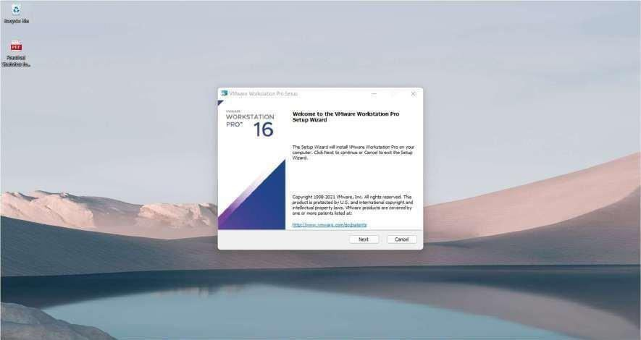

**Step** **6**: On the next screen, some checkboxes are populated, Check them as per your requirement. Click on Next.

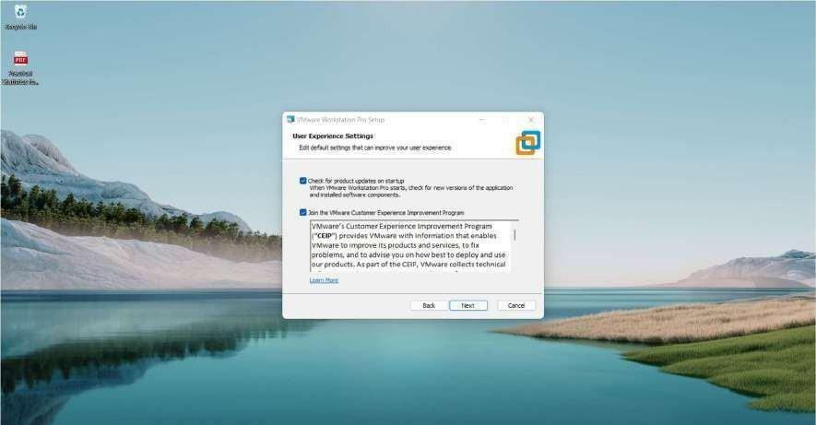

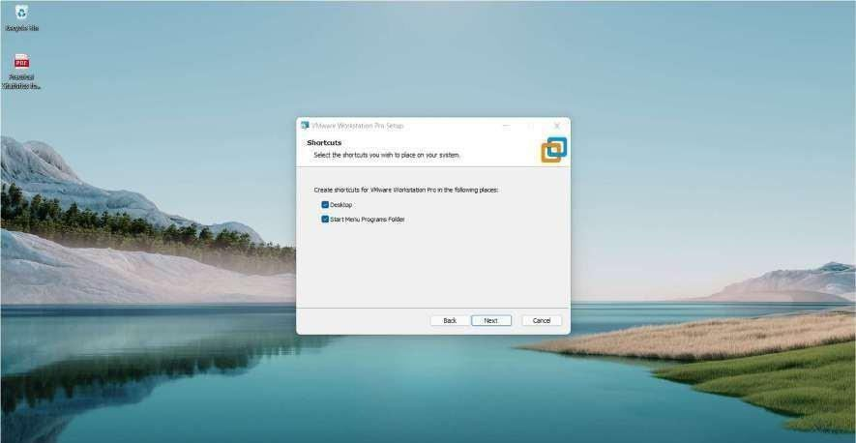

**Step** **7**: At this step, VMware Workstation is ready to install. Click on Install.

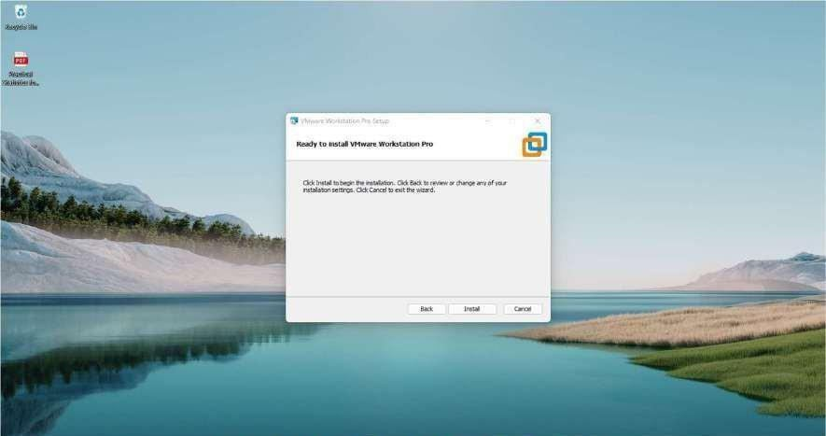

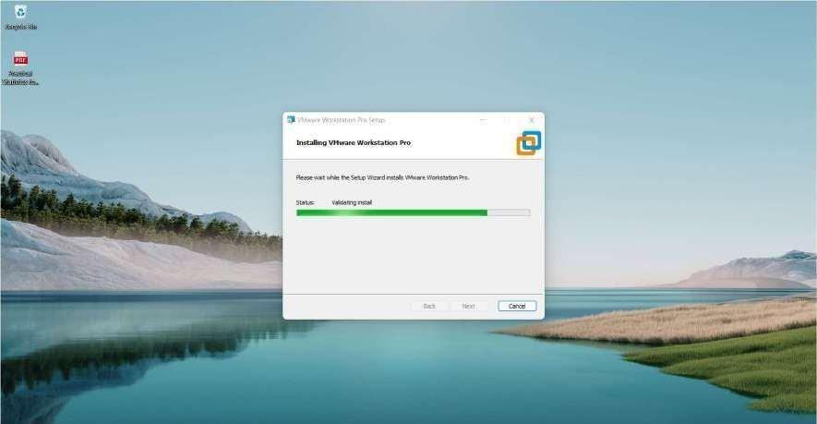

**Step** **8**: Once the installation gets completed you will see the following dialogue box. Click on Finish. If you have purchased the product and have a license key, then you can click on License to enter the key.

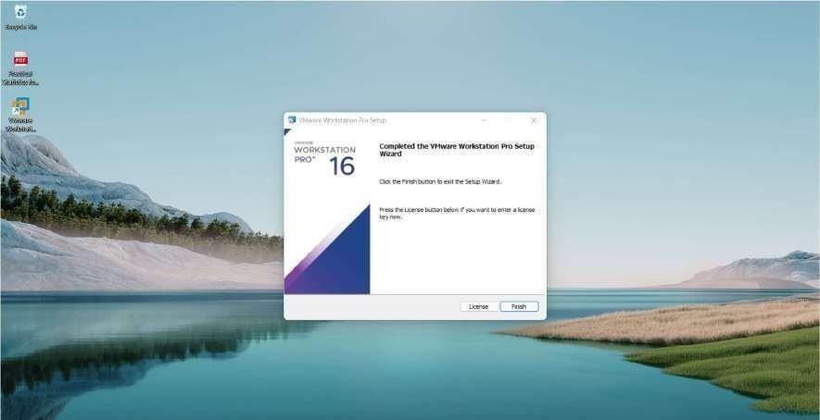

**Step** **9**: Upon Finish, the window will close, and You can see VMware Workstation installed icon on your Desktop. Double Click on the Icon to open the application.

**Step** **10**: For the first time opening, if you have not entered the License key in the previous steps, then it will ask for a license key.

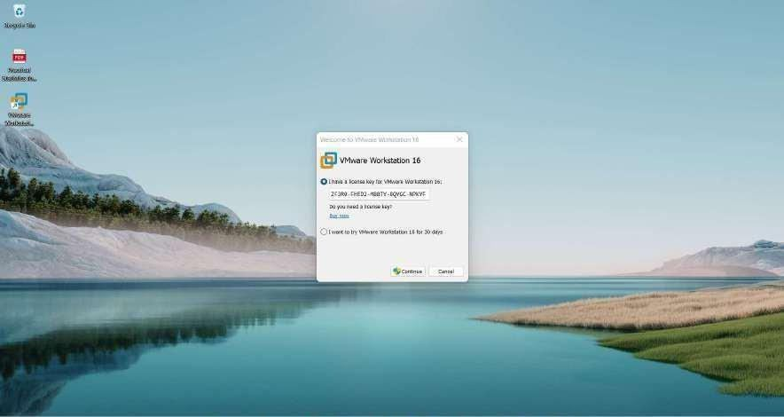

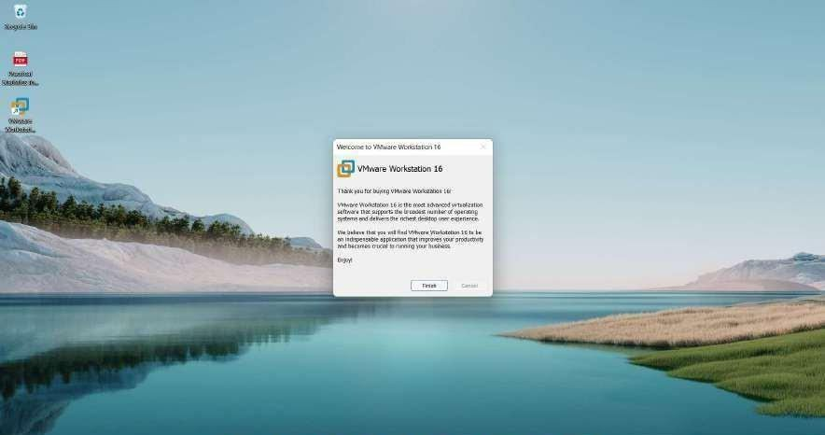

Finally, this will open a window of VMware Workstation Pro.

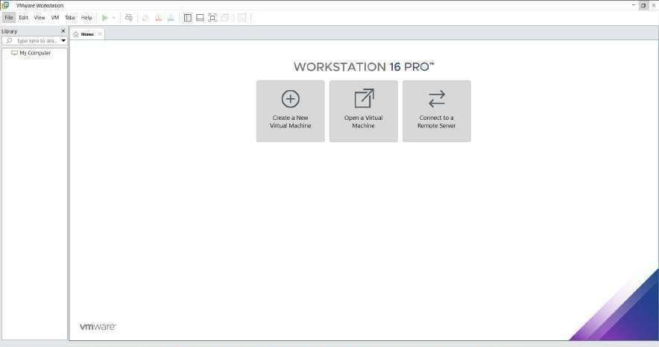

**Step** **11**: Click on File New Virtual Machine. A New Virtual Machine Wizard will appear. Click on Typical.

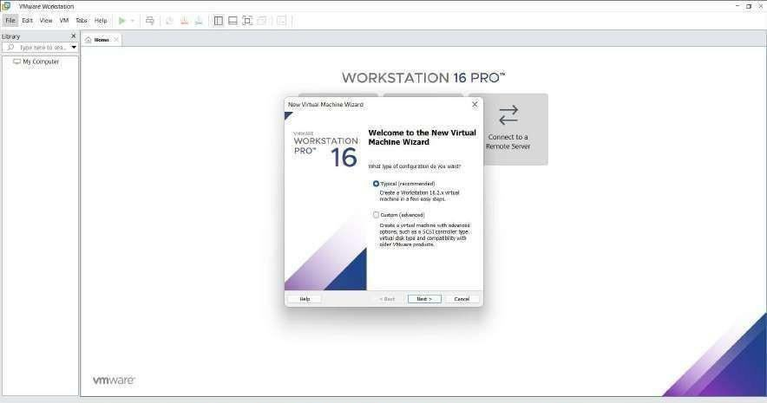

**Step** **12**: Select the ISO File and click on Next

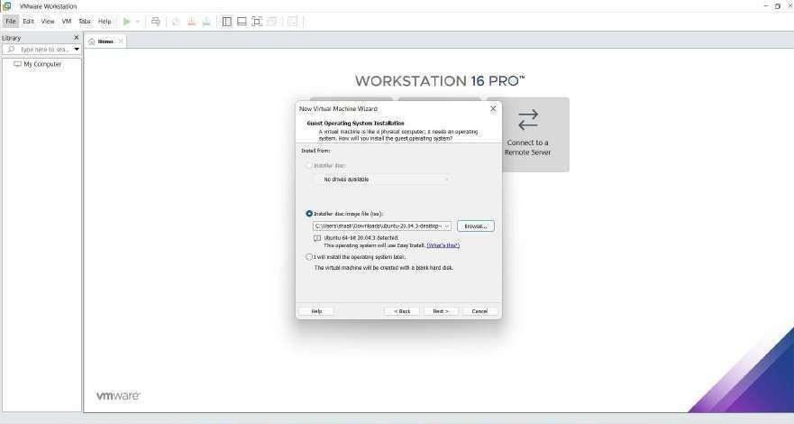

**Step** **13**: Fill in the required details such as username, password and click on next.

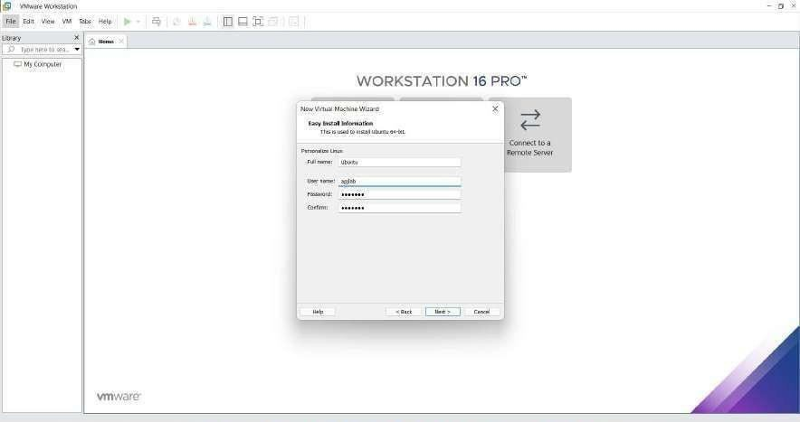

**Step** **14**: Name the virtual machines.

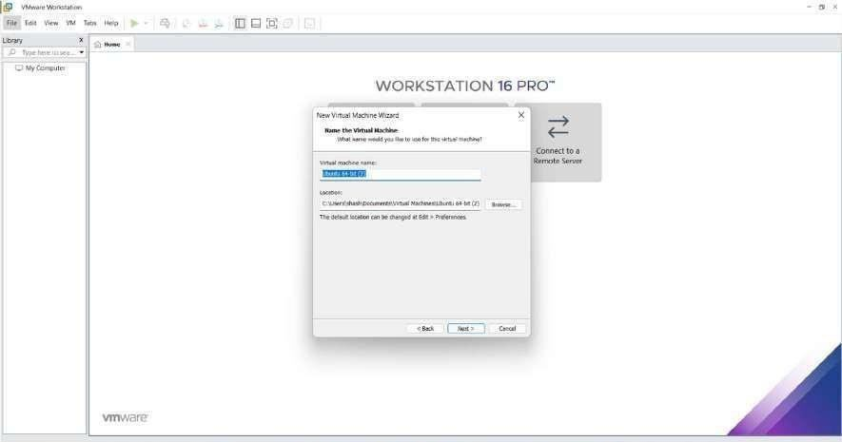

**Step** **15**: Allocate the memory and select Split virtual disk into multiple files and click on next. Click on Customize Hardware.

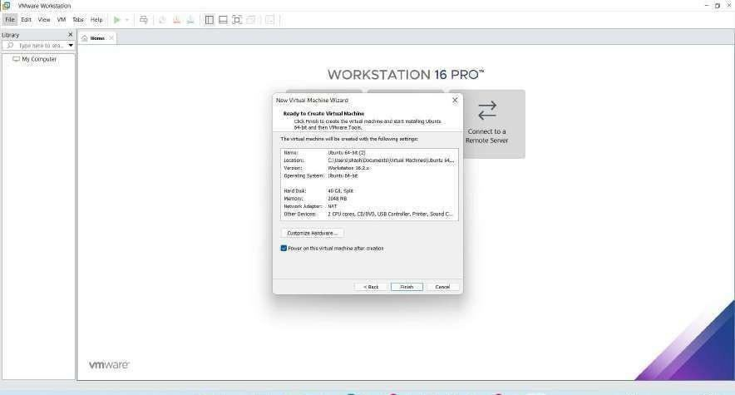

Set the memory size to 4GB

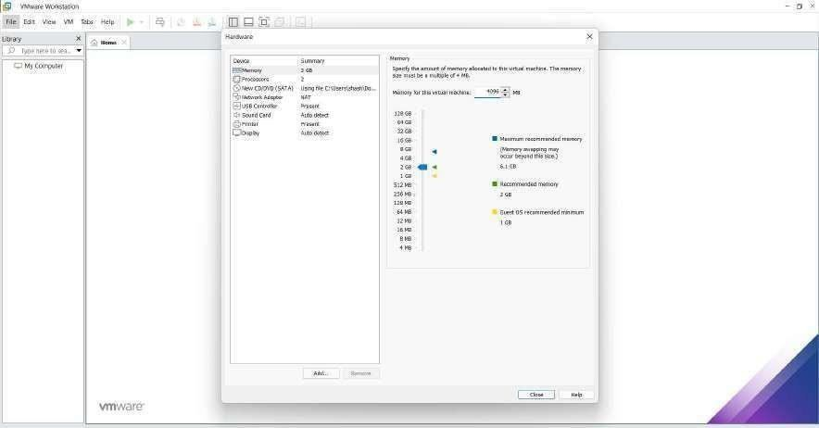

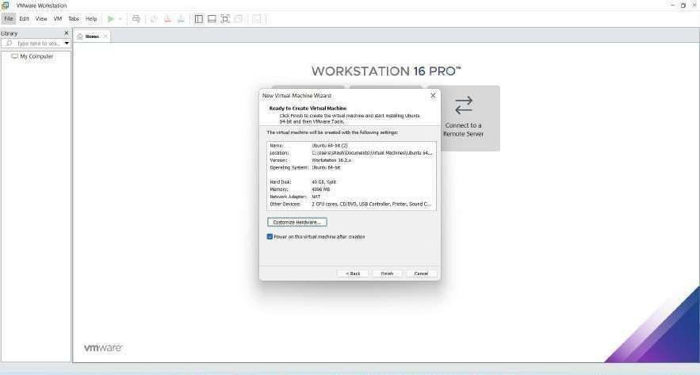

**Step** **16**: Click on Finish. You can see that Ubuntu gets installed in the VM Ware Workstation.

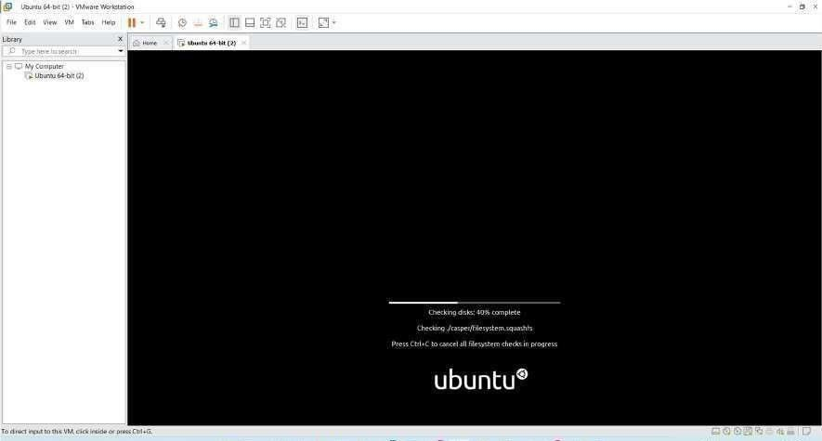

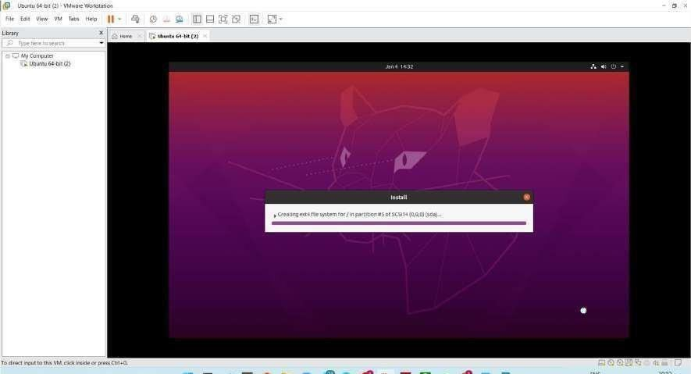

**Step** **17**: Login and Open Terminal and Execute a simple C Program

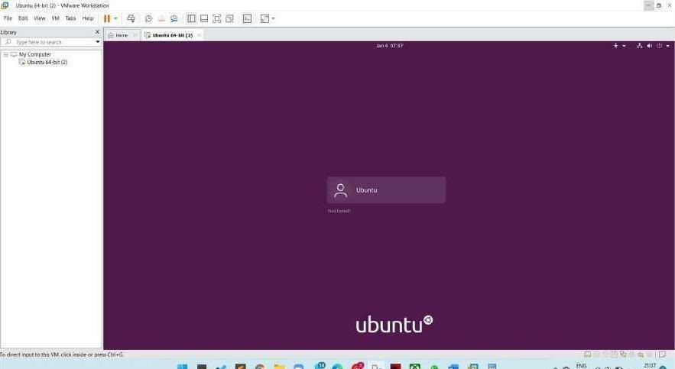

**Step** **18**: Using gedit write a simple C Code. Use the following commands on the terminal:

* To Open the Editor gedit sample.c
* To Compile the code gcc sample.c
* To Get the output ./a.out

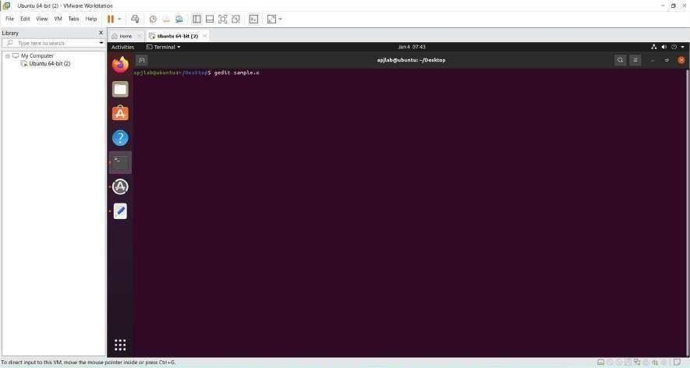

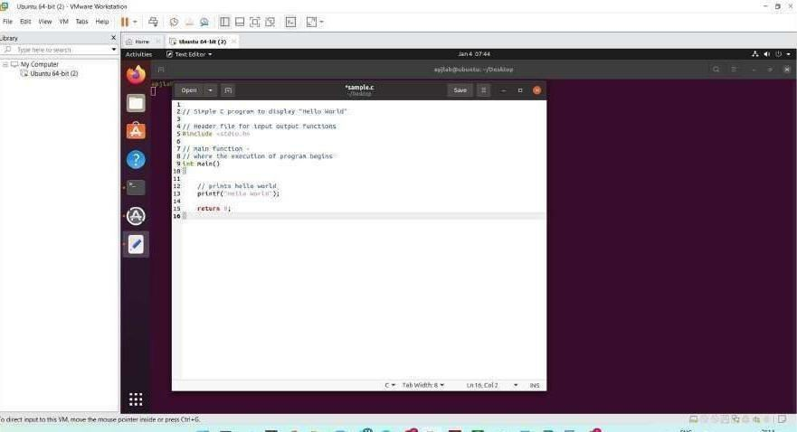

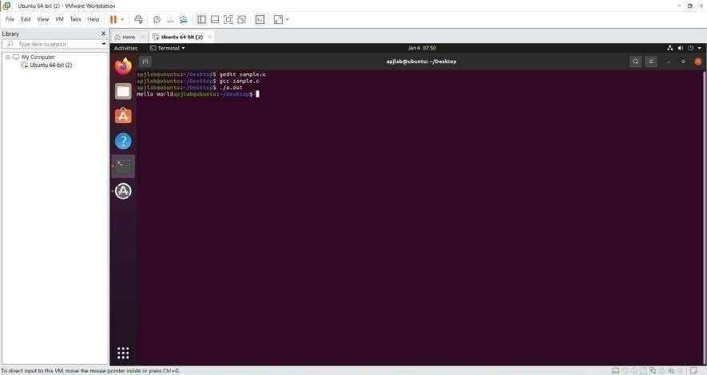

#### VIRTULIZATION AND FILE SHARING

Virtualization

Virtualization is the process of running a virtual instance of a computer system in a layer abstracted from the actual hardware. Most commonly, it refers to running multiple operating systems on a computer system simultaneously. To the applications running on top of the virtualized machine, it can appear as if they are on their own dedicated machine, where the operating system, libraries, and other programs are unique to the guest virtualized system and unconnected to the host operating system which sits below it.

There are many reasons why people utilize virtualization in computing. To desktop users, the most common use is to be able to run applications meant for a different operating system without having to switch computers or reboot into a different system. For administrators of servers, virtualization also offers the ability to run different operating systems, but perhaps, more importantly, it offers a way to segment a large system into many smaller parts, allowing the server to be used more efficiently by a number of different users or applications with different needs. It also allows for isolation, keeping programs running inside of a virtual machine safe from the processes taking place in another virtual machine on the same host.

Working of Virtualization

Software called hypervisors separate the physical resources from the virtual environments— the things that need those resources. Hypervisors can sit on top of an operating system (like on a laptop) or be installed directly onto hardware (like a server), which is how most enterprises virtualize. Hypervisors take your physical resources and divide them up so that virtual environments can use them.

Resources are partitioned as needed from the physical environment to the many virtual environments. Users interact with and run computations within the virtual environment (typically called a guest machine or virtual machine). The virtual machine functions as a single data file. And like any digital file, it can be moved from one computer to another, opened in either one, and be expected to work the same.

When the virtual environment is running and a user or program issues an instruction that requires additional resources from the physical environment, the hypervisor relays the request to the physical system and caches the changes—which all happens at close to native speed (particularly if the request is sent through an open- source hypervisor based on KVM, the Kernel-based Virtual Machine).

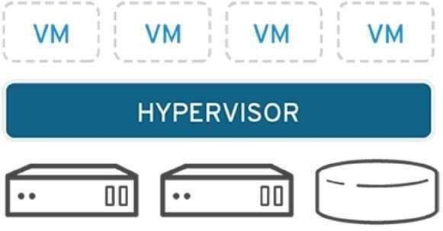

**FILE** **SHARING**

Transferring Files to and from Virtual Machines can be done in the following ways:

1. Creating a Shared Folder in VirtualBox
2. Dragging and Dropping Files in VirtualBox
3. Managing Files with NextCloud

1.Creating a Shared Folder in VirtualBox

A shared folder is a folder that makes its files available on both the guest machine and the host machine at the same time. Creating a shared folder between the guest and the host allows you to easily manage files that should be present on both machines. The course virtual machines are ready to use shared folders right away, but if you are using the virtual machine on your personal computer, then you will need to specify which folder to use as shared storage.

Shared Folders on SCS Lab Computers using Course VMs: If you are using a course VM on a lab computer, it is likely that a shared folder has already been set up for you. On the desktop of your course VM, you should notice a folder titled Shared Folders. Inside this folder, you will find any folders that have been shared between the course VM and lab computers. You should see two folders that have already been configured for you: Z_DRIVE and Temp. Z_DRIVE gives you access to your Windows Account Z:\ drive. This is storage that is persistent to your SCS account and available as a network drive on the lab computers. Temp gives you access to the folder found at D:\temp on the lab computer. Files stored in this folder are local to the machine, meaning that they can be accessed faster but will delete from the system when you log out. If you are working with data that you will need to use again, use the Z_DRIVE for your shared folder. If you need a faster read/write speed, use the Temp folder, but remember to back up your files, or they will be deleted when you log off the computer.

1. Shared Folders on Personal Computers

If you are using your own personal machine, you will need to configure VirtualBox to look in the right place for your shared files. First, click on the guest machine you intend to share files with. From there, you can select the guest Settings and navigate to Shared Folders on the left side menu. To create a new shared folder, either click the New Folder icon on the right menu or right-click the empty list of shared folders and click Add Shared Folder. From here, there are six options:

* + Folder Path: The folder name on the host machine. Click the drop-down menu and navigate to the folder you would like to share.
  + Folder Name: This is the name of the folder as it will appear on the guest machine.
  + Read-Only: If you check read-only, the guest machine will be unable to write changes to the folder. This is valuable when you only want to send files to the virtual machine, but do not want to risk having the files modified by the guest.
  + Auto-Mount: When any external storage is connected to a computer, it must be mounted in order to be used. It is recommended that you turn on auto-mounting unless you are familiar with the process of mounting a drive yourself.
  + Mount Point: Unless you already know about mount points, leave this blank.
  + Make Permanent: If you check this, the shared folder will be a permanent machine folder. If it is not checked, the folder will not be shared after a shutdown.

On the course virtual machines, when you load into the desktop, you should see a folder labelled Shared Folders. In there, you will see any folders that are currently mounted and being shared.

1. Dragging and Dropping Files in VirtualBox

If you only need to transfer a few files quickly, you can simply drag and drop the files in. On the top bar of the running guest machine, click on Devices > Drag and Drop and make sure that Bidirectional is selected. This means that you will be able to drag files from the host to the guest and from the guest to the host. Once bidirectional drag and drop is checked, you should be able to begin dragging and dropping files.

NOTE: Sometimes when dragging files into the course VM, you may not be able to drag them into the file browser directly. If you encounter this issue, you should drag your files onto the Desktop and move the files around from there. You should see the cursor change when it is ready to drop files.

You can also drag files from the guest machine into the host. To do this, simply open the file browser on the host to where you would like to drop the files and drag the files from the virtual machine into the file browser of the host. File transfers should be pretty quick; if the virtual machine seems stuck when transferring, simply cancel the transfer and try again.

Managing Files with NextCloud

On any virtual machine, including VirtualBox, VMWare, or the virtual machines hosted on the SCS OpenStack, you can access the SCS NextCloud services to move files between multiple machines and your SCS Windows Account storage. NextCloud offers you all of your SCS storage in one remote location, similar to how you might use other file hosting services like Dropbox or Google Drive. Before trying to use NextCloud, you should check that you can access the service by logging in here. If you can access the NextCloud services, you can browse the various file storage services available to you:

Linux Home: These are the files from your SCS Linux Account

Windows Home: These are the files from your SCS Windows Account and your lab Z:\ drive.

NextCloud: In addition to the other storage accounts provided to you by the SCS, you can also upload up to 20GB of files directly to NextCloud.

With NextCloud, you can upload your files from any machine with an internet connection and download them onto any other machine with an internet connection. For example, you can move project files off of your virtual machine, onto the NextCloud storage, and then download them on your personal laptop. Alternatively, you can upload files from your personal PC onto the NextCloud storage, place them into the Windows home folder, and access those files from either the lab Z:\ drive or download them on a virtual machine like VirtualBox or OpenStack. **Uploading** **Files** **to** **NextCloud** **from** **a** **Lab** **Computer**

If you would like to upload files from a lab computer, the easiest way to do this is to place the files you would like to transfer into your Z:\ drive. These files will be automatically backup into your NextCloud storage under the Windows home folder. After that, you can move them into the main NextCloud storage or choose to keep them in your Z:\drive.

Uploading Files to NextCloud from a VM or Other PC

If you would like to upload files from either a VM or any other computer, you can log in to the NextCloud service using any of the available interfaces, such as the web interface. Press the “+” icon in the top left of the file browser and select Upload File. From here, you can choose to keep it in the main NextCloud storage, move it into your Windows Account storage (the Windows home folder), or into your Linux Account storage (the Linux Home folder).

Downloading NextCloud Files to a VM or Other PC

Once your files are uploaded, you will be able to download those files onto any machine, which can connect to NextCloud. First, log in to your preferred NextCloud interface (e.g., the web interface). Navigate to the folder which contains the files you would like to download. Once you are in the target folder, click the checkbox next to each file you would like to download. Above the file listing, you should notice the context bar changing to tell you how many files you have selected and a button labelled Actions. Click Actions > Download.

If you selected a single file, it will prompt you to confirm the download. If you have chosen more than one file, NextCloud will place all of the selected files into a zip archive. Before you can use the files, you will need to extract them from the archive. Once you have downloaded your file or extracted your archive, you are ready to use your files on your machine

##### Create a file in one virtual machine and share it on a host machine

**Step** **1**: Install VM Work Station Pro 16 by clicking on the application file.

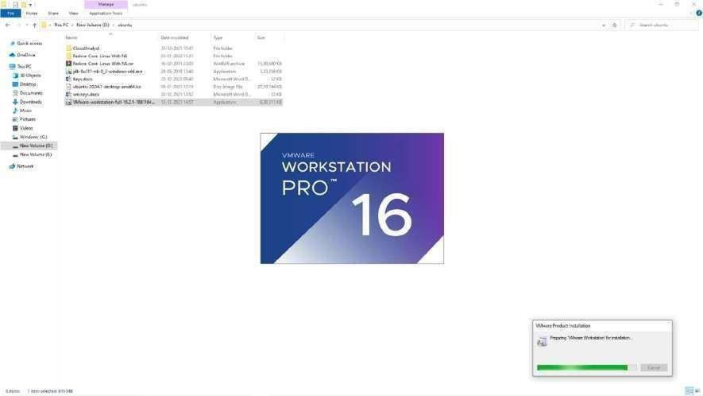

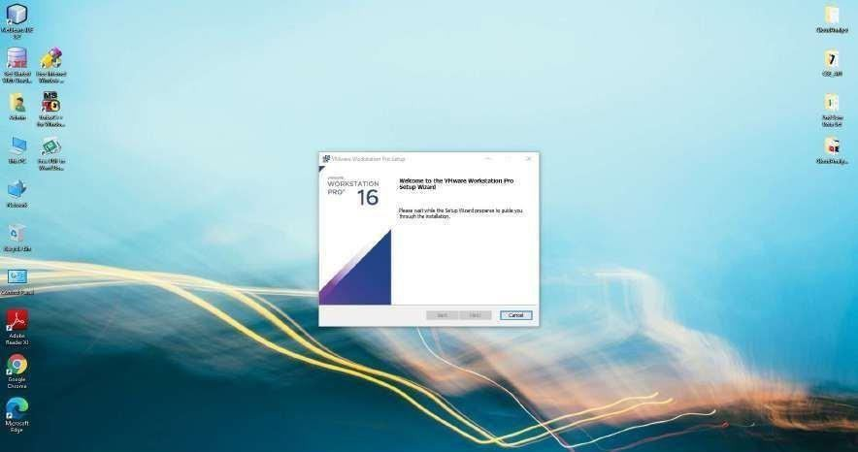

A window appears as shown in the picture. Click on the Next and follow the installation steps.

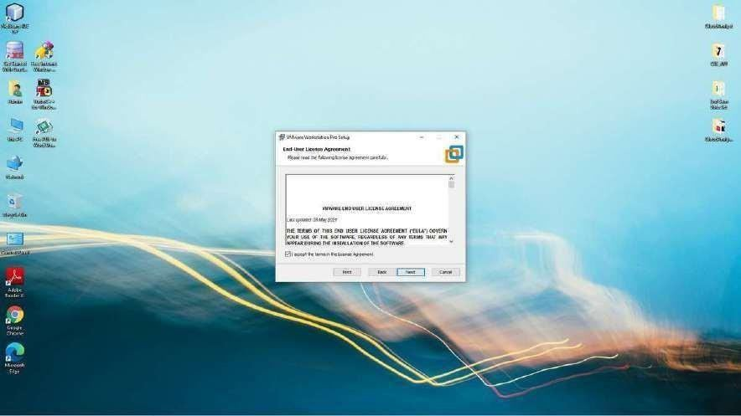

Click on Next.

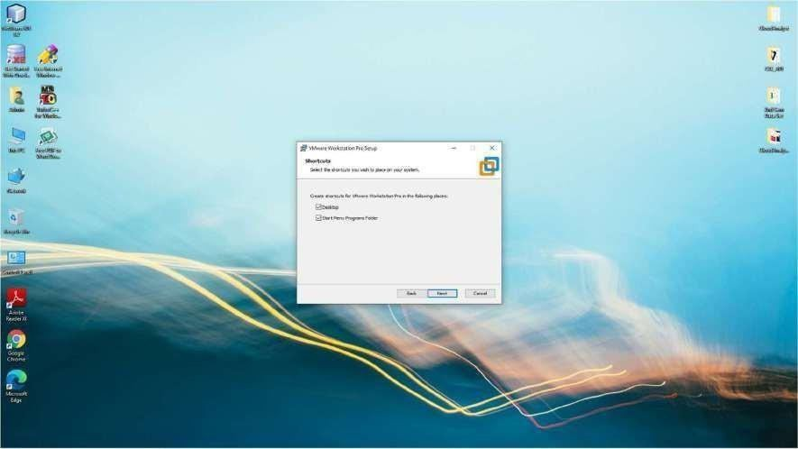

Click on Install

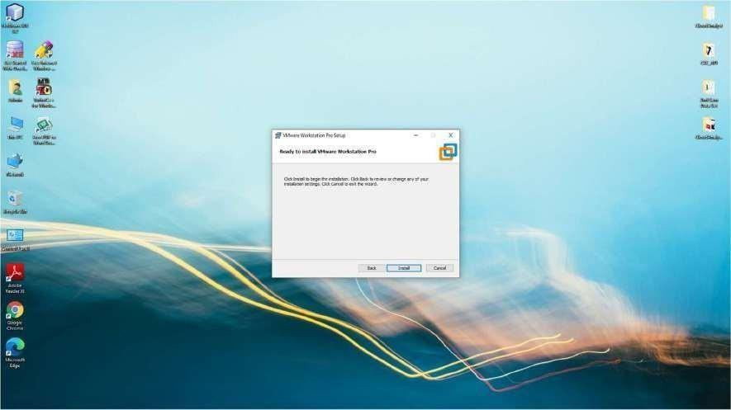

**Step** **2**: Enter the license key received and click on Enter.

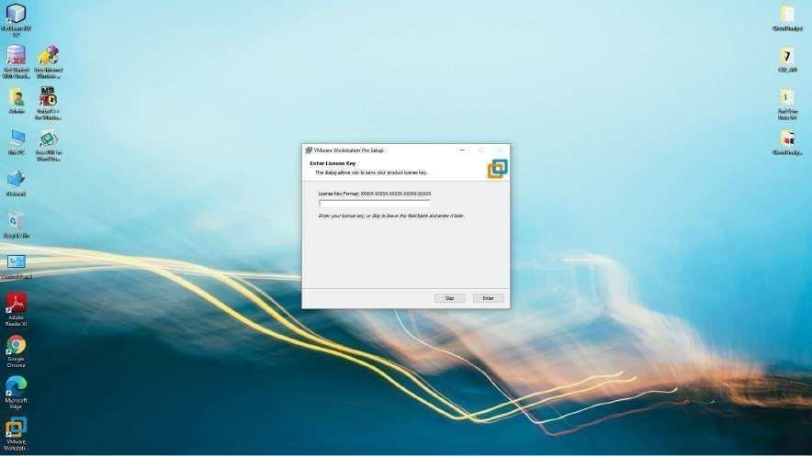

Click on Finish.

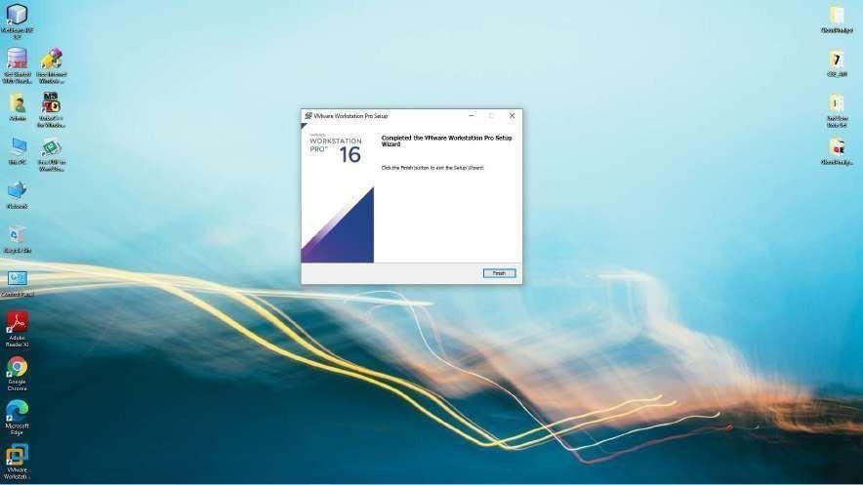

**Step** **3**: Click on File and Click on New Virtual Machine. A window appears as shown in the picture below. Select Typical and click on Next.

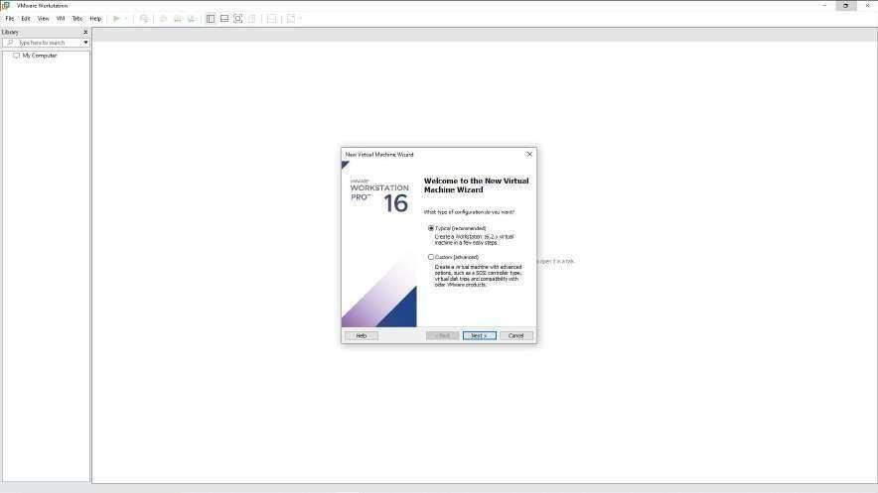

**Step** **4**: Select the Ubuntu ISO file present in the hard disk of your computer. Click on Next.

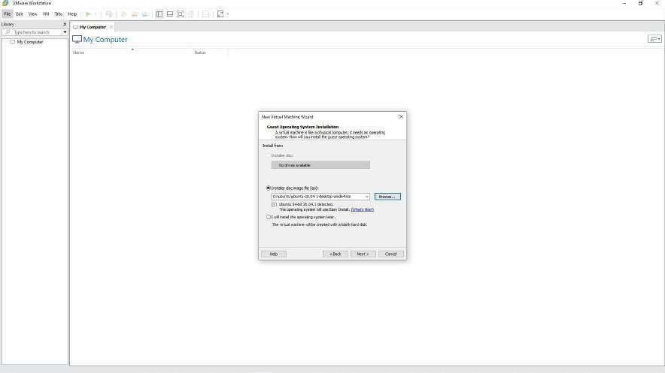

**Step** **5**: Set the Username and Password for your virtual machine and click on next.

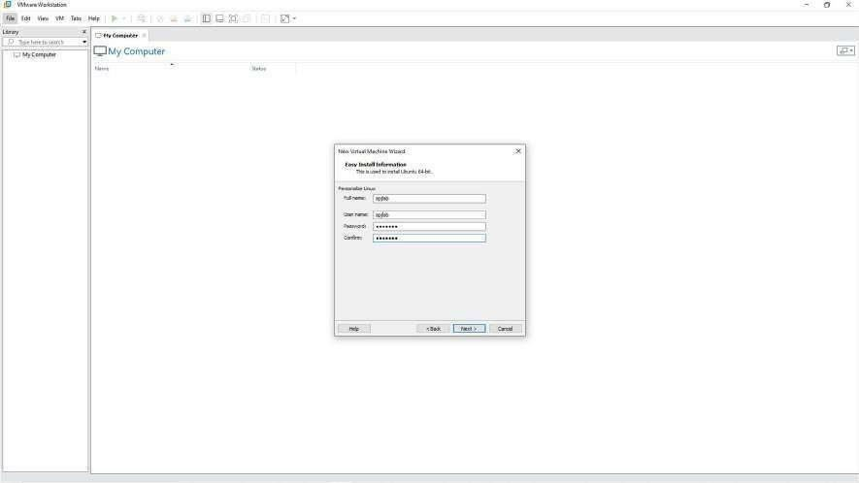

**Step** **6**: Name the virtual machine and click on next.

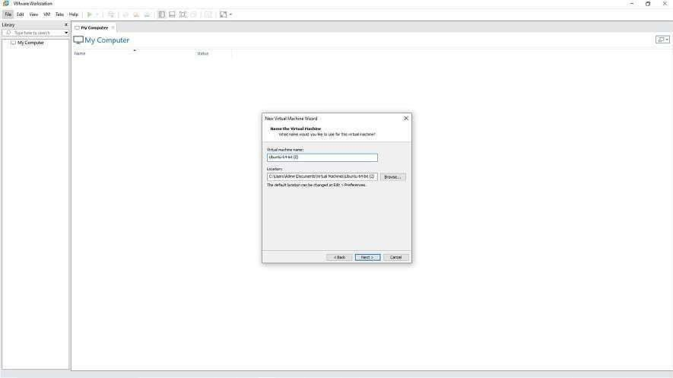

**Step** **7**: Set the disk space to 40GB and click on Next.

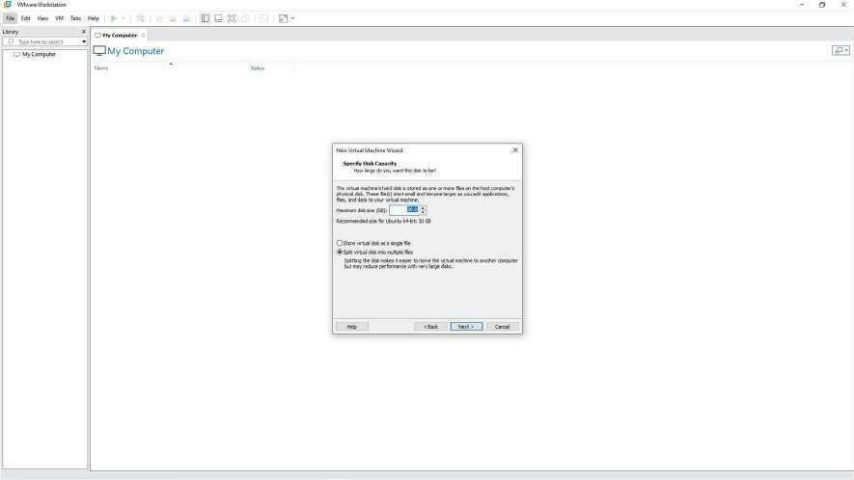

**Step** **8**: Click on Customize Hardware.

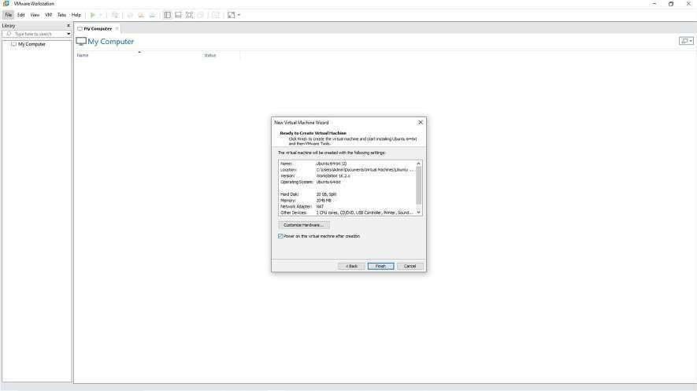

**Step** **9**: Set the RAM Size to 4GB i.e., 4096 MB and click on Close and click on Finish.

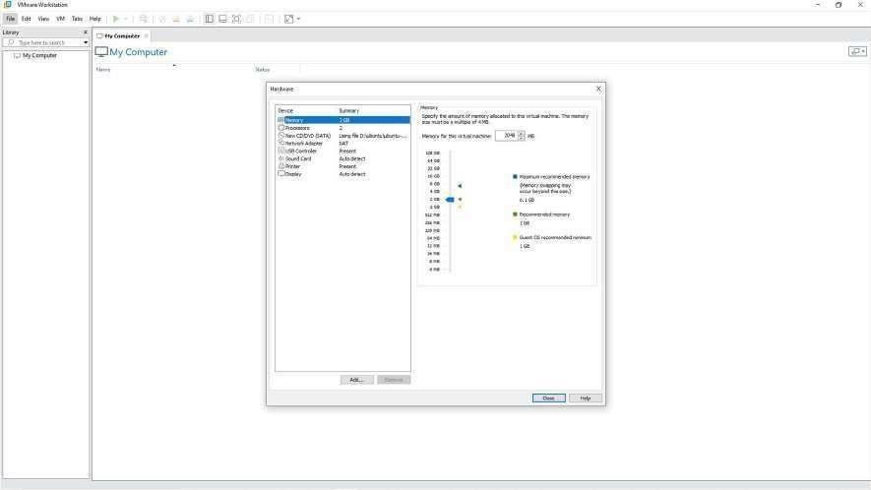

Wait for the installation to complete.

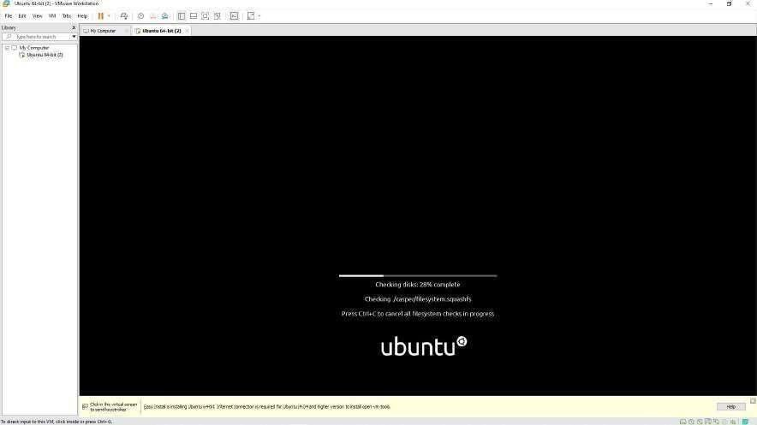

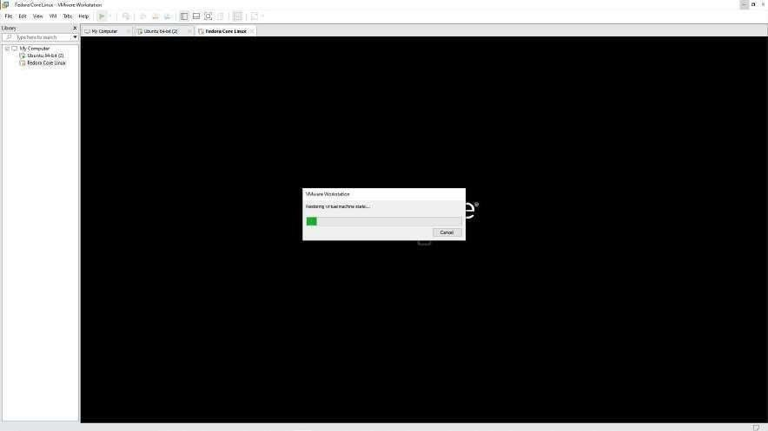

**Step** **10**: Open the terminal and type the following command:

sudo apt install samba

Wait for the installation to complete and close the terminal.

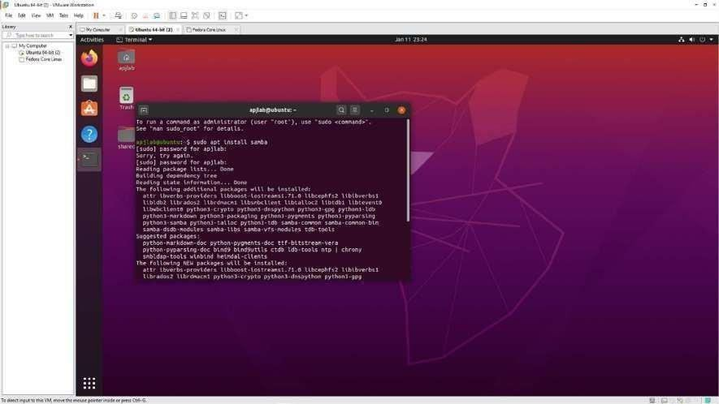

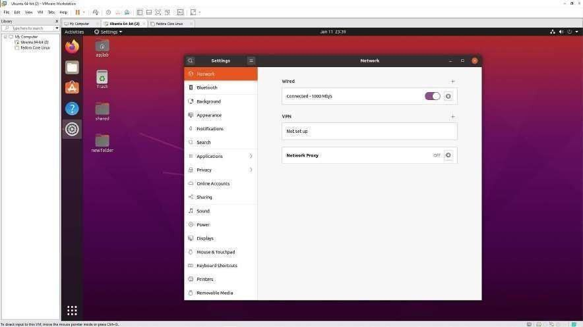

**Step** **15**: Click on Wired Settings and window appears as shown in the below picture. Copy the IPv4 address.

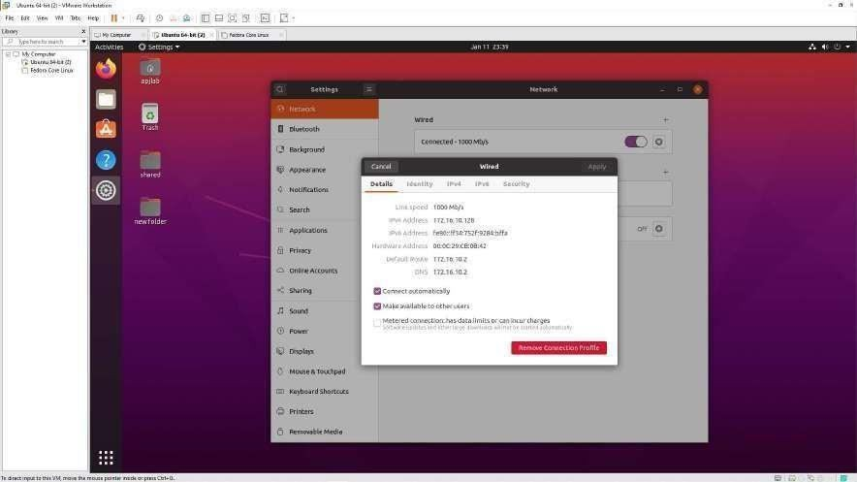

**Step** **16**: Open RUN on Windows and type the IP Address with the “\\”. For example, if the IPv4 Address copied is 172.16.10.128 in the Run window enter

\\172.16.10.128

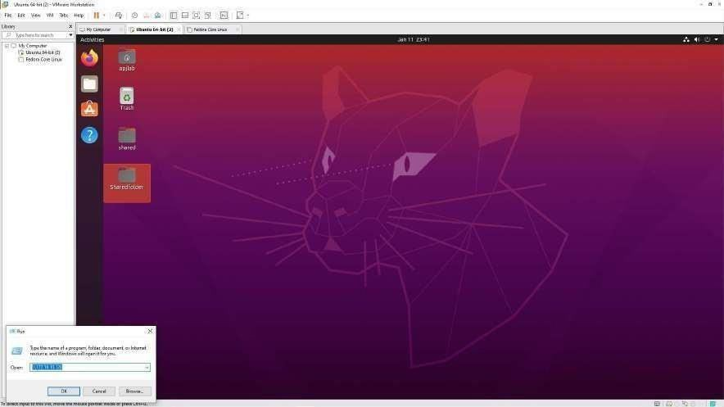

**Step** **17**: A window appears showing the folder that was shared. The user can now access the folder.

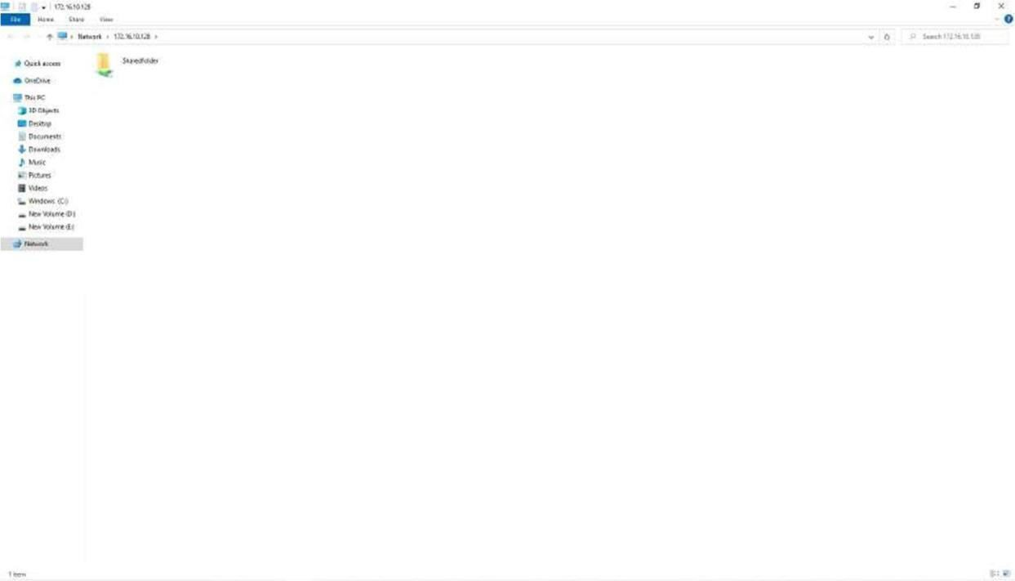

# PART B

(An Autonomous Institute, affiliated to VTU, Belagavi, Accredited by NAAC with ‘A’ Grade)



Near Jnana Bharathi Campus, Bengaluru – 560056

**MINI** **PROJECT** **REPORT** **ON**

### “Movie Explorer”

**Bachelor** **of** **engineering** **in** **COMPUTER** **SCIENCE** **AND** **ENGINEERING**

**Submitted** **by,**

## ESHAN KESARWANI 1DA22CS048

### Under the guidance of,

**Dr.** **Praveena** **M** **V** **Associate** **Professor** **Dr.** **AIT** **CSE**

### Department of Computer Science and Engineering 2023-2024

(An Autonomous Institute, affiliated to VTU, Belagavi, Accredited by NAAC with ‘A’ Grade)



Near Jnana Bharathi Campus, Bengaluru – 560056

**CERTIFICATE**

“Movie Explorer”

This is to certify that the project entitled **“Movie** **Explorer”** submitted in the partial fulfillment of the requirement of the 6th semester Cloud Computing laboratory curriculum during the year 2024-25 is a result of Bonafede work carried out by-

#### ESHAN KESARWANI 1DA22CS048

##### Signature of the Incharge,

**Dr.** **Praveena** **M** **V** **Associate** **Professor** **Dr.** **AIT** **CSE**

1. Internal Examiner
2. External Examiner

Dr. Nandini.N Head of Department

CSE Dr. AIT

#### ACKNOWLEDGEMENT



The satisfaction that accompanies to this project would be incomplete without the mention of the people who made it possible, without whose constant guidance and encouragement would have made our efforts go in vain.

We consider ourselves privileged to express our gratitude and respect towards all those who guided us through the project, **“Movie** **Explorer”**

We would like to express our gratitude to **Dr.M.** **N.** **Thippeswamy,** **Principal** **Dr.**

**AIT,** for providing us the congenial environment to work in.

We would like to express our profuse gratitude to **Dr.** **Nandini** **N,** **HOD,** **Dept.** **of** **Computer** **Science** **&** **Engineering,** **Dr.** **AIT,** for giving us the support, encouragement and providing us the required lab facilities that was necessary for the completion of this project.

As a token of gratitude, we would like to acknowledge our sincere gratefulness to the internal guide **Dr.** **M** **V** **Praveena** **,** **Dept.** **of** **CSE,** **Dr.** **AIT** for her unlimited support and encouragement provided throughout the process.

We also express our gratitude and sincere thanks to all the teaching and non-teaching staff of **Computer** **Science** **&** **Engineering** **Department.**

Finally, yet importantly, we would like to express our heartfelt thanks to our beloved **Parents** for their blessings and our **Friends** for their help and wishes for the successful completion of this project report.

**ESHAN** **KESARWANI**

## ABSTRACT



In response to the increasing demand for seamless digital entertainment experiences, this project presents **Movie** **Explorer**, a web-based movie and TV show exploration platform built using modern web technologies. The core objective is to offer users a dynamic and engaging interface to discover, search, and interact with trending, popular, and upcoming media content. Powered by the TMDB (The Movie Database) Public API, the application fetches comprehensive film and TV data to enhance user engagement through detailed content presentation and personalized recommendations.

The application is developed using **React** and incorporates a suite of tools including **Redux** **Toolkit**, **Axios**, **Sass**, and **MUI**, ensuring responsive performance and maintainable code structure. Key features include a real-time search bar, categorized movie sections (Trending, Now Playing, Coming Soon), detailed movie info pages with related recommendations, and pagination for content navigation. The UI is enhanced using **Bootstrap**, **React** **Bootstrap**, and **Slick** **Carousel**, while **Day.js** supports effective date handling. Lazy loading further optimizes performance by ensuring efficient media rendering.

This project is designed with scalability and user-centric functionality in mind. Future enhancements may include user authentication, watchlists, and integration with streaming services. Ultimately, **Movie** **Explorer** exemplifies how modern web development and third- party APIs can be combined to deliver an immersive and informative digital movie discovery experience.

## TABLE OF CONTENTS



|  |  |  |  |
| --- | --- | --- | --- |
| **Chapter** **No** |  | **Title** | **Page** **Number** |
| Chapter 1 | Introduction |  | 167-169 |
| 1.1 | Existing System | | 168 |
| 1.2 | Proposed System | | 168 |
| 1.2.1 | Scope of Work | | 168 |
| 1.2.2 | Problem Statement | | 169 |
| Chapter 2 | Requirement Specification | | 170-172 |
| 2.1 | Functional Requirements | | 170 |
| 2.2 | Non-Functional Requirements | | 172 |
| 2.3 | Hardware Specification | | 172 |
| 2.4 | Software Specification | | 172 |
| Chapter 3 | Methodology and Design | | 173-176 |
| 3.1 | Key Features | | 173 |
| 3.2 | Development and admin tools | | 175 |
| 3.3 | Planned Enhancment | | 176 |
| Chapter 4 | Deployment | | 177-177 |
| 4.1 | Deploy using Netlify | | 177 |
| 4.2 | Frontend | | 177 |
|  | Development (Code) | | 178 |
|  | Conclusion & | |  |
|  | Future Enhancements | | 179 |
|  | References | | 179 |

**CHAPTER** **1**

## INTRODUCTION

In the realm of cloud-based solutions, the Cloud-Based Job Tracker application stands as a testament to the fusion of innovative cloud technologies and practical employment management systems. This project harnesses the potential of cloud computing while addressing the complexities of job tracking and management in a seamless, user-friendly interface. Built on a foundation of scalability and efficiency, this application exemplifies the transformative power of cloud-based solutions in modern job management paradigms.

##### Objective

The central objective of the **Movie** **Explorer** project is to redefine the user experience in discovering and interacting with movie and TV show content through a responsive, data- driven web application. This project is designed to empower users with instant access to trending, popular, and upcoming entertainment content by utilizing The Movie Database (TMDB) Public API. At the heart of this application lies an intelligent content delivery system that fetches and organizes a vast collection of movie and television data, allowing users to explore detailed information, view trailers, and receive tailored recommendations in an intuitive format.

The project places a strong emphasis on performance, scalability, and modern design principles. Built with React and supported by technologies such as Redux Toolkit, Axios, and Sass, Movie Explorer ensures a fluid and responsive interface across devices. By integrating dynamic features like real-time search, lazy loading, and pagination, the application delivers a seamless browsing experience without overwhelming the user.

A key technical objective is to optimize user interaction through modular UI components, efficient state management, and the use of libraries such as React Bootstrap, MUI, and Slick Carousel. Additionally, the application architecture has been crafted with future scalability in mind, enabling easy incorporation of advanced features such as user authentication, personalized watchlists, and cloud storage for user preferences.

Looking forward, Movie Explorer is positioned for continuous development, incorporating feedback-driven enhancements and expanded integration capabilities.

#### EXISTING SYSTEM

The proposed **Movie** **Explorer** application marks a substantial improvement over traditional movie discovery platforms and static entertainment websites. Existing systems typically offer limited interactivity, outdated user interfaces, and lack dynamic content retrieval, resulting in a less engaging experience. Most rely on manually curated content or slow-refreshing databases, with little personalization or responsiveness. In contrast, **Movie** **Explorer** harnesses the power of The Movie Database (TMDB) Public API to fetch real-time, up-to-date data about movies and TV shows. By integrating technologies such as React, Redux, and Axios, the system delivers a modern, user- friendly interface with features like instant search, category-based content filtering, and interactive detail pages, offering users a more immersive and efficient way to explore entertainment content.

#### PROPOSED SYSTEM

The proposed VIVA Questions Answer Bot is designed to revolutionize the way academic VIVA The proposed **Movie** **Explorer** application is developed to transform the way users engage with film and television content online, offering an advanced and dynamic platform that overcomes the limitations of existing static entertainment portals. By integrating The Movie Database (TMDB) Public API with modern web technologies, the system introduces a responsive and interactive interface, allowing users to explore, search, and receive recommendations in a seamless and visually appealing environment.

At the core of the application is a well-architected data-fetching and state management system, powered by **Redux** **Toolkit** and **Axios**. This framework ensures efficient handling of large volumes of movie and TV data while supporting real-time updates and consistent application performance. The system intelligently categorizes content into Trending, Now Playing, Coming Soon, and Popular segments, making it easier for users to navigate and discover new releases or all-time favorites.

A standout feature of the proposed system is its use of modern UI/UX components built with **React**, **Sass**, **MUI**, and **Bootstrap**, which provide a rich and responsive experience across various devices. Features such as instant search, lazy-loaded images, carousels, and pagination enhance usability, while modular components enable easy scalability and maintenance.

The system is also designed with extensibility in mind. Future upgrades may include features like user profiles, watchlists, personalized recommendations, and secure authentication mechanisms to support a tailored user experience. Additionally, continuous improvement is prioritized through feedback-driven development and the exploration of more advanced integrations such as streaming service APIs or AI-driven recommendation systems.

###### SCOPE OF THE WORK

The scope of this project includes the comprehensive design, development, and deployment of the **Movie** **Explorer** application. Key components of the project involve integrating The Movie Database (TMDB) API to retrieve and display real-time movie and TV show data, building a responsive and dynamic user interface using React, and employing Redux for efficient state management.

The application focuses on core features such as trending and upcoming content display, detailed movie pages, search functionality, recommendations, and pagination to enhance the user experience.

###### PROBLEM STATEMENT

The current landscape of online movie discovery is hindered by outdated interfaces, fragmented content, and a lack of interactivity, making it difficult for users to efficiently find relevant and up-to-date entertainment information. Traditional systems often fail to provide real-time data, engaging visuals, or personalized recommendations, leading to a subpar user experience. Additionally, users frequently face challenges navigating through large volumes of content without clear categorization or intuitive browsing tools.

The proposed **Movie** **Explorer** application aims to address these issues by offering a modern, responsive, and feature-rich platform that integrates real-time data from the TMDB API. Through a clean interface, dynamic content organization, and advanced search and recommendation features, the system seeks to redefine how users explore and engage with movies and TV shows online.

**CHAPTER** **2**

## REQUIREMENT SPECIFICATION

The **Movie** **Explorer** project is built upon a well-defined set of requirements, addressing both functional and non-functional aspects essential to delivering a seamless and engaging user experience. Functionally, the system is designed to integrate with the TMDB Public API, enabling the retrieval and display of up-to-date information on movies and TV shows. The application must support categorized content sections such as Trending, Popular, Now Playing, and Coming Soon. It should include a search functionality embedded in the navbar, detailed movie information pages, and dynamic recommendation systems based on user interest.

Advanced functionality includes efficient state management using **Redux** **Toolkit**, optimized API interactions with **Axios**, and performance enhancements through **React** **Lazy** **Load** **Image** **Component**. The UI components must be modular and responsive, utilizing **React**, **Bootstrap**, **MUI**, and **Slick** **Carousel** for consistent performance across devices. Pagination mechanisms are required to manage large data sets effectively, and the overall layout must be designed for clarity and ease of navigation.

On the non-functional side, the system must demonstrate high performance with minimal loading times and smooth transitions. Scalability is a core requirement, allowing for future expansion with features such as user authentication, personalized watchlists, or integration with streaming platforms. The application should maintain robust reliability, ensuring consistent uptime and handling API errors gracefully. Security considerations include implementing best practices for API key management and planning for future user data protection through secure authentication systems.

User experience is a central focus, requiring a clean, intuitive interface that caters to both casual viewers and dedicated film enthusiasts. The project also emphasizes maintainability through clean code architecture and comprehensive documentation, covering both user guides and technical reference material for developers. Feedback mechanisms are encouraged to support iterative development and refinement of features based on real user behavior and suggestions.

In summary, by adhering to these requirements, **Movie** **Explorer** aims to provide a secure, scalable, and user-centric platform for modern movie and TV show discovery.

#### FUNCTIONAL REQUIREMENTS

functional requirements of the **Movie** **Explorer** application outline the essential features and capabilities the system must incorporate to achieve its objective of delivering a modern,

responsive, and efficient movie and TV show discovery experience. These requirements form the foundation for ensuring smooth navigation, accurate data presentation, and an engaging user interface.

* + 1. Movie and TV Show Data Integration:
       - The system must fetch real-time data from the TMDB (The Movie Database) Public API.
       - It should display categorized content such as Trending, Popular, Now Playing, and Coming Soon movies and shows.
    2. Search Functionality:
       - The application should include a search bar in the navbar that enables users to search for movies and TV shows using keywords.
       - The search should return relevant results instantly, with support for handling partial matches and varied input.
    3. Movie Details Page:
       - On clicking a movie or show, users should be directed to a dedicated page displaying comprehensive details including title, synopsis, release date, genres, ratings, and trailer (if available).
       - Related content or recommendations must also be shown on the details page.
    4. Pagination and Lazy Loading:
       - Implement pagination to handle large datasets in categories like Popular or Trending.
       - Use lazy loading for images and content to optimize performance and minimize load times.
    5. Recommendation System:
       - Provide movie or TV show recommendations based on the selected content using TMDB’s recommendation endpoint.
       - Recommendations should update dynamically based on the content being viewed.
    6. User Interface Design:
       - Design a responsive and visually appealing UI using React, Bootstrap, MUI, and Sass for consistent experience across desktop and mobile devices.
       - Incorporate carousels (React Slick) and styled components for improved user engagement.
    7. Component-Based Architecture:
       - Develop the application using a modular component structure to facilitate reuse, maintenance, and scalability.
       - Use Redux Toolkit for efficient state management and API handling.
    8. Error Handling and Notifications:
       - The system should gracefully handle API errors, displaying user-friendly messages if data cannot be fetched or loaded.
       - Loading states and transitions should be clearly communicated to users.

#### NON-FUNCTIONAL REQUIREMENTS

In systems engineering and requirements engineering, non-functional requirements are those requirements that specifies criteria that can be used to judge the operation of a system. Non - Functional requirements for the proposed system are:

* Performance
* Portability (able to run code on other devices too)
* Extensibility
* Reliability
* Compatibility

#### HARDWARE REQUIREMENTS

Hardware refers to the physical elements of the computer. This is sometimes called the machinery or equipment of the whole model. In contrast to software, hardware is a physical entity. Hardware and software are interconnected. Without software, the hardware of the system would have no function. Here is a list of hardware and software components used in our system along with their functionalities and use.

* **Processor:** Intel i7 10th Gen
* **Processor** **Speed:** 2.4 GHz
* **Ram:** 8 Gb
* **Hard** **Disk:** 10 Gb

#### SOFTWARE REQUIREMENTS

**Movie** **Explorer** application is built on a robust stack of modern web development technologies designed to ensure scalability, responsiveness, and an intuitive user experience. The frontend of the application is developed using **React**, enabling the creation of a dynamic, component-based interface. To manage the application state efficiently, **Redux** **Toolkit** is used, streamlining the data flow and improving maintainability.

**Axios** is employed for making asynchronous API calls to the **TMDB** **(The** **Movie** **Database)** **Public** **API**, which serves as the primary data source for movies, TV shows, and related metadata. **Sass** is used for advanced styling, offering better modularization and theming capabilities, while **Bootstrap** and **Material** **UI** **(MUI)** enhance the UI/UX design with responsive and visually consistent components. **React** **Bootstrap** is also utilized to seamlessly integrate Bootstrap's styling within the React ecosystem.

**CHAPTER** **3**

## METHODOLOGY AND DESIGN

Framework outline is worried about making another framework in the spot of an old one. This The **Movie** **Explorer** web application is designed to provide an immersive and modern platform for discovering movies and TV shows. Built using React and powered by the TMDB API, the platform delivers real-time movie information, trailers, cast details, and more. It is deployed on **Netlify** for reliable and fast access.

* 1. Key Features & Architecture

1. **Home** **Page** **Overview**
   * Displays sections like Trending, Now Playing, Upcoming, and Popular Movies.
   * Uses carousels for smooth navigation.
   * Incorporates lazy loading for improved performance.

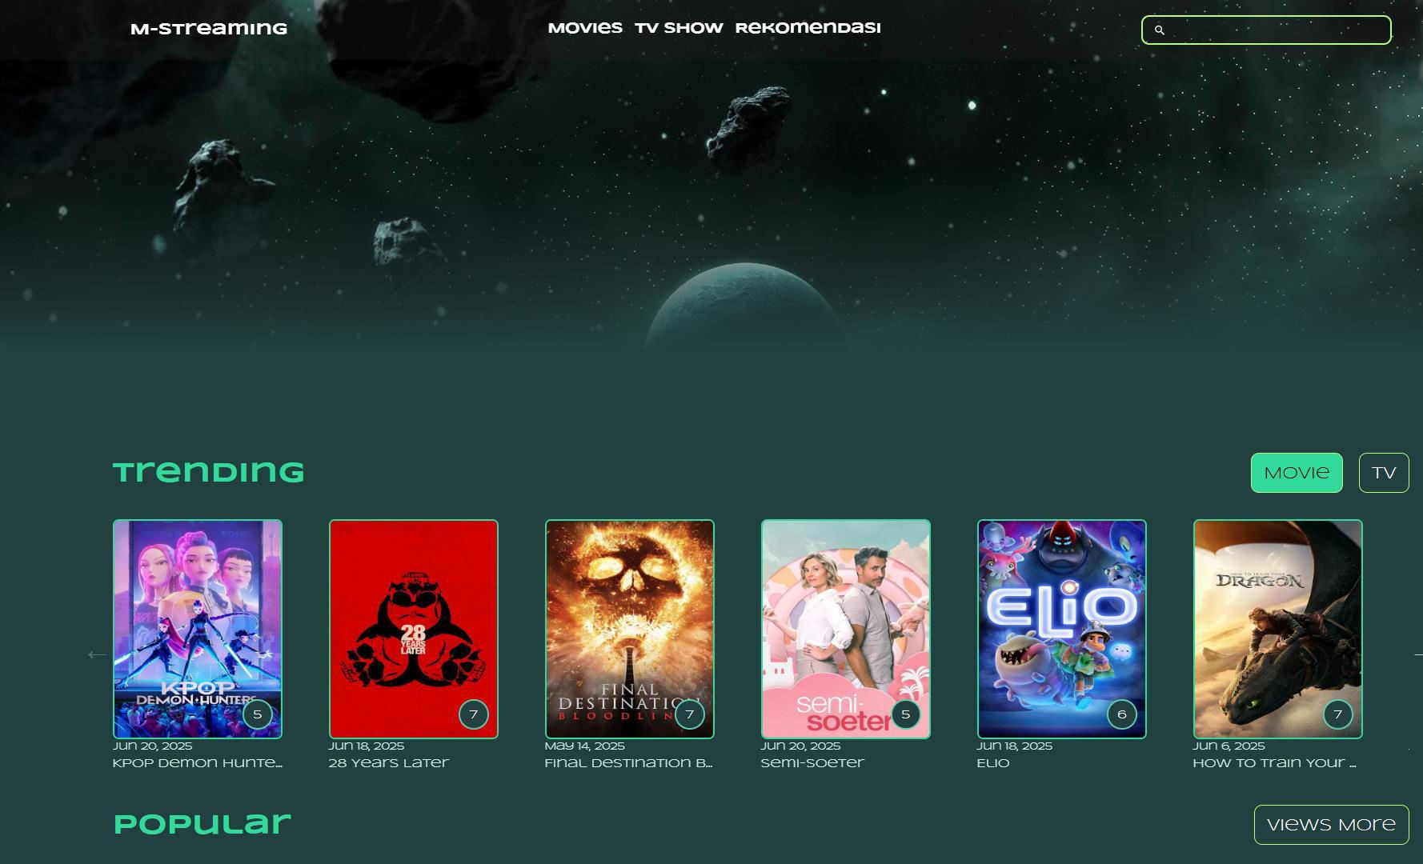 ˙•— ˆ ***Screenshot:*** ***Home*** ***Page***

1. Movie Details Page
   * Shows detailed movie information including:
     + Synopsis
     + Poster
     + Ratings, genres, and release date
     + Movie trailer (YouTube embed)
     + Cast and crew details
     + Related/recommended movies

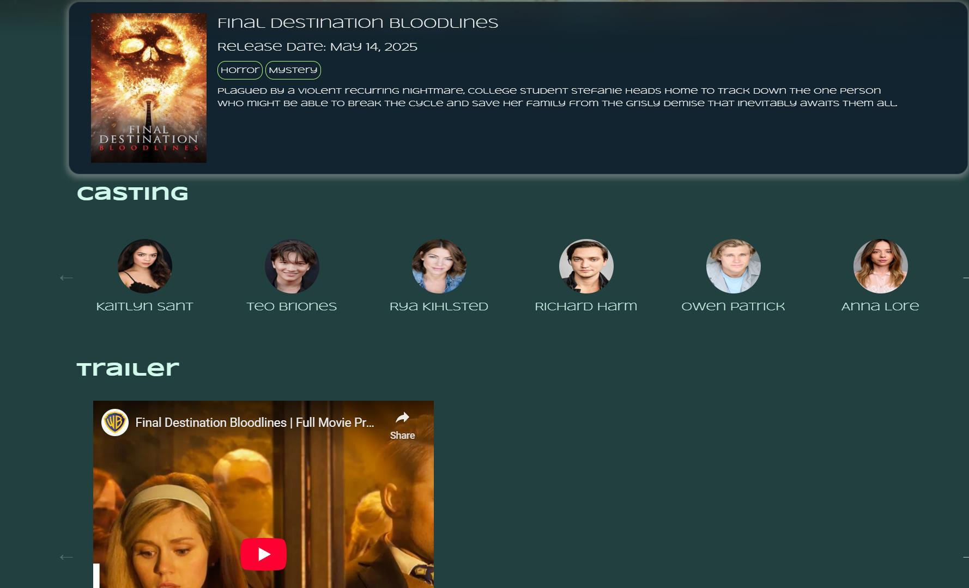 ˙•ˆ— • ***Screenshot:*** ***Movie*** ***Details*** ***Page***

1. Search Functionality
   * Users can search by movie name using the search bar in the navbar.
   * Results are fetched via Axios and displayed dynamically.
2. Movie Recommendations
   * Based on selected movie, similar or recommended movies are displayed.
   * Users can explore related titles and navigate between them.

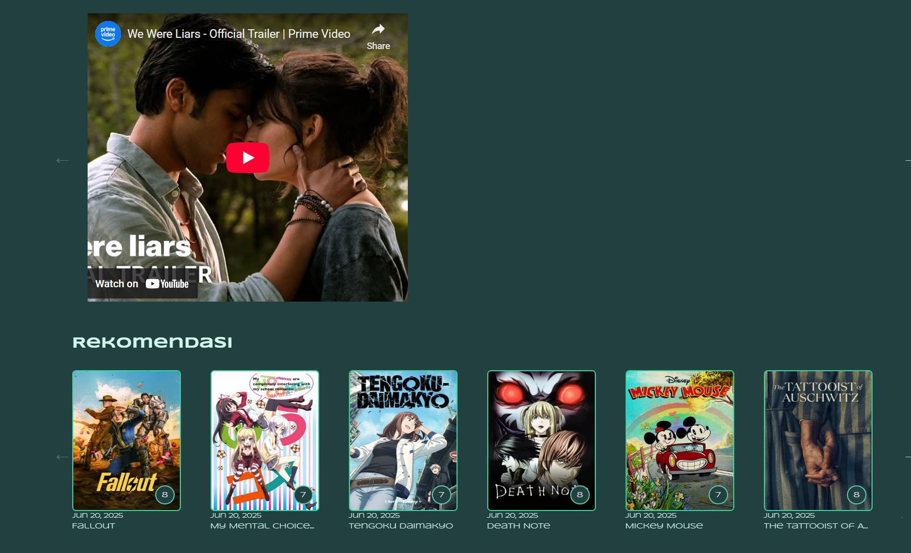 ˙•— ˆ ***Screenshot:*** ***Movie*** ***Recommendations***

1. Responsive UI and Carousels
   * Fully responsive layout across desktop and mobile devices.
   * Slick Carousel is used for smooth scrolling through movies.
   1. Deployment & Admin Tools Hosting on Netlify

* **Continuous** **Deployment** from GitHub repository.
* Supports environment variables for secure API key usage.
* Live preview links and rollback functionality for quick fixes.

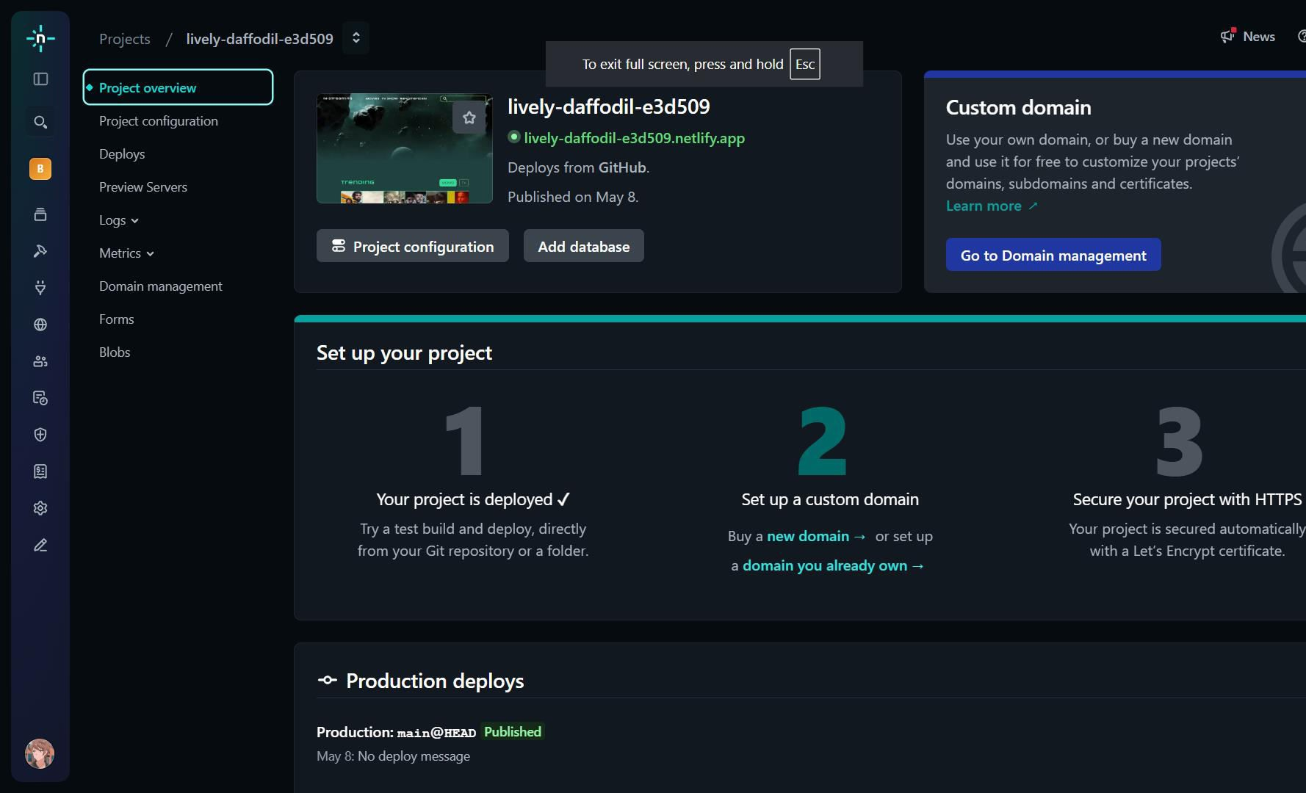—ˆ•˙ ***Screenshot:*** ***Netlify*** ***Deployment*** ***Dashboard***

* 1. Planned Enhancements
* **User** **Authentication**: Login/register features for saving watchlists.
* **Watchlist** **Module**: Users can bookmark and track movies they’re interested in.
* Admin Panel (Future Scope):
  + Add/remove featured content.
  + View usage analytics (via third-party tools like Google Analytics or Netlify Analytics).

.

## CHAPTER 4

### Deployment Using Netlify (CI/CD Setup)

* + - Step 1: Prepare the Application for Deployment
    - **Build** **Process:** Run npm run build to create an optimized production build of the React application. This generates static files in the build/ directory that are ready for deployment.
    - **Environment** **Configuration:** Use .env files to store sensitive information such as the TMDB API key. These environment variables are managed securely via the Netlify dashboard.
    - Step 2: Deploy to Netlify
    - **Connect** **GitHub** **Repository:** In the Netlify UI, connect your GitHub repository containing the Movie Explorer project. Netlify will automatically detect the build command and publish directory.
    - **Build** **Command:** npm run build
    - **Publish** **Directory:** build/
    - **Auto** **Deployment:** Any new commit pushed to the linked GitHub branch (e.g., main) triggers an automatic deployment via Netlify CI/CD.
    - Step 3: Domain Configuration
    - **Custom** **Domain:** Netlify provides a free subdomain (e.g., movie-explorer.netlify.app), but you can also configure a custom domain.
    - **HTTPS** **&** **SSL:** Netlify automatically provisions SSL certificates using Let's Encrypt to ensure secure access over HTTPS.
    - Step 4: Monitor and Optimize
    - **Netlify** **Analytics** **(Optional):** Monitor site traffic and performance.
    - **Rollback** **&** **Versioning:** Easily revert to previous versions using Netlify’s deployment history feature.
    - 4.2 Front End
    - The front end of the **Movie** **Explorer** application is designed with usability and visual appeal in mind. Built using **React**, **Bootstrap**, **Sass**, and **MUI**, it delivers a fast, responsive, and modern interface for discovering movies and TV shows.

## DEPLOYMENT

Software deployment includes all of the steps, processes, and activities that are required to make a software system or update available to its intended users. Today, most IT organizations and software developers deploy software updates, patches and new applications with a combination of manual and automated processes. Some of the most common activities of software deployment include software release, installation, testing, deployment, and performance monitoring.

Software development teams have innovated heavily over the past two decades, creating new paradigms and working methods for software delivery that are designed to meet the changing demands of consumers in an increasingly connected world. In particular, software developers have created workflows that enable faster and more frequent deployment of software updates to the production environment where they can be accessed by users.

Advantages of Cloud Deployment:

* Faster and simplified deployments. Automate builds that deploy code, databases, and application releases, including resource provisioning.
* Cost savings. Control costs using consumption-based pricing and eliminate capex-heavy on- premises environments.
* Platform for growth. Leverage the global infrastructure provided by cloud service providers (CSPs) to seamlessly expand the business into other geographies.
* New digital business models. Exploit the continuous release of features and services by CSPs, incubate new technologies and innovate digital business models.
* Business resiliency. Architect for the availability and fault-tolerance CSPs offer and ensure disaster recovery and business continuity of applications to make the business resilient.
* Agility and scalability. Use autoscaling and scalability to meet peak demands of the business without provisioning for excess capacity.
* Geographic reach. Access applications from any location, on any device, leveraging the connectivity backbone of CSPs.
* Operational efficiency. Use the inherent automation enabled by cloud to increase operational efficiency and reduce human effort.
* A competitive edge. Leverage infrastructure as code and development, security and operations to reduce the time to market for new features and stay ahead of the competition.
* Empowered users. Increase productivity by empowering users with self-service options on cloud, such as portals, DevOps pipelines, and executive and operational dashboards.

## CONCLUSION & FUTURE ENHANCEMENTS

The Cloud Viva chatbot project encapsulates a sophisticated solution, adeptly leveraging the capabilities of The **Movie** **Explorer** project presents a modern and scalable solution for discovering and exploring movies and TV shows, built with a strong emphasis on performance, usability, and dynamic content delivery. By leveraging React and integrating with **The** **Movie** **Database** **(TMDB)** **API**, the platform delivers real-time access to rich entertainment content including trending titles, detailed movie metadata, cast information, and trailers.

Deployed on **Netlify** using continuous integration pipelines, the project ensures seamless updates and reliable accessibility, supporting rapid iteration and minimal downtime. The modular and component-driven architecture enables the project to scale and evolve efficiently as new features are introduced.

Looking ahead, **Movie** **Explorer** is well-positioned for future enhancements that will further enrich its feature set and broaden its appeal. Planned improvements include:

* **User** **Authentication**: Introducing login and registration features using Firebase or Auth0 to enable personalized user experiences.
* **Watchlist** **Functionality**: Allowing users to save and track favorite or to-watch movies.
* **Filter** **and** **Sort** **Options**: Giving users more control to browse content by genre, rating, release year, or language.
* **Dark** **Mode** **Toggle**: Enhancing UI personalization and visual comfort.
* **Performance** **Analytics** **Integration**: Utilizing tools like Google Analytics or Netlify Analytics to monitor user behavior and improve content strategy.
* **Progressive** **Web** **App** **(PWA)** **Support**: Enabling offline access and native app-like behavior for enhanced mobile usability.

In conclusion, **Movie** **Explorer** stands as a strong foundation for a feature-rich movie discovery platform. Its modular architecture, modern design, and seamless integration with TMDB make it a reliable and future- ready solution for entertainment enthusiasts. With continuous improvements and user-driven development, the project is poised to grow into a comprehensive entertainment companion.

## REFERECNES

* https://[www.youtube.com](http://www.youtube.com/)
* https://[www.google.co.in](http://www.google.co.in/)
* https://[www.wikipedia.org](http://www.wikipedia.org/)
* https://aws.amazon.com/

